**Holbrook St Michael’s Church**

**Harvest Fish and Chip Lunch**

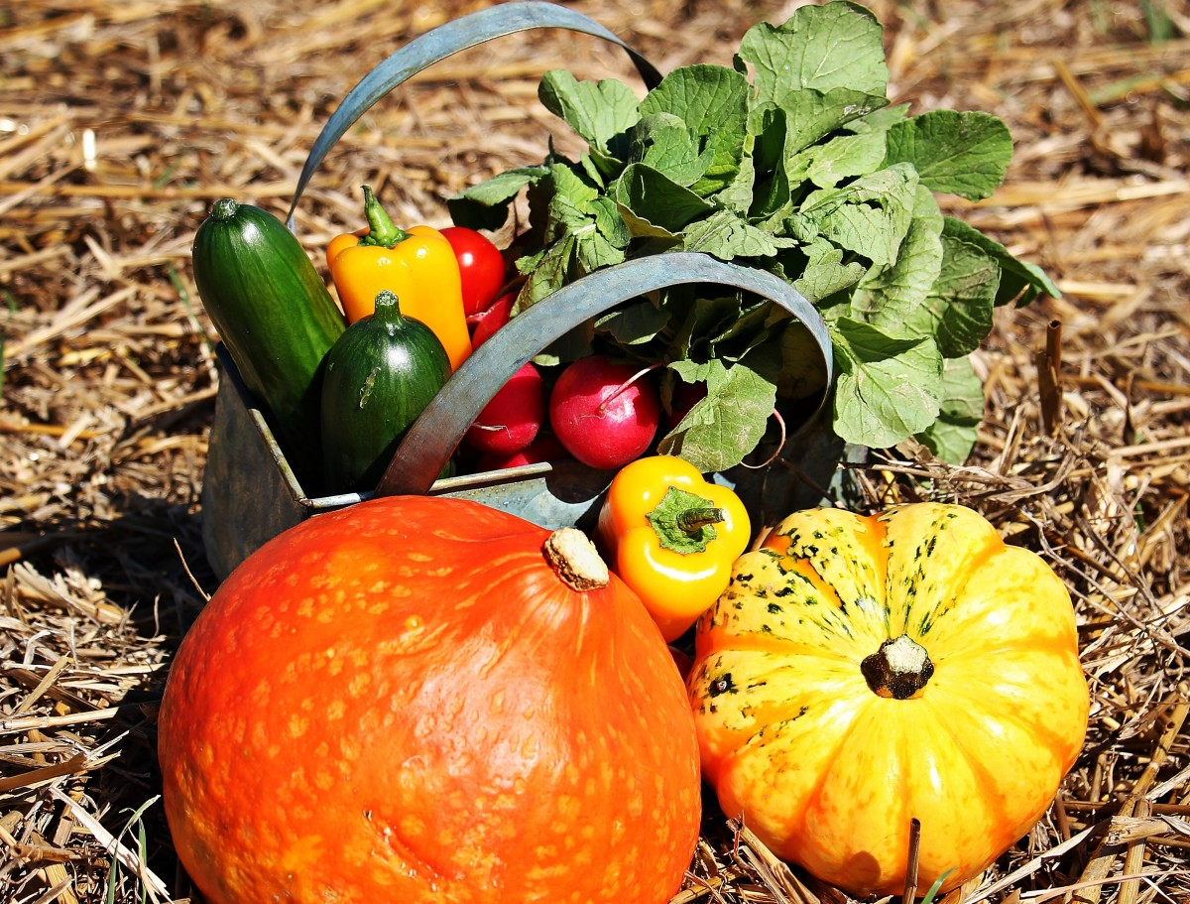

**Saturday 11th October 2025**

**From 12 noon till 2.00 p.m. in the Arkwright Hall.**

**Adults £12.00, Children £6.00**

**Booking before Monday 6th October is essential.**

**Please get your ticket from Lily (01332 883063), Sue (07718679976) or John (07890 241673).**