Sunday 31st August
at 11.15am

The Onny Camlad Benefice Churches
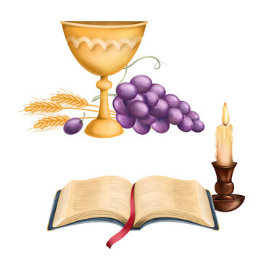
join together for a fifth Sunday
Service of
Holy Communion at
Holy Trinity Church
Lydham

There will be a ‘Bring & Share’ finger buffet lunch afterwards
in Lydham Village Hall
(please call 01588 650580 for more details)

All are welcome.
Please do join with us.

Ample parking in village hall car park

