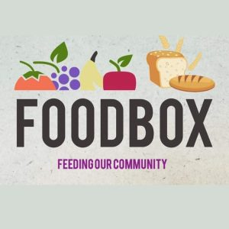

**List of Useful donations this Harvest**

* Cereals - gluten free also if possible
* Rice
* Pasta
* Pasta sauces
* Long life milk
* Coffee/tea
* Biscuits
* Jam/marmalade
* Peanut butter
* Flour
* Tinned items: puddings, vegetables, tuna, corned beef, tinned mince/chicken, hot dogs, beans & sausage mix