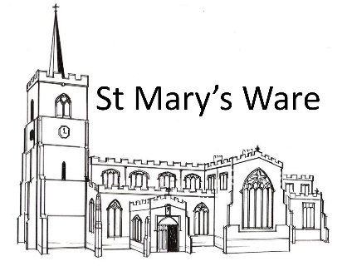
CHORAL EVENSONG with Former Choristers

Sunday 21st September 2025

If you have EVER sung with St Mary’s Church Choir you are invited to join a service of Choral Evensong with current and former choristers.

- Singers arrive from 2pm – refreshments will be served
- 3pm rehearsal
- 4.30pm refreshment break
- 5pm Choral Evensong
- 6pm Reception for all singers and congregation

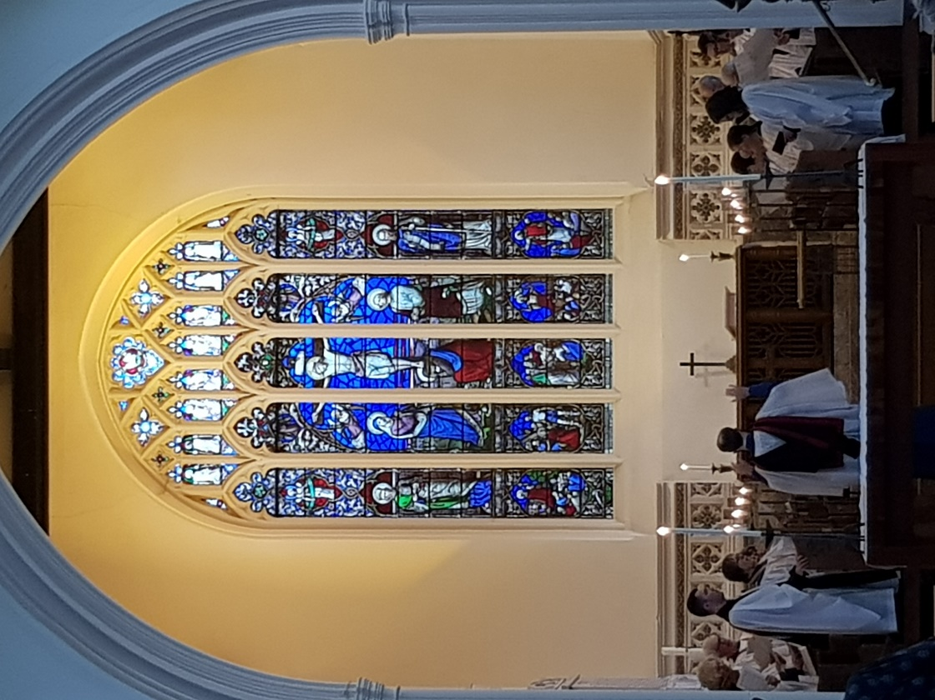
If you would like to attend Evensong but not join the choir, you are welcome to gather for refreshments from 4pm and then come to the service and reception.
To sign up or find out more contact Norah on
norah@henryhickman.com
All Singers welcome
We’d love to have singers & congregation from as many eras as possible
Find old friends and make new
Remember your place in the choir stalls
Celebrate the gift of music and share your memories

CHORAL EVENSONG with Former Choristers

Sunday 21st September 2025

If you have EVER sung with St Mary’s Church Choir you are invited to join a service of Choral Evensong with current and former choristers.

- Singers arrive from 2pm – refreshments will be served
- 3pm rehearsal
- 4.30pm refreshment break
- 5pm Choral Evensong
- 6pm Reception for all singers and congregation

If you would like to attend Evensong but not join the choir, you are welcome to gather for refreshments from 4pm and then come to the service and reception.
To sign up or find out more contact Norah on
norah@henryhickman.com
All Singers welcome
We’d love to have singers & congregation from as many eras as possible
Find old friends and make new
Remember your place in the choir stalls
Celebrate the gift of music and share your memories

