##### 

##### Community Lunch

##### Thank you to those who attended our 2nd Community lunch last Sunday and who brought food. Some 35 people attended and enjoyed a lovely meal and good company. Our next lunch will be on Sunday 28th September as we celebrate Harvest. Please put this date in your diaries.

##### Update on our new vicar

##### Revd Maggie Crosbie will be moving into the vicarage on Monday 21st July. We have been in regular contact with Maggie and she is really looking forward to taking up her new role and to meet you all. She will have 3 weeks settling into the village before she takes up her new position. Her licensing service will be on Monday 11th August at 7.30 pm at St Mary Magdalene, Shippon. Refreshments will be served after the service. Everyone is invited. Maggie’s 1st service at St Peter’s will be the All Age Service on Sunday 17th August.

##### Ride and Stride

##### The annual Sponsored Ride and Stride will be taking place this year on Saturday 13th September. We will be opening St Peter’s to welcome any cyclists or walkers. If anyone would like to take part by cycling or walking round some of our local churches then sponsorship forms are available from Mike Varnom. 50% of all money raised goes to Oxford Historic Church Trust with the remaining 50% going to the church

**St Peter’s Church Wootto**n

##### Sunday 20th July

##### All Age Service

##### 5th Sunday after Trinity

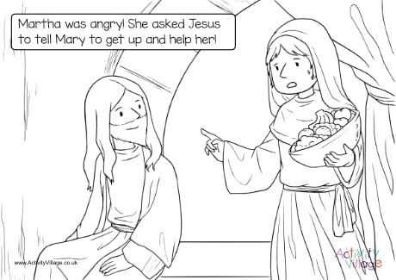

**St Peter’s Wootton**

***A vibrant, growing church***

***at the heart of the community***

***spreading the love, joy and peace of Jesus to all***

**Collect**

Almighty and everlasting God,

by whose spirit the whole body of the Church

is governed and sanctified:

hear our prayer which we offer for all your faithful people,

that in their vocation and ministry

they may serve you in holiness and truth

to the glory of your name;

Through our Lord and saviour Jesus Christ,

who is alive and reigns with you,

in the unity of the Holy Spirit,

one God, now and for ever. **Amen.**

**Today’s Service**

Mike Varnom will be leading our All Age service this morning. Refreshments will be served after the service.

##### Next Sunday

Revd Tony Rogerson will be presiding and preaching at our service of Holy Communion at 10.00 am.

**Prayer meeting**

Shirley, Mike and Simon will continue to meet fortnightly on a Friday at 12.00 for half an hour to pray for our church and parish. We will next meet on Friday 25th July at 12.00. Please join us if you are free.

##### FUTURE SERVICES

Sunday 27th July – Holy Communion at 10.00 am – Revd Tony Rogerson

Sunday 3rd August – Morning Prayer and Praise at 10.00 am – Dr Shirley Northover, with address given by Paul Herrington

Wednesday 6th August – Holy Communion at 10.00 am

Sunday 10th August – Holy Communion at 10.00 am – Revd Stephen Coe

Monday 11th August – Licensing Service for Revd Maggie Crosbie at 7.30 pm at St Mary Magdalene Shippon

Sunday 17th August – All Age Service at 10.00 am – Revd Maggie Crosbie

Sunday 24th August – Holy Communion at 10.00 am – Revd Tony Rogerson

Sunday School next meets on Sunday 3rd August in the Parish room.

**Our next Open Church is on Saturday 26th July between 10.00 and 12.00 - do drop in for a bacon roll, tea, coffee and biscuits and the opportunity for a friendly chat surrounded by the peace and beauty of our ancient church.**

Further details are available at [www.woottonchurch.co.uk](http://www.woottonchurch.co.uk)

You can contact us by email at: [woottonvicarage@btinternet.com](mailto:woottonvicarage@btinternet.com)

or by telephone on 01865 735661.