**Families are welcome to all our services of worship.** On the 1st Sunday of each month we have an All Age Worship Service in which we like children to participate.

**ALL AGE WORSHIP July 6th**

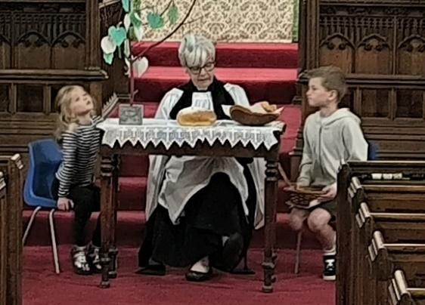

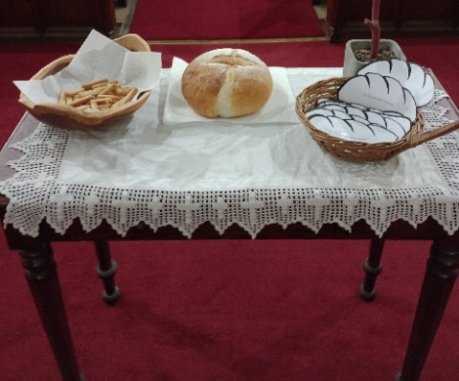 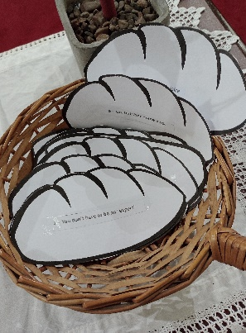

When Jesus walked the earth, He said that HE is the bread of life because knowing Him and doing what He says is life-giving to our spirits. Jesus spent a lot of time teaching his disciples about God’s kingdom. He would have sat at the table sharing food with them just as we did. But one day Jesus told them that there were many other people who needed to hear the good news about God’s kingdom, and that they were to go out in twos and be God’s messengers. In our service children went in two to give bread to the congregation and then with loafs identifying ten things that we can learn about being God’s messengers. After which our children said a prayer.

Our next **All Age Worship Service** is on **August 3rd at 11** **am.**