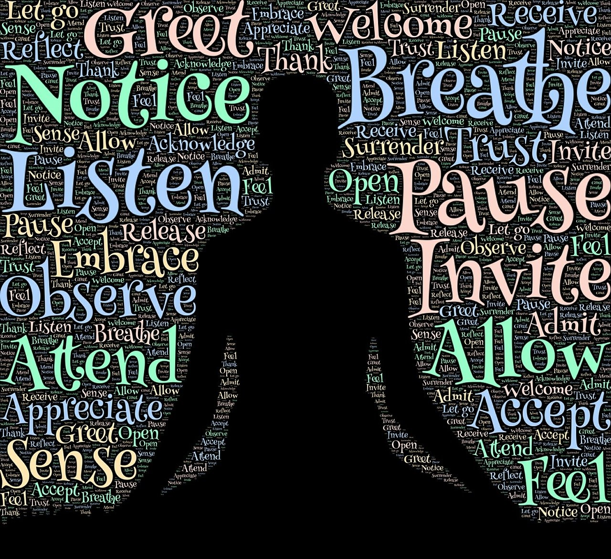  16th August  mindfulness taster session  With Jo Chapman held at St Cuthbert’s Church, Dufton.  If you are curious about mindfulness, come along to a short introductory taster session and have a go. Experience a one-hour mindfulness session guided by a qualified mindfulness teacher which will include:  Introduction to mindfulness, sharing a group mindfulness practice, a short mindfulness walk to the planned area which will be a dedicated outdoor space for reflection, finishing with a candlelight reflection. This session would benefit persons 18 years and above. We aim to have future session specifically targeted at under 18’s.  This event is free, however if you would like to give a donation the donation will be given to St Cuthbert’s Church, Dufton. | What is mindfulness?  ────  What are the benefits?  ────  What does mindfulness involve?  ────  How is mindfulness practiced?  ────  Starts 2pm in Church  We are limited to 20 spaces, please contact to book your space either  Gillian Bryan - 017683 51414 gillianbryan3545@aol.com  Pam Day – pameladay18@msn.com  Lisa Brook – 07747797661 lisam.brook@btopenworld.com or Dawn Hurton – hurtondawn@gmail.com

