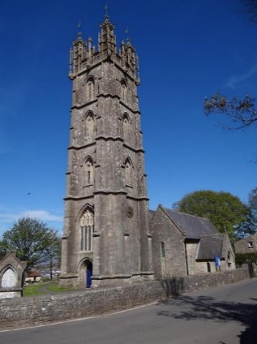
Dundry Church Tower
will be open on the following dates in 2025

7th June, 5thJuly, 2ndAugust, 6thSeptember
10am -12pm
(weather permitting)

TOWER HEALTH & SAFETY REGULATIONS

Due to the steep narrow access to the Tower the following points should be observed –
- No high heels or flip flops
- Only children aged 8 and over are allowed up the Tower, and they must be accompanied by a responsible adult
- No children under the age of 8, this also includes babies in slings
- No rucksacks, large shoulder or hand bags
- It can be windy and cold at the top so you are advised to wear a jumper/coat
- Only 6 people allowed at the top of the tower at any one time, plus 2 volunteers

Please respect our Health & Safety Regulations as they are there to protect you

Suggested Donation
ADULTS £2 and CHILDREN (AGED 8 – 16) £1

