Collect for St Peter’s Day
Almighty God,
who inspired your apostle Saint Peter
to confess Jesus as Christ and Son of the living God:
build up your Church upon this rock,
that in unity and peace it may proclaim one truth
and follow one Lord, your Son our Saviour Christ,
who is alive and reigns with you,
in the unity of the Holy Spirit,
one God, now and for ever. Amen.

Community Lunch

Our 2nd Community lunch will be held on Sunday 13th July at 12.30 pm in Function Room 1 at the Community Centre. We will be serving a ploughman’s followed by crumble and ice cream/custard. There is no charge, but if you would like to come then please sign the list in church. If you are able to bring a salad or fruit pie/crumble then please also sign the other list.

Diana Griffin Thanksgiving Service

A Thanksgiving service for Diana Griffin will be held at St Peter’s on Friday 18th July at 3.00 pm. Everyone is welcome.

St Peter’s Church Wootton

Sunday 29th June

St Peter’s Day

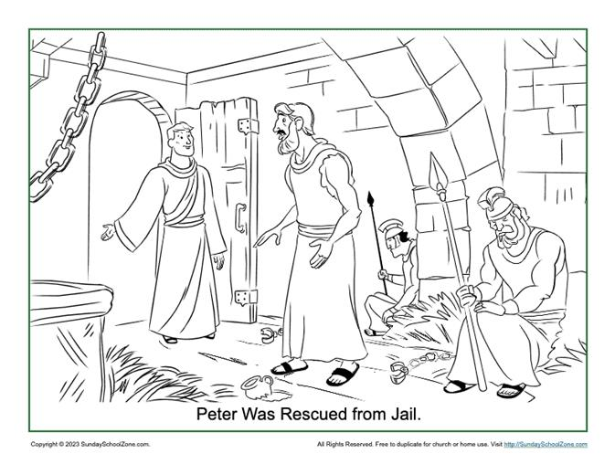
Family Communion

St Peter’s Wootton
A vibrant, growing church
at the heart of the community
spreading the love, joy and peace of Jesus to all

Readings
Acts 12: 1-11
Matthew 16; 13-19

Today’s Service

Revd Stephen Coe will be presiding and preaching at our Family Communion service as we celebrate St Peter’s Day. Thank you to St Mary Magdalene, Shippon, for providing the service booklets.

Next Sunday

Dr Shirley Northover will be leading our service of Morning Prayer and Praise at 10.00 am.

Prayer meeting
Shirley, Mike and Simon will continue to meet fortnightly on a Friday at 12.00 for half an hour to pray for our church and parish. We will next meet on Friday 11th July at 12.00. Please join us if you are free.

Let us pray for: Alex Purbrick and Olivia Hancock who were married at St Peter’s yesterday; for the friends and family of Diana Griffin who sadly passed away on Friday 13th June; and the family and friends of Gerry Quaghebeur, the Chair of the Parish Council, who sadly passed away in hospital on 18th June after a short illness.

FUTURE SERVICES
Wednesday 2nd July – Holy Communion at 10.00 am
Sunday 6th July – Morning Prayer and Praise – Revd Stephen Coe
Sunday 13th July – Holy Communion at 10.00 am – Revd Tony Rogerson
Wednesday 16th July – Holy Communion at 10.00am
Sunday 20th July – All Age Service at 10.00 am – Mike Varnom
Sunday 27th July – Holy Communion at 10.00 am – Revd Tony Rogerson
Sunday 3rd August – Morning Prayer and Praise at 10.00 am – Dr Shirley Northover
Wednesday 6th August – Holy Communion at 10.00 am
Sunday 10th August – Holy Communion at 10.00 am – Revd Stephen Coe
Sunday 17th August – All Age Service – Revd Maggie Crosbie

Sunday School next meets on Sunday 6th July in the Parish room.
Our next Open Church is on Saturday 26th July between 10.00 and 12.00 - do drop in for a bacon roll, tea, coffee and biscuits and the opportunity for a friendly chat surrounded by the peace and beauty of our ancient church.

Further details are available at www.woottonchurch.co.uk
You can contact us by email at: woottonvicarage@btinternet.com
or by telephone on 01854 735661.

