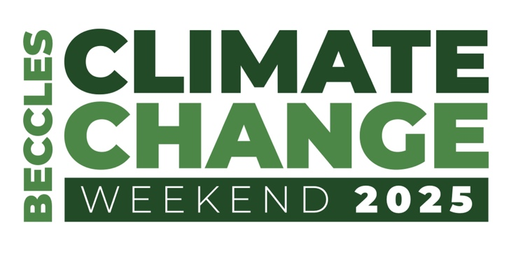
Working Together for a More Sustainable Future

Friday June 6^{th,} Saturday June 7th Sunday June 8th
St Michael the Archangel, New Market, Beccles NR34 9HE

Date | Time | Activity
Friday June 6th | 9.30 – 11.30 | Primary Schools’ Workshop  Located in the Undercroft
 | 18.30 – 21.00  (with a refreshment break at 19.30) | Insight Talks: Setting the Scene  Doors open at 6pm  Chair  Revd Mark Bee  Former Leader of Suffolk County Council and former Mayor of Beccles  Contributors  Jess Asato  MP for Lowestoft  Adrian Ramsey  MP for Waveney Valley and joint leader of the Green Party  Ed Gillespie  Author, Presenter and Activist  Cllr Caroline Topping  Leader of East Suffolk Council  Cllr Rachel Smith-Lyte  Deputy cabinet member for the Environment, ESC  The talks will be followed by a public Q &A session.
Saturday  June 7th | 9.30 – 16.30  Information stands around the church | Sir John Leman High School and Fair Trade  Beccles Wildlife Group  Conga Ltd  Suffolk Wildlife Trust  Broads Authority Peat Restoration  Use Your Voice  River Waveney Trust  Forest School  Mobilityways  Townlands Charity  Deben Climate Centre: 4 Rivers Recovery Project  Plant swap
 | 9.30 – 10.10 | Introduction  Professor Peter Hobson  Saving Earth: A Universal Ethical Framework
 | 10.10 - 11.10 | Session 1  Environment, Land, Water  Prof. Peter Hobson  Deben Climate Centre: 4 Rivers Recovery Project  Revd Leon Collyer  Farming  Lord Somerleyton  Rewilding  River Waveney Trust  Water Quality
 | Break 11.10 – 11.30 | Tea and coffee will be available in the church
 | 11.30 - 12.30 | Session 2  Energy, Carbon Saving and Green Products  Peter Aldous  Solar power  Claire Ling, Community Support Officer, Suffolk Climate Change Partnership  Household Energy Efficiency: schemes on offer to help  Andrea Kelly, Environmental Policy Adviser, Broads Authority  Restoring Peatlands in the Broads and Beccles Marshes: Climate and Biodiversity Solutions
 | Lunch 12.30 – 13.45 | Light lunches available at St Michael’s.  A variety of local options are available in Beccles.
 | 13.45 - 14.15 | Session 3  Recycling, Reducing Waste  Ian Larter, A1 Clearance and Recycling  Waste Management  Barry Darch  Recycling: what more can we do?
 | 14.15 - 15.45 | Session 4  Action by Individual, Companies, Organisations  Tom Mead, Adnams  James Hand, Giki  DIY Carbon Footprint Calculations  Peter Miller, Conga Ltd  Heat Pumps  Phil Bull, Deben Climate Centre  Installing and Using Solar Panels  James Hartley, Townlands Charity
 | 15.45 - 16.15 | Conclusions, thanks - and what’s next?
Sunday  June 8th | 10.30 | Church service
 | 12.00 - 13.30 | Midday roundtable to discuss how Beccles and area can build on the weekend  Packed lunches welcomed.

