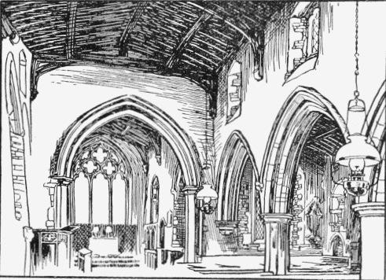



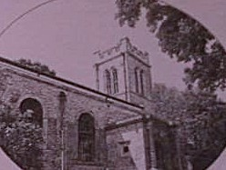
St Mary’s Church, Yelden and St Mary Magdalene Church, Melchbourne in the Stodden Benefice.
Joint Annual Parochial Church Reports for the Annual Parochial Church Meetings 7pm 7th May 2025 at Yelden Village Hall, Spring Lane, Yelden, Bedfordshire
Diocese of St Albans & Deanery of Sharnbrook
PARISHES OF: ST MARY’S CHURCH YELDEN AND ST MARY MAGDALENE CHURCH MELCHBOURNE
ANNUAL MEETINGS WEDNESDAY 7th MAY 2025
7.00 pm Annual Vestry Meeting (open to all those on the Church Electoral Roll and those who reside in the Parishes of Yelden and Melchbourne
- Opening Prayers
- Minutes of last meeting
- Election of Churchwarden(s)
7.10pm (approx. immediately following Annual Vestry Meeting) Annual Parochial Church Meeting: (Only those on the Church Electoral Roll may vote)
Agenda [please note reports will be taken as read & not read out but questions taken & voted upon]
1. Apologies
2. Minutes of 2024 APCM (copy attached)
3. Matters Arising
4. Joint Reports (applicable to both Parishes)
- Deanery Report
- JPCC Report
- JPCC Accounts and statements (subject to Independent Examination)
- Safeguarding Report
- Stodden Choir Report
- Report of the Priest in Charge and
5. Parish Specific Reports
Yelden Melchbourne
i. Churchwarden report inc. Fabric i. Churchwardens report inc. Fabric
ii. PCC report inc. Finance ii. PCC report inc. Finance
iii. Electoral Roll Report iii. Electoral Roll Report

6. Any Other Business
7. Election of any members to the Parochial Church Council & Election of any Deanery Synod Representatives
8. Appointment of Independent Examiner of Accounts
9. Closing Prayers

