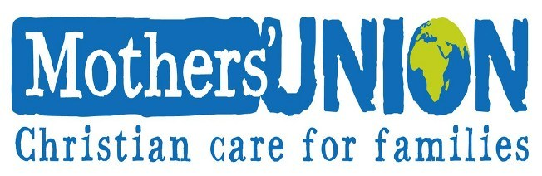

The Mothers' Union Prayer
Loving Lord, We thank you for your love so freely given to us all. We pray for families around the world. Bless the work of the Mothers' Union as we seek to share your love through the encouragement,
strengthening and support of marriage and family life. Empowered by your Spirit, may we be united in prayer and worship and in love and service, reach out as your hands across the world. In Jesus' name. Amen

Leadership - by Committee
Contact - Chris Cooke 01926 813482
Secretary - Sam Talbot 07817 848337
Treasurer - Annie Lane 01926 813075
47 St. Mary’s Close, Southam

2025

January 9th 12.30pm for 1pm
New Year Lunch – Fox & Hen
(Subs due please)
February 13th 2pm – Galanos Hub
Theme ‘Love’
March 7th World Day of Prayer
Details TBA
March 13th 2pm Community Church
“I am wonderfully made”
March 21st 10.30am – 12.30am
Coffee morning at Annie’s
(in aid of Air Ambulance)
47 St. Marys Close
April 10th 2pm St James Church
Speaker from Air Ambulance Invite friends
May 8th 2pm St James’ Church
Theme ‘Peace’ celebrating the
End of World War 2

JOIN US, JOIN IN!
SOUTHAM
MOTHERS’ UNION

MEETING
Second Thursday in the month
held in St. James’ Church
unless otherwise advised

at 2pm

PROGRAMME FOR 2025

2025

June 12th Summer Outing – TBA (Numbers required)
July 10th - Afternoon tea hosted by Sam T,
8 Merestone Close
August 7th No meeting, will advise re
any services for August9th
Mary Sumner Day
September 11th 10am St James’ Church
Holy Communion
followed by AGM
October 9th 2pm St. James’ Church
‘Special Book & Book Swap’
November 13th 2pm St James Church
‘Floral Decorations’
December 11th 2pm - St. James’ Church,
‘Carol Service’

