The Mortimer Maying Service
The Annual Service of Thanksgiving
for the Community Life of this Parish of Stratfield Mortimer

Sunday 18th May 2025
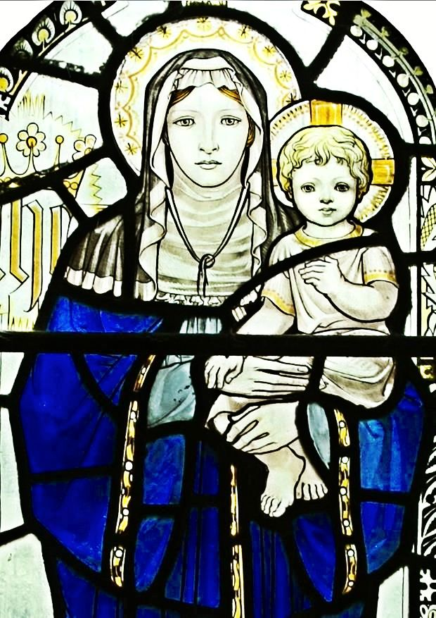
St. Mary’s Church, Mortimer
4 p.m.

