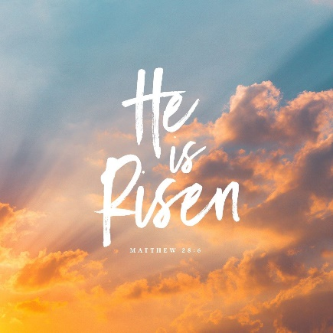
Onny Camlad Churches
Evening Praise
Easter Season

Welcome
O Lord, open our lips
And our mouth shall proclaim your praise
In Your resurrection, O Christ,
Let heaven and earth rejoice. Alleluia

Thanksgiving
Blessed are You Lord God of our salvation,
to You be praise and glory for ever.
As once You ransomed Your people from Egypt
and led them to freedom in the promised land,
so now You have delivered us from the dominion of darkness
and brought us into the Kingdom of Your risen Son.
May we, the first fruits of Your creation,
rejoice in this new day You have made,
and praise You for Your mighty acts.
Blessed be God, Father, Son and Holy Spirit
Blessed be God for ever.

Hymn

We say sorry
Christ our Passover Lamb has been sacrificed for us.
Let us therefore rejoice by putting away all malice and evil
and confessing our sins with a sincere and true heart.

Jesus Christ, risen master and triumphant Lord,
we come to you in sorrow for our sins,
and confess to you our weakness and unbelief.
We have lived by our own strength,
and not by the power of your resurrection.
In your mercy, forgive us.
Lord, hear us and help us.

We have lived by the light of our own eyes,
as faithless and not believing.
In your mercy, forgive us.
Lord, hear us and help us.

We have lived for this world alone,
and doubted our home in heaven.
In your mercy, forgive us.
Lord, hear us and help us.

May the Father of all mercies cleanse you from your sins and restore you in His image to the praise and glory of His name,
through Jesus Christ our Lord. Amen

The prayer for today (Collect)

Bible Reading(s)
At the end:
This is the Word of the Lord
Thanks be to God

Sermon

We declare what we believe
Let us declare our faith in the resurrection of our Lord Jesus Christ.
Jesus Christ died for our sins
in accordance with the Scriptures;
He was buried;
He was raised to life on the third day
in accordance with the Scriptures;
afterwards He appeared to His followers,
and to all the apostles:
this we have received,
and this we believe. Amen

Prayers
The following response may be used:
Lord in Your mercy Hear our prayer
At the end Merciful Father, accept these prayers for the sake of Your Son, our Saviour Jesus Christ. Amen

The Lord’s Prayer
As our Saviour taught us let us say together
Our Father in heaven
hallowed be Your name.
Your Kingdom come
Your will be done
on earth as in heaven.
Give us today our daily bread.
Forgive us our sins as we forgive those who sin against us.
Lead us not into temptation
but deliver us from evil.
For the Kingdom, the power and the glory are Yours
now and forever. Amen
Hymn

Notices

Closing Prayer
God of our salvation,
you have restored us to life,
you have brought us back again into your love
by the triumphant death and resurrection of Christ.
Continue to heal us,
as we go to live and work
in the power of your Spirit,
to your praise and glory. Amen

Blessing
May the risen Lord Jesus bless us.
May He watch over us and renew us
As He renews the whole of creation.
May our hearts and lives echo His love. Amen

Sending out
Go in the light and peace of Christ
Thanks be to God.

© Church of England Common Worship

