Parish of St Paul Kersal Moor and St Andrew Carr Clough
Churchyard Walks at St Paul’s
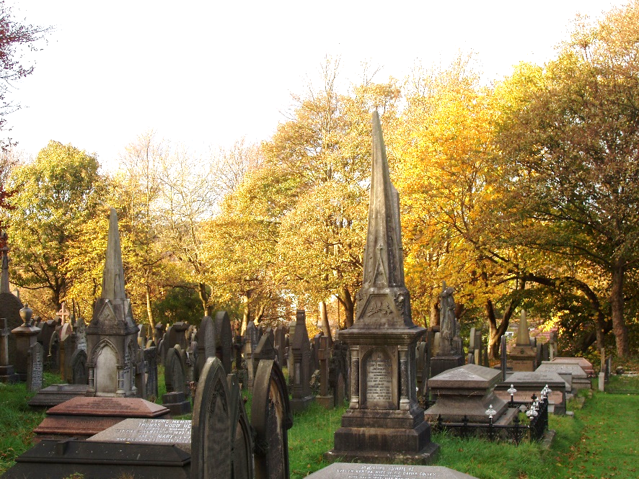
Guided walks round our historic churchyard
Sunday 15 September 12 noon
Wednesday 18 September 11.30 am
*Sunday 22 September 1.00 pm
*(Harvest Brunch at 12 noon in church)
Meet at the front porch- church open

