Christ Church, Denton with St George’s Church Dane Bank Denton

Family Worship Service at Home

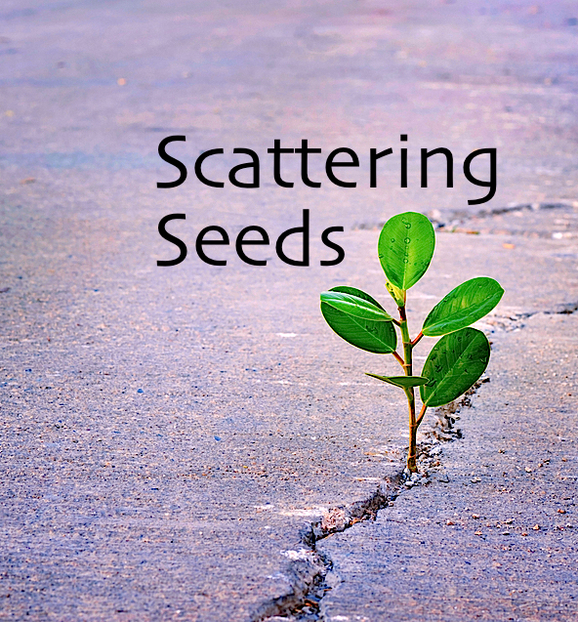

Matthew 13.

The 5th Sunday after Trinity

Sunday 12th July 2020.
The Welcome. The Lord be with you. And also with you!

We now sing our 1st worship song

Hymn

The Call to Worship as we come together as the family of God, and in our Father’s presence:

All - To offer him praise and thanksgiving
To hear and receive his holy word
To bring before him the needs of the world. To ask his forgiveness of our sins, and to seek his grace, that through his son Jesus Christ we may give ourselves to his service

Loving Lord, fill us with your life-giving, joy-giving, peace-giving presence, that we may praise you now with our lips, and all the day long with our lives, through Jesus Christ our Lord. Amen
Confession- Which is saying `Sorry` to God, for the things we have said, thought or done, for which we are sorry – Confession

All - Father we have sinned against heaven and before you and are not worthy to be called your children.
We turn to you again. Have mercy on us, bring us back to yourself as those who once were dead but now have life through Christ our Lord. Amen

Our Father in heaven, hallowed be your name. Your kingdom come. Your will be done, on earth as in heaven. Give us today our daily bread. Forgive us our sins, as we forgive those who sin against us. Lead us not into temptation, but deliver us from evil. For the kingdom, the power and the glory are yours, now and forever. Amen

Time to Praise

Let us give thanks to the God of our Lord Jesus Christ:

All - Who has blessed us in Christ with every spiritual blessing.

Before the world was made, God chose us in Christ:

All - That we might be holy and blameless before him.

Let us praise God for the glory of his grace:

All - For the free gift he gave us in his dear Son. To Father, Son and Holy Spirit, give praise and dominion, honour and might for ever and ever. Amen

Time to Listen to a reading from the Bible

The 1st reading is from the book of Genesis; Chapter 25 verses 19-34.
These are the descendants of Isaac, Abraham’s son: Abraham was the father of Isaac, ²⁰and Isaac was forty years old when he married Rebekah, daughter of Bethuel the Aramean of Paddan-aram, sister of Laban the Aramean. ²¹Isaac prayed to the Lord for his wife because she was barren; and the Lord granted his prayer, and his wife Rebekah conceived. ²²The children struggled together within her; and she said, “If it is to be this way, why do I live?” So she went to inquire of the Lord. ²³And the Lord said to her, “Two nations are in your womb, and two peoples born of you shall be divided; the one shall be stronger than the other, the elder shall serve the younger.” ²⁴When her time to give birth was at hand, there were twins in her womb. ²⁵The first came out red, all his body like a hairy mantle; so they named him Esau. ²⁶Afterward his brother came out, with his hand gripping Esau’s heel; so he was named Jacob. Isaac was sixty years old when she bore them. ²⁷When the boys grew up, Esau was a skillful hunter, a man of the field, while Jacob was a quiet man, living in tents. ²⁸Isaac loved Esau because he was fond of game; but Rebekah loved Jacob.
²⁹Once when Jacob was cooking a stew, Esau came in from the field, and he was famished. ³⁰Esau said to Jacob, “Let me eat some of that red stuff, for I am famished!” (Therefore he was called Edom.) ³¹Jacob said, “First sell me your birthright.” ³²Esau said, “I am about to die; of what use is a birthright to me?” ³³Jacob said, “Swear to me first.” So he swore to him and sold his birthright to Jacob. ³⁴Then Jacob gave Esau bread and lentil stew, and he ate and drank, and rose and went his way. Thus Esau despised his birthright….This is the word of the Lord. All. Thanks be to God.

The 2nd reading is from the Gospel of Matthew chapter 13: verses 1-9, 18-23.

That same day Jesus went out of the house and sat beside the sea. ²Such great crowds gathered around him that he got into a boat and sat there, while the whole crowd stood on the beach. ³And he told them many things in parables, saying: “Listen! A sower went out to sow. ⁴And as he sowed, some seeds fell on the path, and the birds came and ate them up. ⁵Other seeds fell on rocky ground, where they did not have much soil, and they sprang up quickly, since they had no depth of soil. ⁶But when the sun rose, they were scorched; and since they had no root, they withered away. ⁷Other seeds fell among thorns, and the thorns grew up and choked them. ⁸Other seeds fell on good soil and brought forth grain, some a hundredfold, some sixty, some thirty. ⁹Let anyone with ears listen!” ¹⁸“Hear then the parable of the sower. ¹⁹When anyone hears the word of the kingdom and does not understand it, the evil one comes and snatches away what is sown in the heart; this is what was sown on the path. ²⁰As for what was sown on rocky ground, this is the one who hears the word and immediately receives it with joy; ²¹yet such a person has no root, but endures only for a while, and when trouble or persecution arises on account of the word, that person immediately falls away. ²²As for what was sown among thorns, this is the one who hears the word, but the cares of the world and the lure of wealth choke the word, and it yields nothing. ²³But as for what was sown on good soil, this is the one who hears the word and understands it, who indeed bears fruit and yields, in one case a hundredfold, in another sixty, and in another thirty.”This is the Gospel of the Lord. All. Praise to you O Christ.

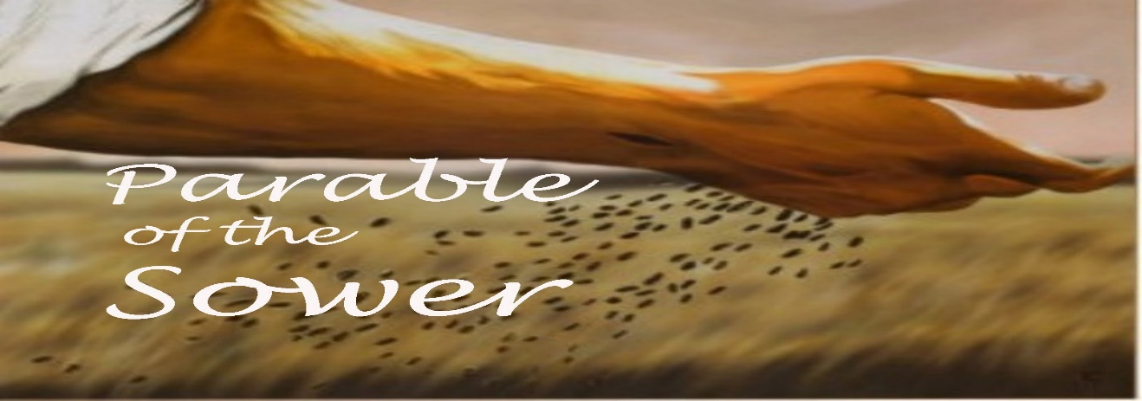
Talk/Activities

Act of Faith: Speaking together about all the things we believe are important in our Christian faith.

Do you believe and trust in God the Father who made the world?

All - I believe and trust in him

Do you believe and trust in his Son, Jesus Christ who redeemed mankind?

All - I believe and trust in him

Do you believe and trust in his Holy Spirit who gives life to the people of God?

All -I believe and trust in him, This is our faith, we believe and trust in one God, Father, Son and Holy Spirit.

Time to pray for the Church, the World and other things.

Notices and final Worship song.

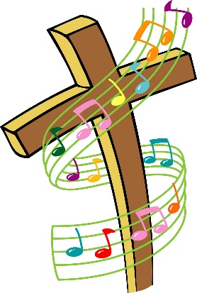

Blessing

The Dismissal Go in peace to love and serve the Lord All In the name of Christ. Amen

Please join us after the service for chat on Zoom, we thank you for joining us this morning and look forward to being Church at home again next Sunday.

Common Worship: Services and Prayers for the Church of England, material from which is included in this service, is copyright © The Archbishops` Council 2000.

Hymns reproduced with permission: CCLI: 1224602.

And with permission for live streaming with additional licence number 866012.

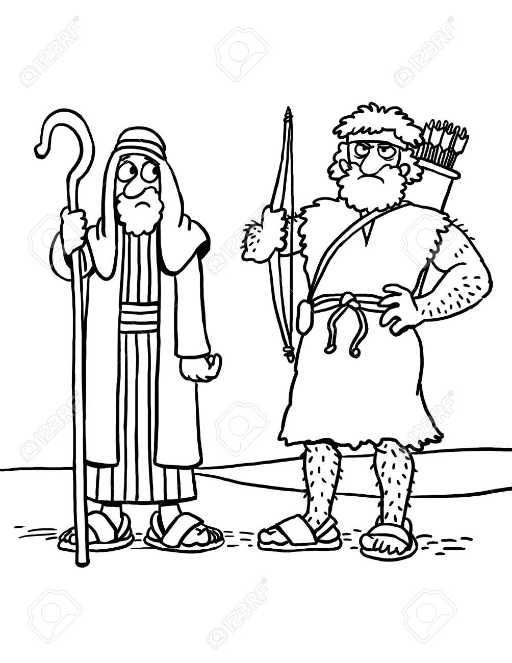

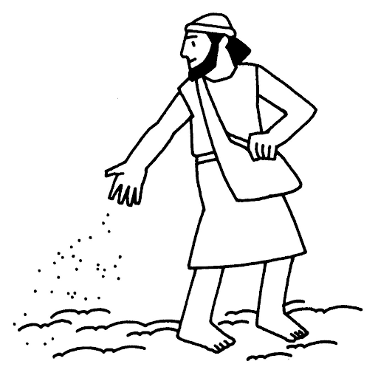

Colour me in

