YOUR GUIDE TO MARKING HOLY WEEK AND EASTER 2019

ST AUGUSTINE’S, GILLINGHAM

Since the earliest days, Christians have sought to reflect upon the meaning of Christ’s journey to the cross and resurrection by walking this final week with rituals that are dramatic, historic, reflective and sombre. We invite you to join us at St Augustine this year to meet Christ, and one another, on his journey – a journey that will change history and change your life. Here is your guide to what we’ll be doing, and why, so that you can take whatever part you can in our Passion commemorations and Easter celebrations.

May God meet you on the road.

PASSION SUNDAY, 7th April

10am Mass
They cried out, ‘Away with him! Away with him! Crucify him!’ – John 19:15

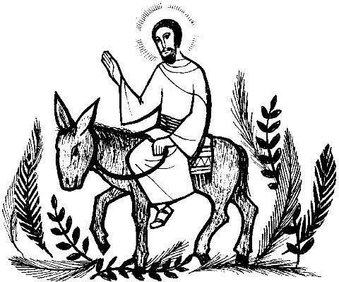
As has been customary in the Eastern Church for two millennia, and in the Western Church for a thousand years now, 5th Sunday in Lent marks the beginning of Passiontide, two weeks where we turn our Lenten attention particularly toward what Christ did for each of us by his death and resurrection.

PALM SUNDAY, 14th April- 10am Parish Mass and Procession
Your king comes to you…humble and riding on a donkey. – Zechariah 9:9

As Jesus entered Jerusalem in this final week, he rode a donkey, subverting ideas of power and prestige, and was welcomed and adorned by the crowds with palm leaves and singing. At 10am Mass we begin in the Church Hall, to process with palm crosses singing of Jesus’ entry and offering our praise too. In place of a sermon at Mass, there is a characterized reading of a Passion narrative – the Gospel story of Christ’s final trial and crucifixion. This offers a chance to reflect on this major event, before the proceeding story of Holy Week begins.

HOLY MONDAY, 8pm Mass, Tuesday 8pm – Deanery venue to be confirmed Wednesday 9.30am Mass, Stations of the cross 8.00pm

Each day in Holy Week follows set readings, such as the anointing of Jesus with perfume by Mary, and Judas’ betrayal, and a simple Mass in the Lady Chapel helps us to reflect and meditate on these events in the light of what will happen in the coming days.

HOLY WEDNESDAY, 17th April

9:30am Mass, 8pm Stations of the Cross
After mocking him…they led him out to crucify him. – Mark 15:20

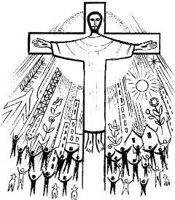
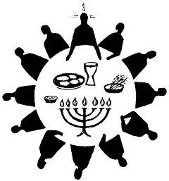
Our Wednesday morning Mass this week continues the story of Holy Week, In the evening, we follow a series of meditations around 14 stages or ‘stations’ of Jesus’ journey from trial to burial. We use the “stations” figures around the church, and texts from the Gospels to draw us into Christ’s journey.

MAUNDY THURSDAY, 18th April
8pm Mass of the Last Supper

9-10pm Silent Vigil 9.45pm Compline
So, if I, your Lord and Teacher, have washed your feet, you also ought to wash one another’s feet. – John 13:14

All clergy renew their ordination vows and commitment to Christ’s ministry at the Cathedral Chrism Mass in the morning. In the evening, we celebrate the Mass of the Last Supper, an occasion of great drama and ritual. There will be the washing of feet, as Christ washed his disciples’ feet like a servant. At the end of the service, the Sacrament is processed solemnly to the Altar of Repose in the Lady Chapel. This altar, decorated candles, represents the Garden of Gethsemane, where Christ went after the Supper, to pray and consider what lay before him. Once laid there, vestments change to the mournful purple, and in silence and darkness the chancel is cleared of all items, reflecting how the disciples fled and left Jesus in his hour of need, to face the burden alone and desolate. A silent Vigil before the Altar of Repose reflects the night watch before Jesus’ arrest, and concludes with a simple service of night prayer, called Compline at 9.45pm.

GOOD FRIDAY 19th April

10am Family Service & Hot X buns, 12.30 Stations of the Cross

2.00pm Liturgy of Good Friday –The Last Hour.
It was about noon, and darkness came over
the whole land… - Luke 23:44a

We mark the day of Christ’s death on the
Cross through a variety of ways, beginning with a short service, followed by refreshments. We gather with other Christians in Gillingham for the walk of witness. At the Liturgy of Good Friday at 2pm a very ancient rite, where everything is designed to show that things are not right: furniture is out of place, the altar cloth does not fit, and ministers enter and fall prostrate in the chancel. There are simple but sombre prayers, and the veneration of the cross sometimes made from the stump of the Christmas tree. To reflect the desolation of the day, no bread or wine is consecrated, and the reserved Sacrament from last night is distributed and used up completely.

HOLY SATURDAY, 20th April

7.30pm Easter Vigil Ceremonies
And suddenly there was a great earthquake; for an angel of the Lord, descending from heaven, came and rolled back the stone and sat on it. – Matthew 28:2

The Easter Vigil is a powerful service, the first Mass of Easter. We commence with a bonfire outside Church, the blessing of the Paschal candle (the symbol of Christ’s resurrection presence with us), its procession into Church and singing of the ancient Exultant by the sub deacon, which announces Christ’s rising from the tomb, and a set of Bible readings emphasise this as the event which transforms everything with God’s power and hope.

EASTER DAY, 21st April

10am High Mass and Procession
Why do you look for the living among the dead? He is not here, but has risen. – Luke 24:5

Join us as we pull out all the stops in celebration that ‘Christ is risen indeed – Alleluia!’
Let us rejoice of the rigours of Lent as we now celebrate 50 days of Easter Joy!

