THE ORDER FOR THE ADMINISTRATION OF

THE LORD’S SUPPER

ACCORDING TO

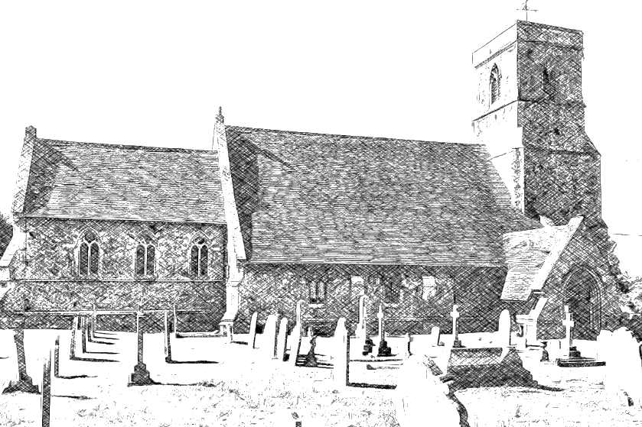
THE BOOK OF COMMON PRAYER

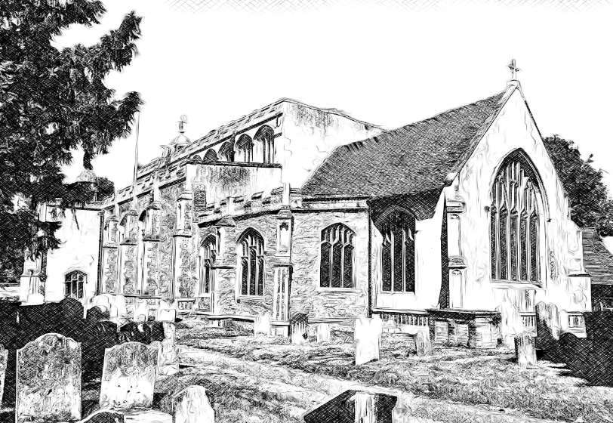

THE BENEFICE OF

EAST BERGHOLT AND BRANTHAM

Service on First Wednesday of the month
Welcome!

The Lord's Prayer

Our Father which art in heaven,
hallowed be thy Name,
thy kingdom come,
thy will be done, in earth as it is in heaven.
Give us this day our daily bread;
and forgive us our trespasses,
as we forgive them that trespass against us;
and lead us not into temptation,
but deliver us from evil.
Amen.

The Collect

All: ALMIGHTY God, unto whom all hearts be open,
all desires known, and from whom no secrets are hid:
Cleanse the thoughts of our hearts
by the inspiration of thy Holy Spirit,
that we may perfectly love thee,
and worthily magnify thy holy Name;
through Christ our Lord.
Amen.

THE SUMMARY OF THE 10 COMMANDMENTS

Our Lord Jesus Christ said:
Hear, O Israel, the Lord our God is one Lord;
and thou shalt love the Lord thy God with all thy heart,
and with all thy soul, and with all thy mind,
and with all thy strength.
This is the first commandment.
And the second is like, namely this:
thou shalt love thy neighbour as thyself.
There is none other commandment greater than these.
On these two commandments hang all the law and the prophets.
All: Lord, have mercy upon us and incline our hearts to keep this law.

A Prayer for our Sovereign

Let us pray.

ALMIGHTY God, whose kingdom is ever-lasting, and power infinite: have mercy upon the whole Church; and so rule the heart of thy chosen servant Elizabeth, our Queen and Governor, that she (knowing whose minister she is) may above all things seek thy honour and glory: and that we and all her subjects (duly considering whose authority she hath) may faithfully serve, honour, and humbly obey her, in thee, and for thee, according to thy blessed Word and ordinance; through Jesus Christ our Lord, who with thee and the Holy Ghost liveth and reigneth, ever one God, world without end.
Amen.

The Collect of the day
(on the pew sheet from Sunday)

Said by everyone
The Gospel

The holy Gospel is written in the X Chapter of N beginning at the ^{th} Verse.
All: Glory be to thee, O Lord

The text of the reading is in the newsletter issued on Friday.

This is the Gospel of the Lord.
All: Praise to you, O Christ.

The Sermon

The Creed

All: I BELIEVE in one God the Father Almighty, Maker of heaven and earth, And of all things visible and invisible:

And in one Lord Jesus Christ,
the only-begotten Son of God,
begotten of his Father before all worlds,
God of God, Light of Light,
very God of very God, Begotten, not made,
being of one substance with the Father,
by whom all things were made: Who for us men and for our salvation came down from heaven,
and was incarnate by the Holy Ghost of the Virgin Mary,
and was made man,
and was crucified also for us under Pontius Pilate.
He suffered and was buried,
and the third day he rose again according to the Scriptures, and ascended into heaven,
and sitteth on the right hand of the Father,
and he shall come again with glory to judge both the quick and the dead: Whose kingdom shall have no end.
And I believe in the Holy Ghost, The Lord and giver of life,
who proceedeth from the Father and the Son,
who with the Father and the Son together is worshipped and glorified, who spake by the Prophets.
And I believe one Catholick and Apostolick Church.
I acknowledge one Baptism for the remission of sins.
And I look for the Resurrection of the dead,
and the life of the world to come.
Amen.

Let your light so shine before men, that they may see your good works, and glorify your Father which is in heaven. Matthew 5.16

The Intercession

Let us pray for the whole state of Christ’s Church here in earth.

ALMIGHTY and ever-living God, who by thy holy Apostle hast taught us to make prayers and supplications, and to give thanks, for all men: We humbly beseech thee most mercifully to receive these our prayers, which we offer unto thy Divine Majesty; beseeching thee to inspire continually the universal Church with the spirit of truth, unity, and concord: And grant, that all they that do confess thy holy Name may agree in the truth of thy holy Word, and live in unity, and godly love. We beseech thee also to lead all nations in the way of righteousness and peace; and so, to direct all kings and rulers, that under them thy people may be godly and quietly governed. And grant to thy servant Elizabeth our Queen and to all that are put in authority under her that they may truly and impartially minister justice, to the punishment of wickedness and vice, and to the maintenance of thy true religion, and virtue.
Give grace, O heavenly Father, to all Bishops, Priests and Deacons especially thy servants, Martin and Mike our Bishops and Justin and Stephen our Archbishops, that they may both by their life and doctrine set forth thy true and living Word, and rightly and duly administer thy holy Sacraments: Guide and prosper we pray thee all those who are labouring for the spread of thy Gospel among the nations, and enlighten with thy Spirit all places of education and learning; that the whole world may be filled with the knowledge of thy truth.
And to all thy people give thy heavenly grace; and specially to this congregation here present; that, with meek heart and due reverence, they may hear, and receive thy holy Word; truly serving thee in holiness and righteousness all the days of their life.
And we most humbly beseech thee of thy goodness, O Lord, to comfort and succour all them, who in this transitory life are in trouble, sorrow, need, sickness, or any other adversity.

And we commend to thy gracious keeping O Lord, all thy servants departed this life in thy faith and fear beseeching thee to grant them everlasting light and peace.

And here we give thee, most high praise and hearty thanks for all thy Saints, who have been the chosen vessels of thy grace and lights of the world in their several generations, and we pray that rejoicing in their fellowship, and following their good examples, we may be partakers with them of thy heavenly kingdom.

Grant this, O Father, for Jesus Christ’s sake, our only Mediator and Advocate who liveth and reigneth with thee in the unity of the Holy Ghost, one God, world without end.
Amen.
The Preparation
YE that do truly and earnestly repent you of your sins, and are in love and charity with your neighbours, and intend to lead a new life, following the commandments of God, and walking from henceforth in his holy ways: Draw near with faith, and take this holy Sacrament to your comfort; and make your humble confession to Almighty God.

Silence is kept
Confession

All: ALMIGHTY God, Father of our Lord Jesus Christ, maker of all things, Judge of all men: we acknowledge and bewail our manifold sins and wickedness, which we from time to time most grievously have committed, by thought, word, and deed, against thy Divine Majesty, provoking most justly thy wrath and indignation against us.

We do earnestly repent, and are heartily sorry for these our misdoings; the remembrance of them is grievous unto us; the burden of them is intolerable. Have mercy upon us, have mercy upon us, most merciful Father; for thy Son our Lord Jesus Christ’s sake, forgive us all that is past; and grant that we may ever hereafter serve and please thee in newness of life, To the honour and glory of thy Name; through Jesus Christ our Lord.
Amen.
Absolution
ALMIGHTY God, our heavenly Father, who of his great mercy hath promised forgiveness of sins to all of them that with hearty repentance and true faith turn unto him;

Have mercy upon you; pardon and deliver you from all your sins; confirm and strengthen you in all goodness; and bring you to everlasting life; through Jesus Christ our Lord.
All: Amen.

The Comfortable Words

Hear what comfortable words our Saviour Christ saith unto all that truly turn to him.

COME unto me all that travail and are heavy laden, and I will refresh you. St. Matthew 11.28

The Sursum Corda:
Lift up your hearts.
All: We lift them up unto the Lord.

Let us give thanks unto our Lord God.
All: It is meet and right so to do.

IT is very meet, right, and our bounden duty, that we should at all times, and in all places, give thanks unto thee, O Lord, Holy Father, Almighty, Everlasting God.

THEREFORE, with Angels and Archangels, and with all the company of heaven, we laud and magnify thy glorious Name; evermore praising thee, and saying:

The Sanctus

All: Holy, holy, holy, Lord God of hosts, heaven and earth are full of thy glory: Glory be to thee, O Lord most High. Amen.

The Prayer of Humble Access

All: WE do not presume to come to this thy Table, O merciful Lord, trusting in our own righteousness, but in thy manifold and great mercies. We are not worthy so much as to gather up the crumbs under thy Table. But thou art the same Lord, whose property is always to have mercy: Grant us therefore, gracious Lord, so to eat the flesh of thy dear Son Jesus Christ, and to drink his blood, that our sinful bodies may be made clean by his body, and our souls washed through his most precious blood, and that we may evermore dwell in him, and he in us.
Amen.

The Prayer of Consecration

ALMIGHTY God, our heavenly Father, who of thy tender mercy didst give thine only Son Jesus Christ to suffer death upon the Cross for our redemption; who made there (by his one oblation of himself once offered) a full, perfect, and sufficient sacrifice, oblation, and satisfaction, for the sins of the whole world; and did institute, and in his holy Gospel command us to continue, a perpetual memory of that his precious death, until his coming again: who, in the same night that he was betrayed, took Bread; and, when he had given thanks, he brake it, and gave it to his disciples, saying, Take, eat; this is my Body which is given for you:
Do this in remembrance of me.
Likewise, after supper he took the Cup; and, when he had given thanks, he gave it to them, saying, Drink ye all of this; for this is my Blood of the New Testament, which is shed for you and for many for the remission of sins: Do this, as oft as ye shall drink it, in remembrance of me. Amen

Silence
Spiritual Communion
For all those sharing our service online or at home.
All: Almighty God, Father of all mercies, we your unworthy servants give you most humble and hearty thanks for all your goodness and loving kindness. We bless you for our creation, preservation, and all the blessings of this life; but above all for your immeasurable love in the redemption of the world by our Lord Jesus Christ, for the means of grace, and for the hope of glory. And give us, we pray, such a sense of all your mercies that our hearts may be unfeignedly thankful, and that we show forth your praise, not only with our lips but in our lives, by giving up ourselves to your service, and by walking before you in holiness and righteousness all our days; through Jesus Christ our Lord, to whom, with you and the Holy Spirit, be all honour and glory, for ever and ever.

Silence is kept

The Lord’s Prayer
All: OUR Father, which art in heaven,
Hallowed be thy Name,
thy kingdom come, thy will be done,
in earth as it is in heaven.
Give us this day our daily bread;
and forgive us our trespasses,
as we forgive them that trespass against us;
and lead us not into temptation,
but deliver us from evil.
For thine is the kingdom, the power,
and the glory, For ever and ever.
Amen.

We receive communion in our hearts
The Gloria
All: GLORY be to God on high, and in earth peace, good will towards men. We praise thee, we bless thee, we worship thee, we glorify thee, we give thanks to thee for thy great glory, O Lord God, heavenly King, God the Father Almighty.
O Lord, the only-begotten Son, Jesu Christ; O Lord God, Lamb of God, Son of the Father, that takest away the sins of the world, have mercy upon us. Thou that takest away the sins of the world, have mercy upon us. Thou that takest away the sins of the world, receive our prayer. Thou that sittest at the right hand of God the Father, have mercy upon us.

For thou only art holy; thou only art the Lord; thou only, O Christ, with the Holy Ghost, art most high in the glory of God the Father. Amen.
The Blessing

THE peace of God, which passeth all understanding, keep your hearts and minds in the knowledge and love of God, and of his Son Jesus Christ our Lord: And the blessing of God Almighty, the Father, the Son, and the Holy Ghost, be amongst you and remain with you always.
Amen.

Do make yourself a cup of coffee and then telephone someone for a chat!

