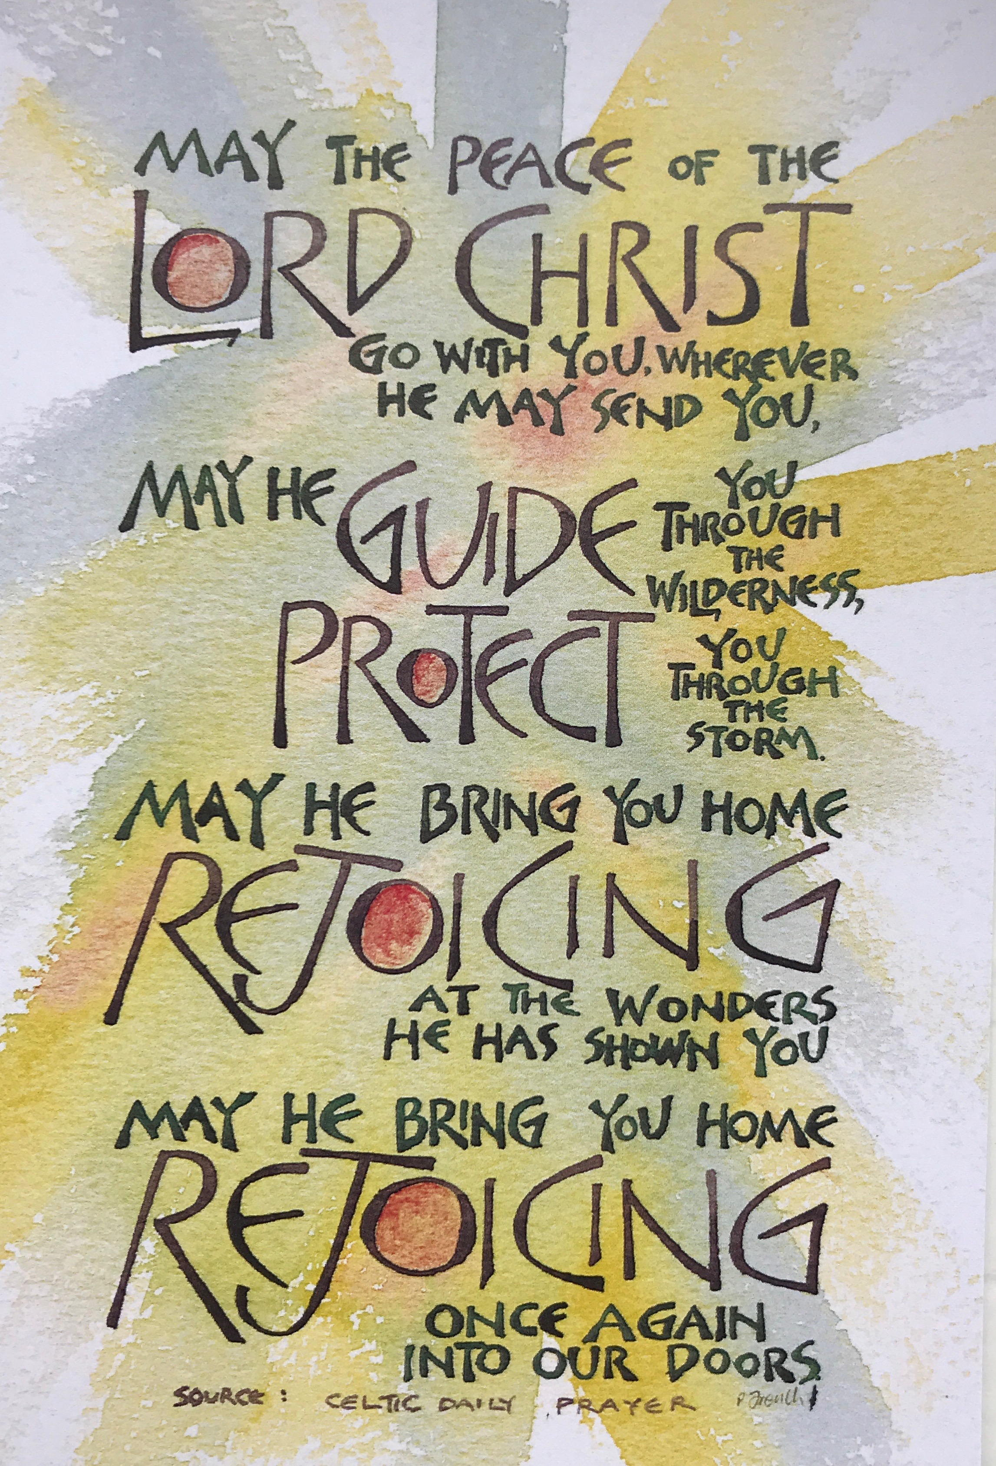

The Parishes of Topcliffe, Baldersby with Dishforth,
Dalton and Skipton on Swale

Together Alone

Morning Prayer
Night Prayer
during times of isolation

If possible, try to pray
Morning Prayer between 7.00am and 9.00am
Night Prayer between 7.00pm and 9.00pm
and know that, at whatever time you’re praying, you pray as part of the Body of Christ, and others will be praying with you.
If you are praying with another person, one of you might lead the worship and the other say the words in bold type and give the reading. Alternate the verses of the Psalm.

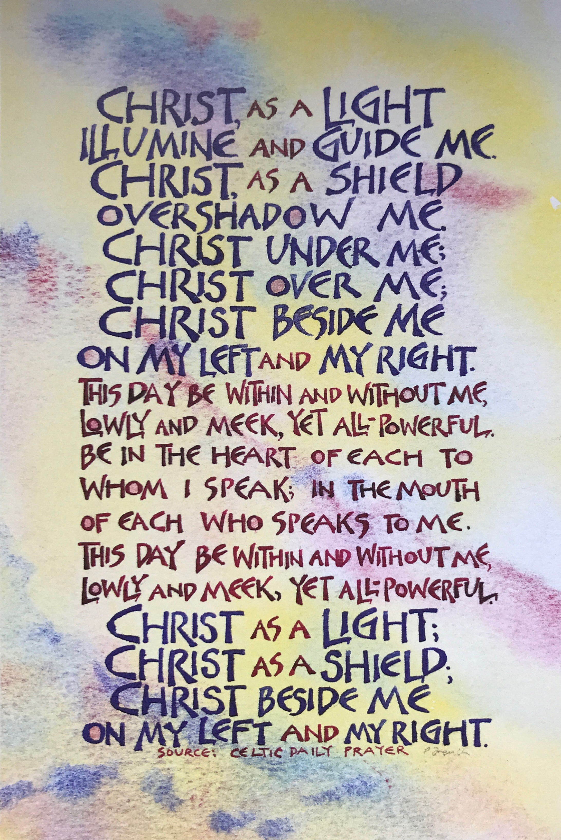

2

15

Visit this place, O Lord, we pray,
and drive far from it the snares of the enemy;
may your holy angels dwell with us in peace,
and may your blessing be always upon us;
through Jesus Christ our Lord. Amen.

The Lord’s Prayer
Our Father,
who art in heaven,
hallowed be thy name;
thy kingdom come;
thy will be done;
on earth as it is in heaven.
Give us this day our daily bread.
And forgive us our trespasses,
as we forgive those who trespass against us.
And lead us not into temptation;
but deliver us from evil.
For thine is the kingdom,
the power and the glory,
for ever and ever. Amen.

The Conclusion

In peace we will lie down and sleep;
for you alone, Lord, make us dwell in safety.

The Lord bless us and watch over us;
The Lord make his face to shine upon us
and be gracious to us;

The Lord look kindly upon us and give us peace. Amen.

Materials in this booklet are drawn from Common Worship: Services and Prayers for the Church of England, Common Worship: Pastoral
Services, and Common Worship: Daily Prayer, all of which are copyright © The Archbishops' Council of the
Church of England. 14
Morning Prayer

You may wish to light a candle and have some reflective music playing in the background.

In the name of the Father, and of the Son, and of the Holy Spirit. Amen

The Lord is good, a strong refuge when trouble comes.
God is close to those who trust in him. Nahum 1.7

Opening Sentences
O Lord, open our lips
and our mouth shall proclaim your praise.

The night has passed, and the day lies open before us;
let us pray with one heart and mind.

Pause for reflection as you offer the day to God.

As we rejoice in the gift of this new day,
so may the light of your presence, O God,
set our hearts on fire with love for you;
now and for ever. Amen.

Bible Reading
You may wish to say Psalm 23 or another psalm here, such as Psalm 16 or Psalm 139.

Psalm 23

1 The Lord is my shepherd; ♦︎
therefore can I lack nothing.

2 He makes me lie down in green pastures ♦︎
and leads me beside still waters.

3 He shall refresh my soul ♦︎
and guide me in the paths of righteousness for his name’s sake.

3
4 Though I walk through the valley of the shadow of death,
I will fear no evil; ♦︎
for you are with me;
your rod and your staff, they comfort me.

5 You spread a table before me
in the presence of those who trouble me; ♦︎
you have anointed my head with oil
and my cup shall be full.

6 Surely goodness and loving mercy shall follow me
all the days of my life, ♦︎
and I will dwell in the house of the Lord for ever.

Glory to the Father and to the Son
and to the Holy Spirit;
as it was in the beginning is now
and shall be for ever. Amen.

You may wish to use the weekly pattern of short readings given below, or choose a passage of your own.

Sunday Morning

But now thus says the Lord,
he who created you, O Jacob,
he who formed you, O Israel:
Do not fear, for I have redeemed you;
I have called you by name, you are mine.
When you pass through the waters, I will be with you;
and through the rivers, they shall not overwhelm you;
when you walk through fire you shall not be burned,
and the flame shall not consume you.
For I am the Lord your God,
the Holy One of Israel, your Saviour. Isaiah 43.1-3a

4
Thursday Evening

Jesus said, ‘I have said this to you, so that in me you may have peace. In the
world you face persecution. But take courage; I have conquered the world!’ John 16.33

Friday Evening

God has destined us not for wrath but for obtaining salvation through our
Lord Jesus Christ, who died for us, so that whether we are awake or asleep we may live with him. 1 Thessalonians 5.9,10

Saturday Evening

Jesus said, ‘I am the light of the world. Whoever follows me will never walk in darkness but will have the light of life.’ John 8.12

Prayers
You may like to make your own prayers, or keep a time of silence.

Merciful God,
we entrust to your unfailing and tender care this night
those who are ill or in pain,
knowing that whenever danger threatens
your everlasting arms are there to hold us safe.
Comfort and heal them,
and restore them to health and strength;
through Jesus Christ our Lord. Amen.

Be present, O merciful God,
and protect us through the silent hours of this night,
so that we who are wearied
by the changes and chances of this fleeting world,
may rest upon your eternal changelessness;
through Jesus Christ our Lord. Amen.
13
I will deliver them and bring them to honour.

16 With long life will I satisfy them ♦︎
and show them my salvation.

Glory to the Father and to the Son
and to the Holy Spirit;
as it was in the beginning is now
and shall be for ever. Amen.

You may wish to use one of the following short readings or choose a passage of your own.

Sunday Evening

You, O Lord, are in the midst of us, and we are called by your name; leave us not, O Lord our God. Jeremiah 14.9

Monday Evening

Thus said the Lord God, the Holy One of Israel: In returning and rest you shall be saved; in quietness and in trust shall be your strength. Isaiah 30.15

Tuesday Evening

Jesus said, ‘Come to me, all you that are weary and are carrying heavy
burdens, and I will give you rest. Take my yoke upon you, and learn from me; for I am gentle and humble in heart, and you will find rest for your souls. For my yoke is easy, and my burden is light. Matthew 11.28-end

Wednesday Evening

Humble yourselves under the mighty hand of God, so that he may exalt you in due time. Cast all your anxiety on him, because he cares for you.
1 Peter 5.6,7
12
Monday Morning

‘Do not let your hearts be troubled. Believe in God, believe also in me. In my Father’s house there are many dwelling-places. If it were not so, would I have told you that I go to prepare a place for you? And if I go and prepare a place for you, I will come again and will take you to myself, so that where I am, there you may be also. And you know the way to the place where I am going.’ Thomas said to him, ‘Lord, we do not know where you are going. How can we know the way?’ Jesus said to him, ‘I am the way, and the truth, and the life. No one comes to the Father except through me.
John 14.1-6

Tuesday Morning

Finally, beloved, whatever is true, whatever is honourable, whatever is just,
whatever is pure, whatever is pleasing, whatever is commendable, if there is any excellence and if there is anything worthy of praise, think about these things. Keep on doing the things that you have learned and received and heard and seen in me, and the God of peace will be with you.
Philippians 4.8-9

Wednesday Morning

Let the word of Christ dwell in you richly; teach and admonish one another in all wisdom; and with gratitude in your hearts sing psalms, hymns, and spiritual songs to God. And whatever you do, in word or deed, do everything in the name of the Lord Jesus, giving thanks to God the Father through him. Colossians 3.16,17

Thursday Morning

You are no longer strangers and aliens, but you are citizens with the saints and also members of the household of God, built upon the foundation of the apostles and prophets, with Christ Jesus himself as the cornerstone. In him the whole structure is joined together and grows into a holy temple in the Lord; in whom you also are built together spiritually into a dwelling-place for God. 5 Ephesians 2.19-22
Friday Morning

Let love be genuine; hate what is evil, hold fast to what is good; love one another with mutual affection; outdo one another in showing honour. Do not lag in zeal, be ardent in spirit, serve the Lord. Rejoice in hope, be patient in suffering, persevere in prayer. Romans 19.9-12

Saturday Morning

Jesus said to his disciples, ‘Therefore I tell you, do not worry about your life, what you will eat, or about your body, what you will wear. For life is more than food, and the body more than clothing. Consider the ravens: they neither sow nor reap, they have neither storehouse nor barn, and yet God feeds them. Of how much more value are you than the birds! And can any of you by worrying add a single hour to your span of life? If then you are not able to do so small a thing as that, why do you worry about the rest? Consider the lilies, how they grow: they neither toil nor spin; yet I tell you, even Solomon in all his glory was not clothed like one of these.
But if God so clothes the grass of the field, which is alive today and tomorrow is thrown into the oven, how much more will he clothe you—you of little faith! And do not keep striving for what you are to eat and what you are to drink, and do not keep worrying. For it is the nations of the world that strive after all these things, and your Father knows that you need them. Instead, strive for his kingdom, and these things will be given to you as well. Luke 12.22-31

Prayers

You may like to make your own prayers, or keep a time of silence.

Almighty and everlasting God,
we thank you that you have brought us safely
to the beginning of this day.
Keep us from falling into sin
or running into danger;
6
and you shall be safe under his feathers; ♦︎
his faithfulness shall be your shield and buckler.

5 You shall not be afraid of any terror by night, ♦︎
nor of the arrow that flies by day;

6 Of the pestilence that stalks in darkness, ♦︎
nor of the sickness that destroys at noonday.

7 Though a thousand fall at your side
and ten thousand at your right hand, ♦︎
yet it shall not come near you.

8 Your eyes have only to behold ♦︎
to see the reward of the wicked.

9 Because you have made the Lord your refuge ♦︎
and the Most High your stronghold,

10 There shall no evil happen to you, ♦︎
neither shall any plague come near your tent.

11 For he shall give his angels charge over you, ♦︎
to keep you in all your ways.

12 They shall bear you in their hands, ♦︎
lest you dash your foot against a stone.

13 You shall tread upon the lion and adder; ♦︎
the young lion and the serpent you shall trample underfoot.

14 Because they have set their love upon me,
therefore will I deliver them; ♦︎
I will lift them up, because they know my name.

15 They will call upon me and I will answer them; ♦︎
I am with them in trouble,
11
Night Prayer

You may wish to light a candle and have some reflective music playing in the background.

The eternal God is your refuge,
and underneath are the everlasting arms. Deuteronomy 33.27

Opening Sentences

The Lord almighty grant us a quiet night and a perfect end. Amen.

Our help is in the name of the Lord
who made heaven and earth.

Pause and reflect on the day that is past.

Save us, O Lord, while waking,
and guard us while sleeping,
that awake we may watch with Christ
and asleep may rest in peace.

Bible Reading

You may wish to say here the psalm given below, or Psalm 27, or another chosen psalm.

Psalm 91

1 Whoever dwells in the shelter of the Most High ♦︎
and abides under the shadow of the Almighty,

2 Shall say to the Lord, ‘My refuge and my stronghold, ♦︎
my God, in whom I put my trust.’

3 For he shall deliver you from the snare of the fowler ♦︎
and from the deadly pestilence.

4 He shall cover you with his wings
7
10
order us in all our doings
and guide us to do always
what is righteous in your sight;
through Jesus Christ our Lord. Amen.

Keep us, good Lord,
under the shadow of your mercy
in this time of uncertainty and distress.
Sustain and support the anxious and fearful,
and lift up all who are brought low;
that we may rejoice in your comfort
knowing that nothing can separate us from your love
in Christ Jesus our Lord. Amen.

The Lord’s Prayer
Our Father,
who art in heaven,
hallowed be thy name;
thy kingdom come;
thy will be done;
on earth as it is in heaven.
Give us this day our daily bread.
And forgive us our trespasses,
as we forgive those who trespass against us.
And lead us not into temptation;
but deliver us from evil.
For thine is the kingdom,
the power and the glory,
for ever and ever. Amen.

The Conclusion
The Lord bless us, and preserve us from all evil,
and keep us in eternal life.
Amen.

Let us bless the Lord.
Thanks be to God.

8

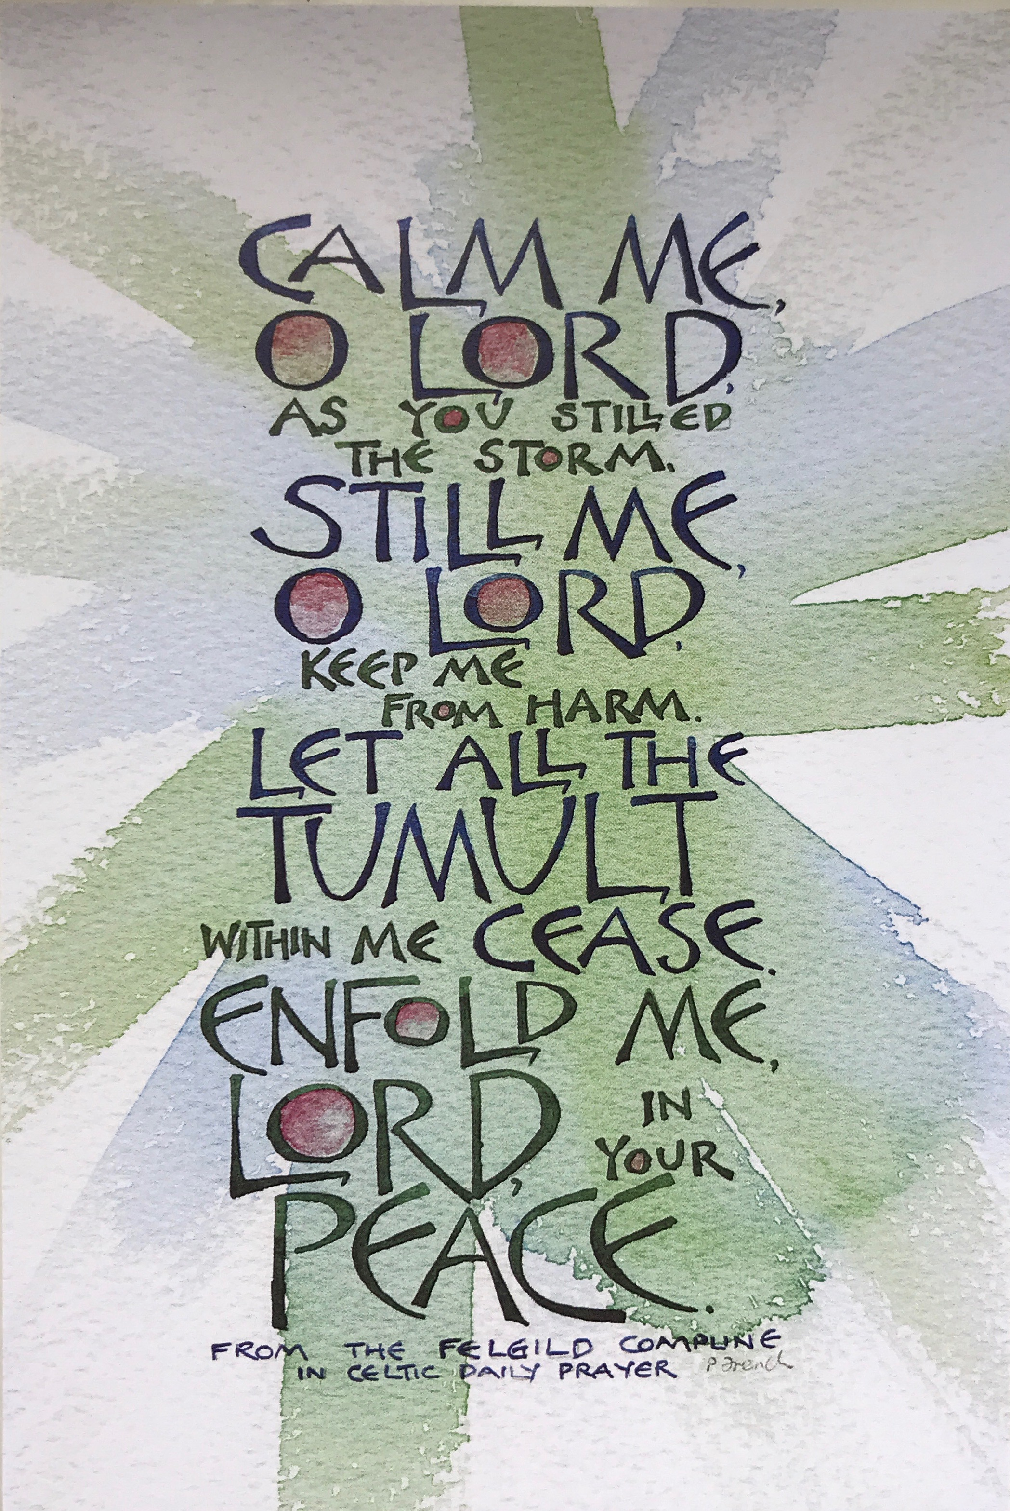

9

