The Thanet Community Gospel Choir
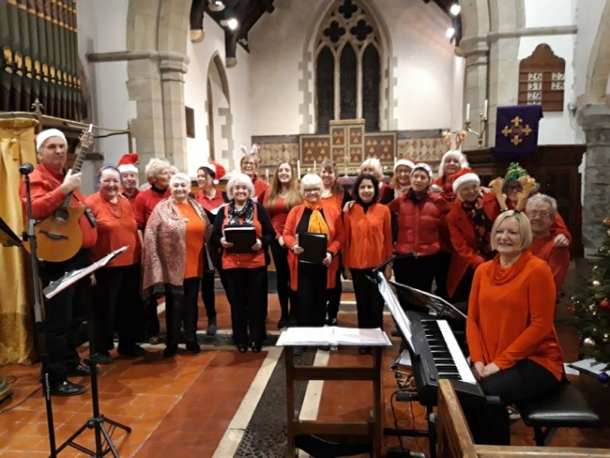

Performing classic Gospel and uplifting Popular Music at…

St Martin’s Church,
Mongeham Church Close, Great Mongeham, Deal CT14 0HL
On
Friday 24th March, 7.30pm
Admission £5 on the door or in advance from the church office
Refreshments available during the interval
Phone: 01304 369919 for more information
Support your local church – enjoy live music!

