Ramsbottom and Edenfield Team Churches

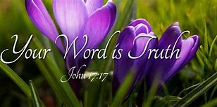

Our Team churches are open at 9.30am every Sunday morning throughout May for a service of Holy Communion. This is on a ‘four-week’ rotation.

Dates for May:
2nd Edenfield
9th St Philip’s
16th St Paul’s
23rd St Andrew’s
30th Edenfield

Please note, Edenfield also have a service of Holy Communion BCP on the 23rd May at 8.00am.

