St John the Divine, Chevington

Stations of the Cross
This booklet contains all you need to join in with Stations of the Cross either in church or via your telephone.
If you would like to join via telephone then the number to call is 03330 164757
You will be asked to key in a room number 66744423#
And then a guest pin number 4827#

If you are at home, you might like to light a candle as our worship begins.

The leader will introduce each station
The nth station - …….
We adore you O Christ and we bless you
And we respond
Because by your holy cross you have redeemed the world.

The following prayers may be used at some stations …
Our Father in heaven, hallowed be your name
Your kingdom come, your will be done, on earth as in heaven
Give us today our daily bread
Forgive us our sins as we forgive those who sin against us
Lead us not into temptation, but deliver us from evil.
For the kingdom, the power and the glory are yours
Now and forever
Amen

Hail Mary, full of grace, the Lord is with thee
Blessed art thou amongst women
and blessed is the fruit of thy womb, Jesus
Holy Mary, mother of God,
Pray for us now and at the hour of our death

Glory be to the Father,
And to the Son and to the Holy Spirit
As it was in the beginning, is now, and shall be forever
Amen

THE WORSHIP
In the name of the Father,
and of the Son, and of the Holy Spirit
All | Amen
 | Let us return to the Lord our God and say to him
All | Father, we have sinned against heaven and against you.  We are not worthy to be called your children.  We turn to you again.  Have mercy on us, bring us back to yourself as those who once were dead but now have life through Jesus Christ our Lord.  Amen
The First Station : Jesus is condemned to death
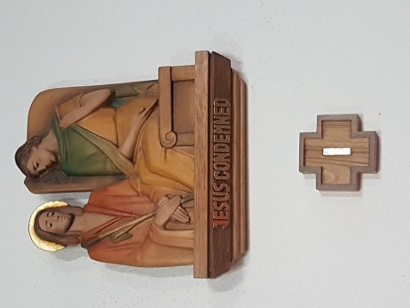

The Second Station : Jesus receives his cross
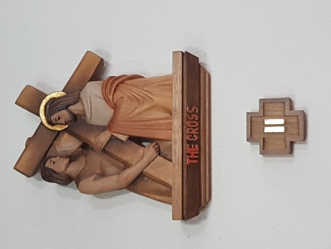

The Third Station : Jesus falls for the first time
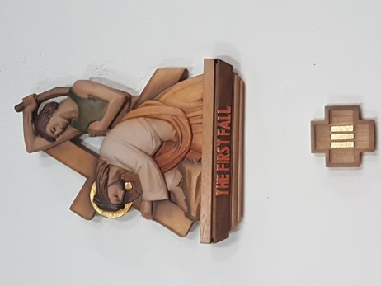

The Fourth Station : Jesus meets his mother
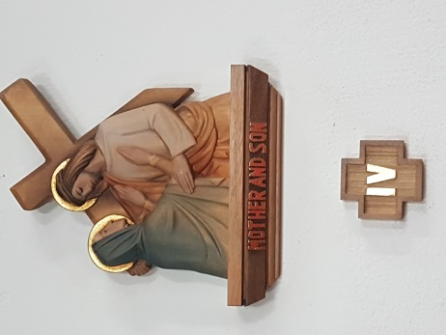

The Fifth Station : Simon of Cyrene helps Jesus to carry his cross
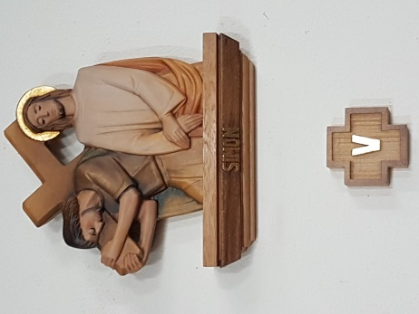

The Sixth Station : Veronica wipes the face of Jesus
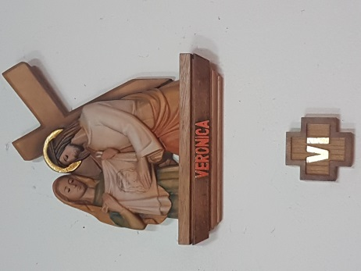

The Seventh Station : Jesus falls a second time
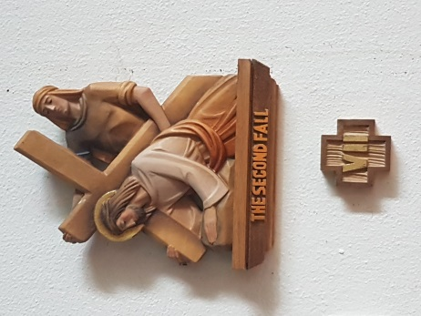

The Eighth Station : Jesus meets the women of Jerusalem
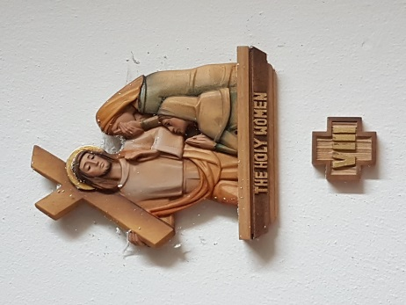

The Ninth Station : Jesus falls a third time
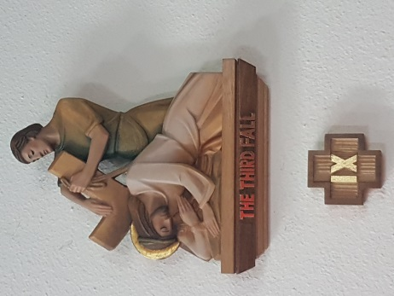

The Tenth Station : Jesus is stripped of his garments
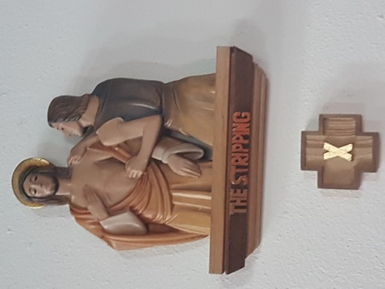

The Eleventh Station : Jesus is nailed to the cross
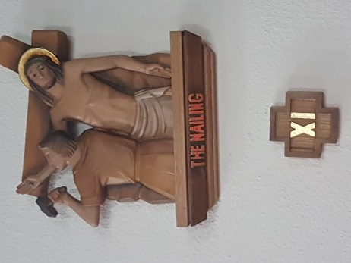

The Twelfth Station : Jesus dies
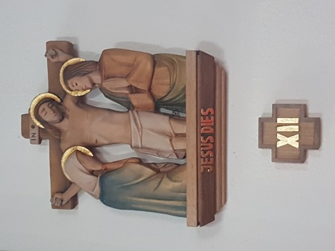

The Thirteenth Station : Jesus is taken down from the cross
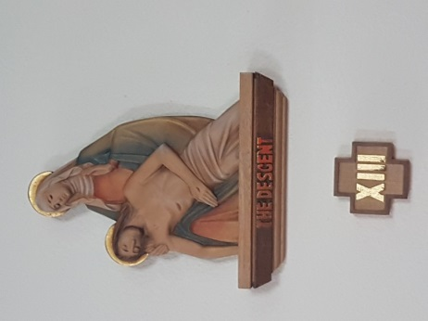

The Fourteenth Station : Jesus is laid in the tomb
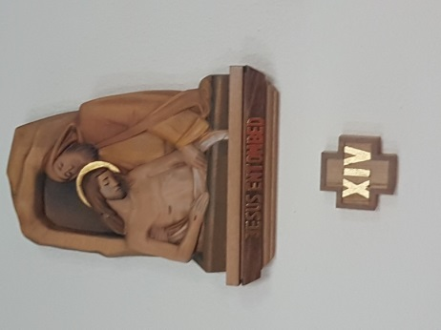

The Fifteenth Station : Jesus is risen

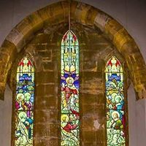
This station may be omitted from some meditations

 | Let us conclude our worship by saying the grace together
All | May the grace of our Lord Jesus Christ, the love of God and the fellowship of the Holy Spirit, be with us all, evermore.  Amen

