St Aidan’s Gravesend Welcomes You

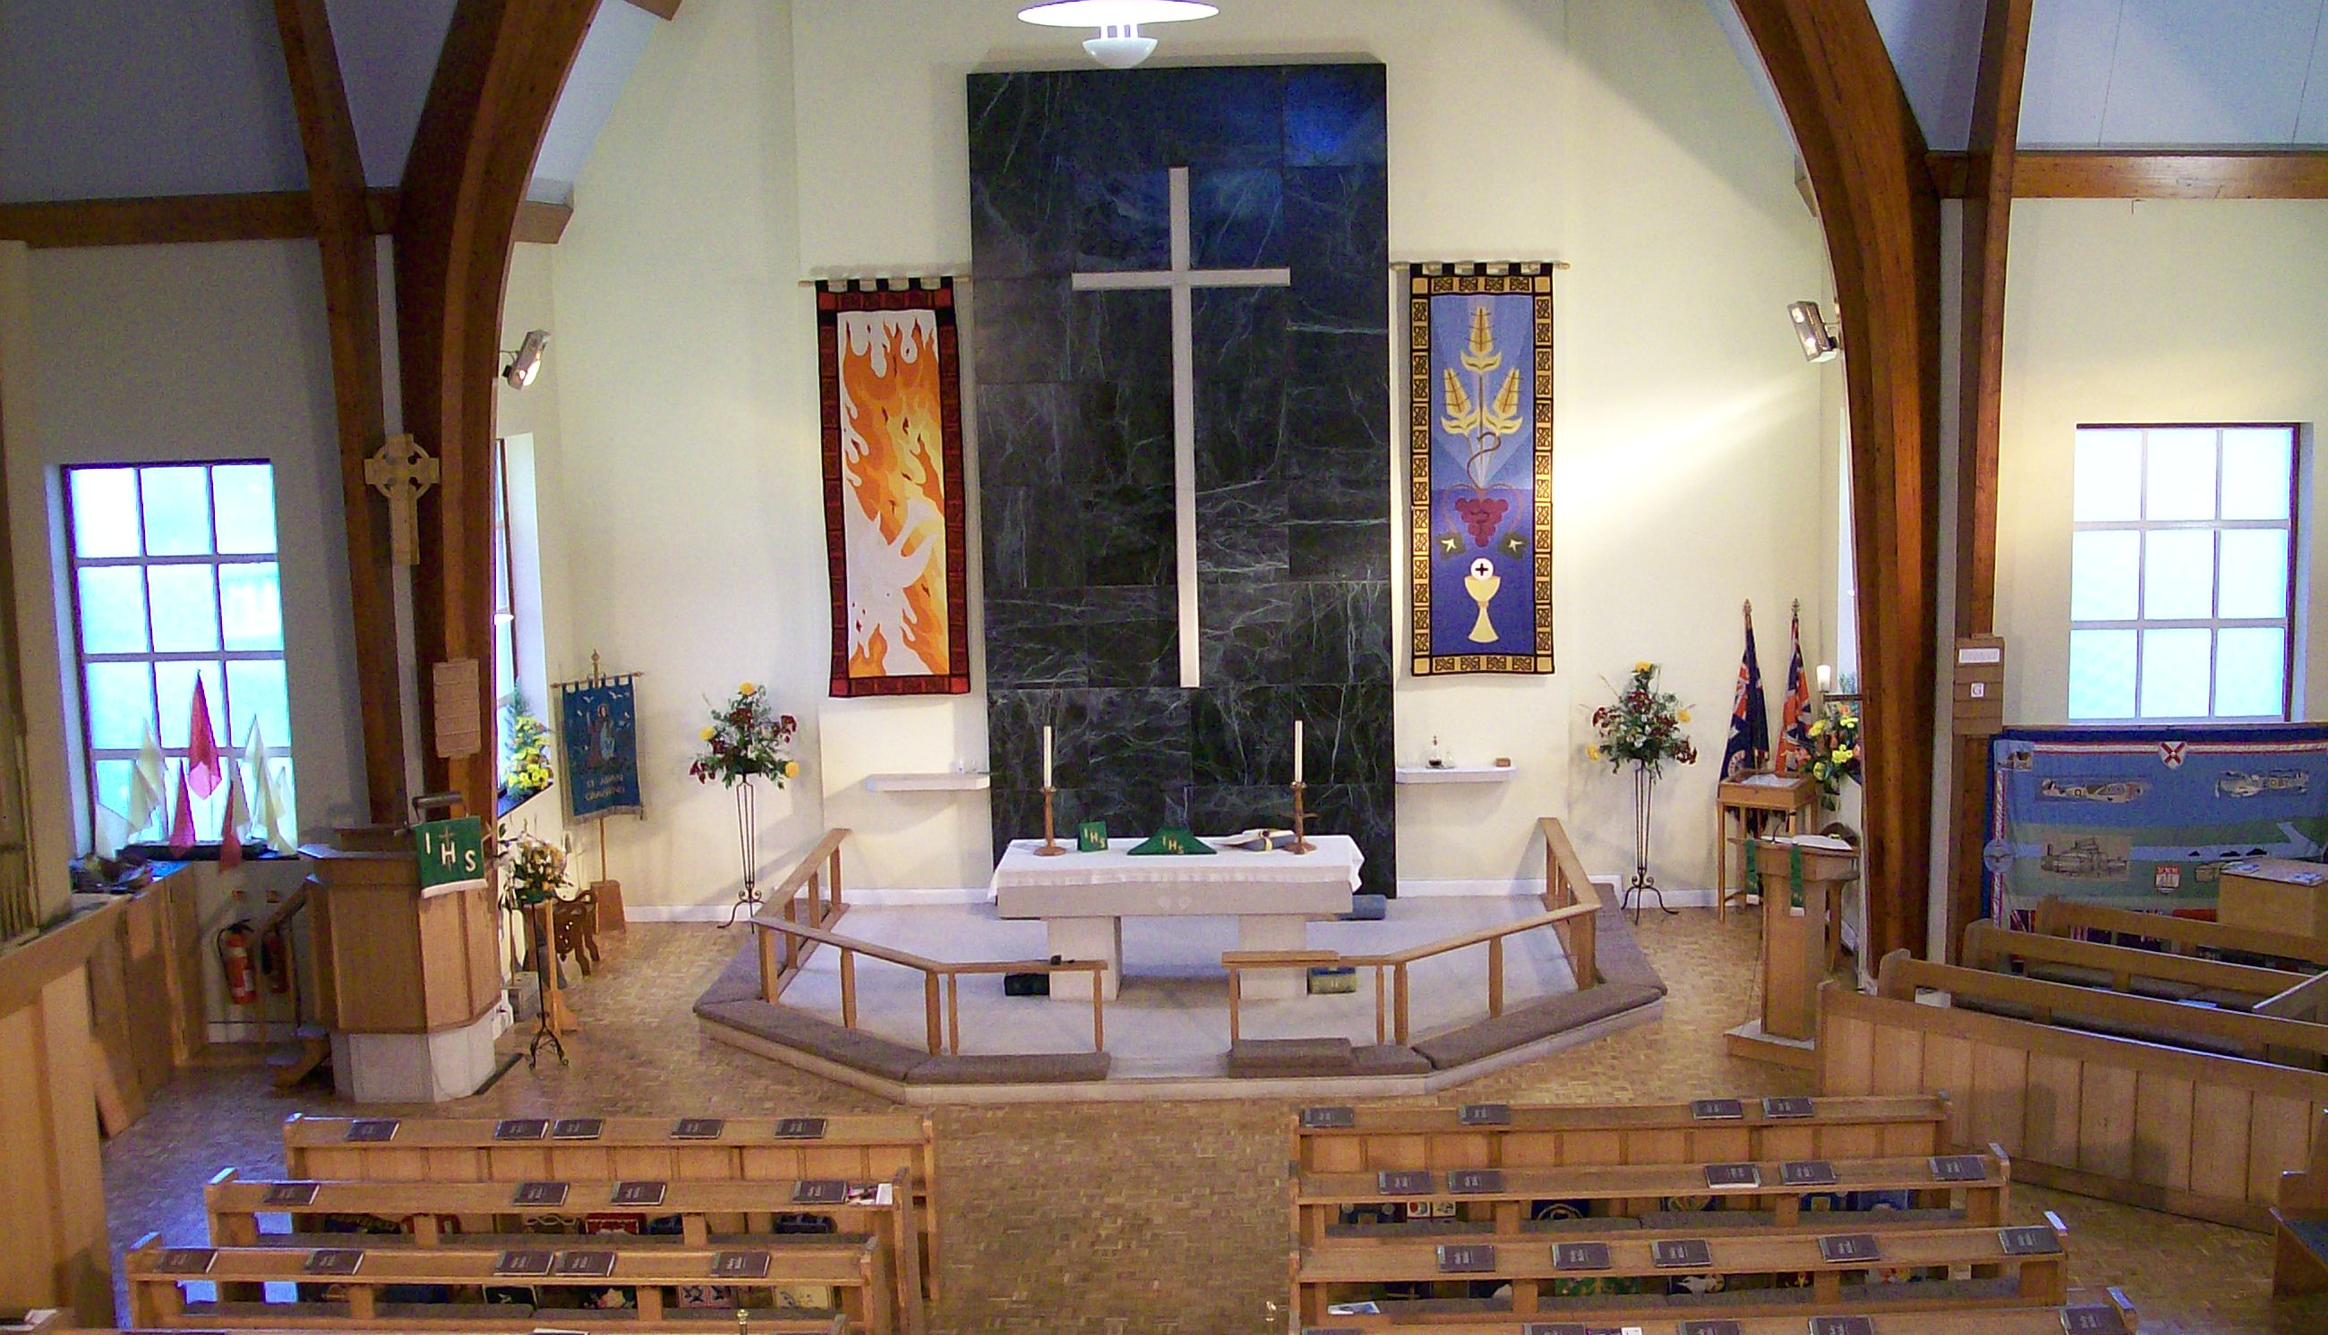

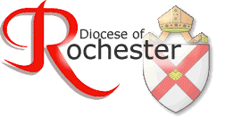

Sundays 10.00 am Eucharist(Holy Communion)
with Sunday School

Wednesdays 9.30 am Eucharist

You are warmly welcome to the parish church of St Aidan. We hope you will feel that this is a place where you can grow in faith and fellowship.

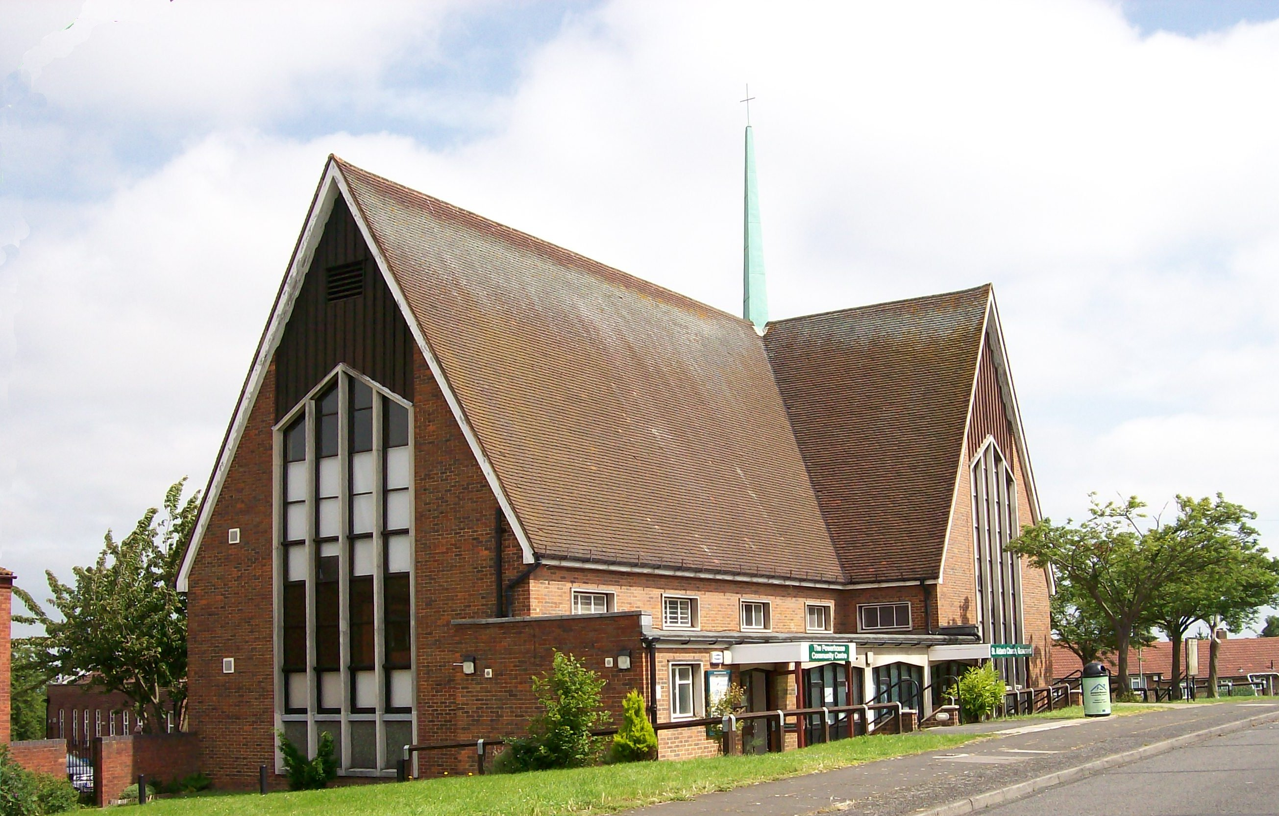

People of all walks of life worship together here; we have an active Sunday School for children each week and a monthly all-age service.
We are a fully accessible church for people with disabilities and have a hearing loop.

Services:
Our worship style is traditional Church of England worship and is open to all. Visitors usually comment on the good welcome they receive and people are always struck by the pleasant and inviting interior of the church.
We meet every Sunday at 10.00 am for a parish Eucarist (sometimes called Holy Communion or Mass). We have an organist and choir and a good team of readers who contribute to our worship. In the all-age service, Children usually participate in the service in various ways.
We also have a short Eucharist on Wednesday mornings at 9.30 am. Other seasonal and special services, and social and community events take place throughout the year. These are advertised in the weekly news sheet and on our website www.staidangravesend.org.uk. And Facebook page (St Aidan’s Church Gravesend)
If this is your first visit:
When you come in you will be greeted and given a hymn book, service book and news sheet. Please feel free to sit wherever you feel comfortable; there is plenty of seating. If you have children they are very welcome to come to Sunday School if they would like to. Books and toys for very young children are just on the left as you come in, with seating close by. The Sunday School children are invited to gather at the front of church at the beginning of the service and the leader introduces what will be covered.
They then go into the area at the back of church through the glass doors. You are welcome to accompany children (and please do so for children under 4 years), but you will also be able to see them through the windows. If they require the toilet, please accompany them.
During the Eucharist we usually stand to sing hymns and at certain other points in the service and there are parts where the people make spoken responses, but it is important that you feel comfortable, so don’t feel that you ‘have to’ stand or speak when others do; it’s important to get a ‘feel’ for the service so you may prefer to simply watch and listen rather than follow the service page by page in the book until you feel more familiar with things.
Receiving Holy Communion (the consecrated bread and wine): If you usually receive Communion at church services you are welcome to come and receive the Sacrament. Children who have been confirmed may also receive. Alternatively, you may like to come forward for a blessing. The priest will lay his hand on your head and say a brief blessing prayer. Children are very welcome to receive a blessing. To make your intention clear, either ask for a blessing when you come up or carry the service book in your hand as a sign to the priest. You are encouraged to join this important part of the service.
Gluten Free Gluten free wafers are available at Communion. Please let the welcomers know.
Donations A collection is taken during the service for church funds. On certain Sundays the collection is donated to local and international charities. Please consider paying by Standing Order if you worship regularly. If you are a UK tax payer, please fill out a Gift Aid form with your offering. Thank you.
Prayer Corner To the left of the altar is the prayer corner, where candles may be lit. There is a book in which names of people you would like prayed for can be written. Prayers from the book are said for a month at a time. There is a seating area for reflection. After each service, two members of our pastoral team are there to pray with you, should you wish it.
Toilets There is a disabled toilet and a unisex toilet available through the back of the church. Please accompany children to the toilet.

After the Service:
We offer tea, coffee, squash and biscuits (sometimes cake!) in the café area. Do make yourselves known to the vicar or to the welcomers who wear a badge; we are always delighted to meet new people. We are happy to arrange Baptisms (Christening), weddings and funerals. Please speak to the vicar or churchwardens.
Facilities:
- A well-equipped and comfortable café area and kitchen
- Toilets (Including disabled)
- Car Park (plus additional parking on local roads)
- Comfortable pews! We have movable chairs, too.
- A good, clear sound system and hearing loop
- Children’s area for very small children equipped with small toys and books
- Computer suite for community use
- A well-maintained and popular church hall with stage, kitchen and toilets.

Safety
We are committed to your safety at St Aidan’s. We have fire wardens and first aid kits and CCTV records the car park and immediate area outside the church. The Vicar and Church Council are responsible for safeguarding children and vulnerable adults and receive the latest training.

Contact Details
Vicar- The Rev’d Michael Payne-
01474 352500
vicar.staidans@gmail.com
Churchwardens:
Mr David Rawlinson
01474 352253
Mr Dennis Ashurst
01474 567300

Parish Website: www.staidansgravesend.org.uk

Facebook: St Aidan’s Church Gravesend

Twitter: @AidansGravesend

Who was St Aidan?
Aidan lived in the seventh century and left his native Ireland to become a monk on the island of Iona before becoming a bishop and Abbot of Lindisfarne (Holy Island). Rather than shut himself up on the island, Aidan learned the local Northumbria dialect and regularly journeyed around the mainland areas talking to local people about Jesus. He was known for his simplicity and gentleness. Here at St Aidan’s we try to model our own faith on his way, by looking to speak about and worship Jesus in a way people in our own time can understand, whilst respecting the traditions of the Church. We believe that being part of a church community strengthens society and builds up our own spiritual well-being. We believe in the importance of prayer, and in showing compassion and care.

https://www.rochester.anglican.org/strategy/called-together/

