A Reflective Service of Prayer

A short service for use in worship together at church or at home.

The Greenway Benefice:
Holy Trinity, Badgeworth,
St Paul’s, Shurdington, and
St Mary’s, Witcombe with Bentham
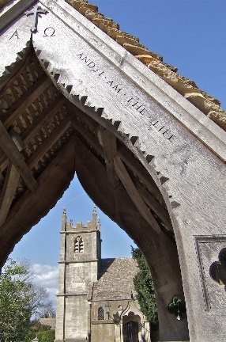
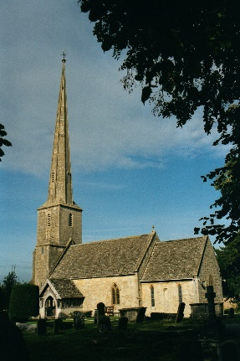
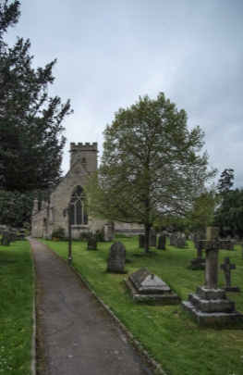
Leader: We come from scattered lives to meet with God.
All: Let us recognise God’s presence with us now.

Keep a short silence, still your heart.

Leader: As God’s people we have gathered;
All: Let us worship God now together.

Leader: Let us pray.
All: Come, Holy Spirit, fill the hearts of your faithful people, and kindle in us the fire of your love;
through Jesus Christ our Lord,
Amen.

Leader: In the light of Jesus, let us examine ourselves
and confess our sins.
Keep a short silence.

Confession:
All: Father, we have sinned against heaven and against you. We are not worthy to be called your children.
We turn to you again, have mercy on us, bring us back to yourself as those who once were dead but now have life through Christ our Lord. Amen.

Absolution:
Leader: May the Father forgive us by the death of the Son,
and strengthen us to live in the power of The Spirit
all our days. Amen.

If you are at home, please find the bible reading by reference to the weekly sheet on A Church Near You. If in church, you may wish to bring your own bible, or simply listen to the readings. A homily/talk/sermon may be given after the readings.
Leader: We affirm our faith in Jesus Christ the Son of God:

All: Though he was divine, he did not cling to equality with God, but made himself nothing. Taking the form of a slave, he was born in human likeness. He humbled himself and was obedient to death, even the death of the cross. Therefore, God has raised him on high, and given him the name above every name: that at the name of Jesus every knee should bow, and every voice proclaim that Jesus Christ is Lord, to the glory of God the Father. Amen. cf Philippians 2.6-11

Leader: We intercede for others.
All: Lord, meet us in the stillness and hear our prayer.

In church, someone will lead intercessions. If you are at home, you may like to: Pray for yourself in your isolation, Pray for others in their loneliness, Pray for the church and leaders of the nations, Pray for our country, Pray for the world.

The leader may read the Collect for the day.
Leader: Let us pray with confidence as our Saviour has taught us.
All: Our Father, who art in heaven,
hallowed be thy name; thy kingdom come;
thy will be done; on earth as it is in heaven.
Give us this day our daily bread.
And forgive us our trespasses,
as we forgive those who trespass against us.
And lead us not into temptation; but deliver us from evil. For thine is the kingdom, the power and the glory,
for ever and ever. Amen.
Silence is kept

Leader: Faithful God, may we who share in this time of worship glory in the cross of our Lord Jesus Christ, our salvation and hope, who reigns as Lord now and forever.

All: Fill us, Good Lord with your Spirit of love;
And as you have fed us with your presence,
so, make us one in heart and mind,
In Jesus Christ our Lord. Amen.

Leader: Let us bless the Lord
All: Thanks be to God.

PLEASE TAKE THIS SERVICE SHEET WITH YOU, TO USE AT HOME AND TO BRING AGAIN TO GATHERED WORSHIP.

Online worship resources and information:

Facebook: https://www.facebook.com/greenwaychurches/

Greenway Churches YouTube Page: https://www.youtube.com/channel/UC6jdAqgLdOic0_pVLNT2r5g

A Church Near You:
St Paul’s https://www.achurchnearyou.com/church/14188/
Holy Trinity https://www.achurchnearyou.com/church/14187/
St Mary’s https://www.achurchnearyou.com/church/14176/

