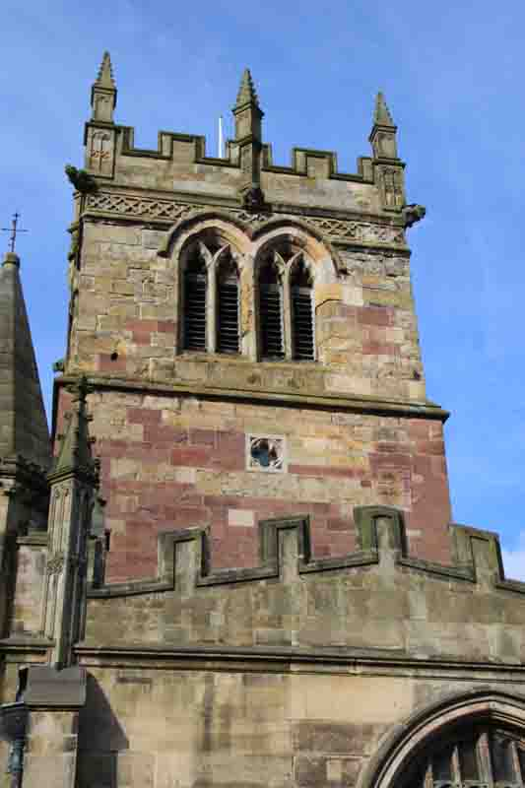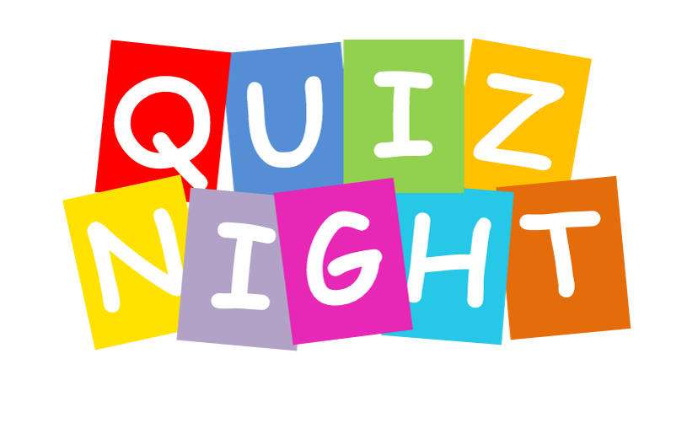

St Mary’s Church, Ellesmere
SPRING QUIZ NIGHT
With Bangers and Mash Supper
At Ellesmere Town Hall
Friday 24th February 2023
7.00 for 7.30 p.m.
Tickets (only £10 including supper) will be available from Church or from davidwreffell@gmail.com (01691 622516) from February 1st
BUT FOR NOW PLEASE SAVE THE DATE AND AWAIT TICKETS
or from February,see Rodney Stokes in the market(Tuesdays 8 a.m. to 12 noon)
Teams of 4
All welcome!
Do come along for a jolly night of brain-teasing competition and a wholesome supper including apple pie for pudding!
Bar open in the Town Hall for drinks.

