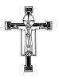
The Benefice of Martock, Kingsbury Episcopi and Ash

STILL WATERS
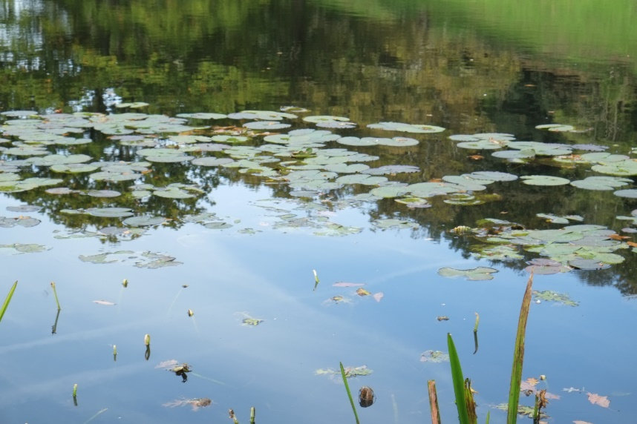

‘HE LEADS ME BESIDE STILL WATERS,
HE RESTORES MY SOUL’
Psalm 23: v2-3

A Gentle 40-Minute Service
drawing on words, music and silence

Every second Sunday of the month,
at 6.30pm as follows:

Sunday 12th Sept Church Rooms, Kingsbury Episcopi
Sunday 10th Oct All Saints’ church, Martock
Sunday 14th Nov Church Rooms, Kingsbury Episcopi
Sunday 12th Dec All Saints’ church, Martock

Do Join Us For A Time Of Reflection, Restoration And Renewal

ALL ARE VERY WELCOME!

