Worship at Home on The Feast of Pentecost

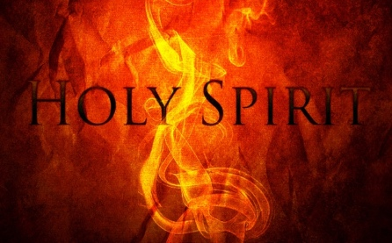

The love of God has been poured into our hearts through the Holy Spirit who has been given to us!

The Welcome
Jesus Christ, whom we worship, is our crucified, risen and ascended Lord and we have walked with him through his journey of love.
We have faced the agony of his suffering and death on a cross.
We have rejoiced at his bursting free from the bonds of death.
We have enjoyed his risen presence with us and his revelation of himself through the breaking of bread.
We have seen his return to the throne before which every knee shall bow and every tongue confess that this Jesus is Lord.
And now, with the followers of his own time, we await the coming of the promised Holy Spirit, his gift to his people,
through whom we make Christ known to the world.

Hymn
1 Breathe on me, breath of God:
fill me with life anew,
that I may love as you have loved
and do as you would do.

2 Breathe on me, breath of God,
until my heart is pure,
until my will is one with yours
to do and to endure.

3 Breathe on me, breath of God;
fulfil my heart's desire,
until this earthly part of me
glows with your heavenly fire.

4 Breathe on me, breath of God;
so shall I never die,
but live with you the perfect life
of your eternity.

The Gloria
Glory to God in the highest, and peace to his people on earth.
Lord God, heavenly King, almighty God and Father, we worship you, we give you thanks, we praise you for your glory.
Lord Jesus Christ, only Son of the Father, Lord God, Lamb of God, you take away the sin of the world: have mercy on us;
you are seated at the right hand of the Father: receive our prayer. For you alone are the Holy One, you alone are the Lord, you alone are the most high, Jesus Christ, with the Holy Spirit, in the glory of God the Father. Amen.

The Collect
Holy Spirit, sent by the Father, ignite in us your holy fire; strengthen your children with the gift of faith, revive your Church with the breath of love and renew the face of the earth, through Christ our Lord. Amen.

The Reading: Acts 2.1-21
When the day of Pentecost had come, they were all together in one place. And suddenly from heaven there came a sound like the rush of a violent wind, and it filled the entire house where they were sitting. Divided tongues, as of fire, appeared among them, and a tongue rested on each of them. All of them were filled with the Holy Spirit and began to speak in other languages, as the Spirit gave them ability.

Now there were devout Jews from every nation under heaven living in Jerusalem. And at this sound the crowd gathered and was bewildered, because each one heard them speaking in the native language of each. Amazed and astonished, they asked, ‘Are not all these who are speaking Galileans? And how is it that we hear, each of us, in our own native language? Parthians, Medes, Elamites, and residents of Mesopotamia, Judea and Cappadocia, Pontus and Asia, Phrygia and Pamphylia, Egypt and the parts of Libya belonging to Cyrene, and visitors from Rome, both Jews and proselytes, Cretans and Arabs—in our own languages we hear them speaking about God’s deeds of power.’ All were amazed and perplexed, saying to one another, ‘What does this mean?’ But others sneered, ‘They are filled with new wine.’

But Peter, standing with the eleven, raised his voice and addressed them: ‘Men of Judea and all who live in Jerusalem, let this be known to you, and listen to what I say. Indeed, these are not drunk, as you suppose, for it is only nine o’clock in the morning.
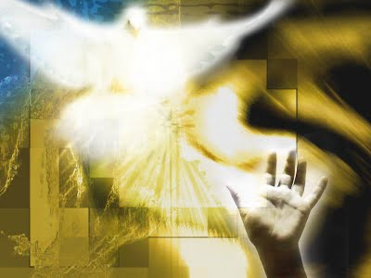
No, this is what was spoken through the prophet Joel: “In the last days it will be, God declares,
that I will pour out my Spirit upon all flesh and your sons and your daughters shall prophesy,
and your young men shall see visions,
and your old men shall dream dreams.
Even upon my slaves, both men and women,
in those days I will pour out my Spirit; and they shall prophesy.
And I will show portents in the heaven above and signs on the earth below, blood, and fire,
and smoky mist. The sun shall be turned to darkness and the moon to blood, before the coming of the Lord’s great and glorious day. Then everyone who calls on the name of the Lord shall be saved.”

A Reflection for Pentecost:
The first Pentecost was a frightening and mysterious event: something like a wind and things like divided flames; different gifts as the Spirit gave; wonder at those hearing their languages being spoken; confusion at others thinking these people were drunk...

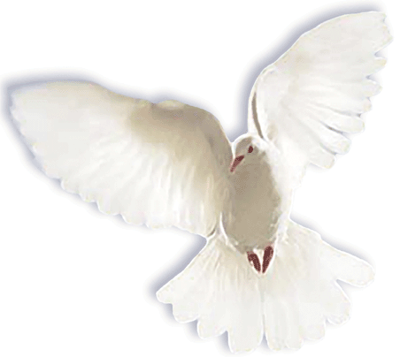
God’s spirit acts in ordinary people but in extraordinary ways, giving his followers different gifts, but with the same point - to enable them to share his love powerfully with others.
This Photo by Unknown Author is licensed under CC BY
I imagine for the early disciples it must have been
something like emerging from a Lockdown.

Rather than "lifting us up" above others, away from our communities into a group that is somehow ‘more favoured’ by God, Pentecost draws us outwards to engage with those whom we might feel unable to connect to, without the spirit’s help. Rather than leading us out of the world, Pentecost leads us more fully into it - to proclaim and live out God’s message of love, as Jesus did.

- In what ways do you sense the Spirit ‘leading you out’ as a church community to live Christ’s way of grace and love among those around you?
- What signs do you see of your local community sensing something of God through what is happening because of the lockdown?
- How are all these things affecting how you see life; how you relate to others; how you pray?

The Creed
I believe in God, the Father of all,
who began and upholds a universe
that makes itself through evolving processes.
God is Love, granting to creation a freedom
that restricts his power.
Through his Son Jesus
this self-giving God rescued us and
showed us what he is like:
loving in life and death;
sharing our pain;
suffering the consequences of our sin;
offering forgiveness.
Jesus died for us but was raised by God
and now lives with us through his Spirit
to build God’s kingdom of unselfish love
and lead us, as our judge and Saviour,
to eternity with him.

Intercessions for Pentecost
Come Holy Spirit, direct the rulers of the world. Fill our leaders with talents and discernment to seek the common good.
Inspire our artists and musicians, writers and craftspeople, all whose creativity remind us of the beauty and worth of your creation
Lord, Your Spirit is with us, Hear our prayer

O Advocate, lead us to bring peace and justice and unity to your world.
We ask for your energy and vision for those who are tiring in the battle against injustice and oppression, and those exhausted by the struggle with poverty and hunger.
Lord, Your Spirit is with us, Hear our prayer

Holy Spirit, fill our homes and lives and set our hearts on fire with the warmth of your love. Help us to share Christ’s love with others to bring hope to those in distress. Lord, Your Spirit is with us, Hear our prayer
Holy Spirit, we pray to you for those who are eaten up with guilt anxiety or despair, those who feel their lives are beyond salvation. May they know your healing, and your strength.
Lord, Your Spirit is with us, Hear our prayer
O Comforter, we pray for all who are weak, lonely or lost; we pray for those who are ill, those who cannot cope on their own, those feeling overwhelmed by pressure of work or responsibility. Surround these with consolation, comfort and your grace.
Lord, Your Spirit is with us Hear our prayer

Holy Spirit, we pray for those who have died, especially Roy Trerise and Anthony Rushton; we pray for all who have died from Covid 19 and for their loved ones and all whose lives are darkened by sorrow and mourning.
Jesus Christ, light of the world, you turn our darkness into light; in your light shall we see light, a light which no darkness can quench. Lord, Your Spirit is with us, Hear our prayer

Merciful father, accept these prayers through Christ our Lord. Amen

The Lord’s Prayer
Our Father in heaven, hallowed be your name. Your kingdom come,
your will be done, on earth as in heaven. Give us today our daily bread, forgive us our sins as we forgive those who sin against us. Lead us not into temptation but deliver us from evil, for the kingdom, the power and the glory are yours now and for ever. Amen.

The Peace
God has made us one in Christ. He has set his seal upon us and as a pledge of what is to come, has given us the Spirit to dwell in our hearts.
Alleluia!

The Pentecost Commission
As part of God’s Church here in Mabe and Ponsanooth, I call upon you to live out what you proclaim:
Empowered by the Holy Spirit, will you dare to walk into God’s future, trusting him to be your guide?

All By the Spirit’s power, we will.
Will you dare to embrace each other and grow together in love?
All We will.
Will you dare to share your riches in common and minister to each other in need?
All We will.
Will you dare to pray for each other until your hearts beat with the longings of God?
All We will.
Will you dare to carry the light of Christ into the world’s dark places?
All We will.

Hymn
1. Brother, sister, let me serve you;
let me be as Christ to you;
pray that I may have the grace to
let you be my servant too.

2. We are pilgrims on a journey,
and companions on the road;
we are here to help each other
walk the mile and bear the load.

3. I will hold the Christ light for you
in the night time of your fear;
I will hold my hand out to you,
speak the peace you long to hear.

4. I will weep when you are weeping;
when you laugh I'll laugh with you;
I will share your joy and sorrow,
till we've seen this journey through.

5. When we sing to God in heaven,
we shall find such harmony,
born of all we've known together
of Christ's love and agony.

6. Brother, sister, let me serve you;
let me be as Christ to you;
pray thatl may have the grace to
let you be my servant too.

The Blessing
May the Spirit, who hovered over the waters when the world was created, breathe into you the life s/he gives.

May the Spirit, who overshadowed the Virgin when the eternal Son came among us, make you joyful in the service of the Lord.

May the Spirit, who set the Church on fire upon the Day of Pentecost,
bring the world alive with the love of the risen Christ.

And the blessing of God almighty, Father, Son and Holy Spirit,
be among you and remain with you always. Amen.

Filled with the Spirit’s power, remain in the light and peace of Christ. Thanks be to God!
