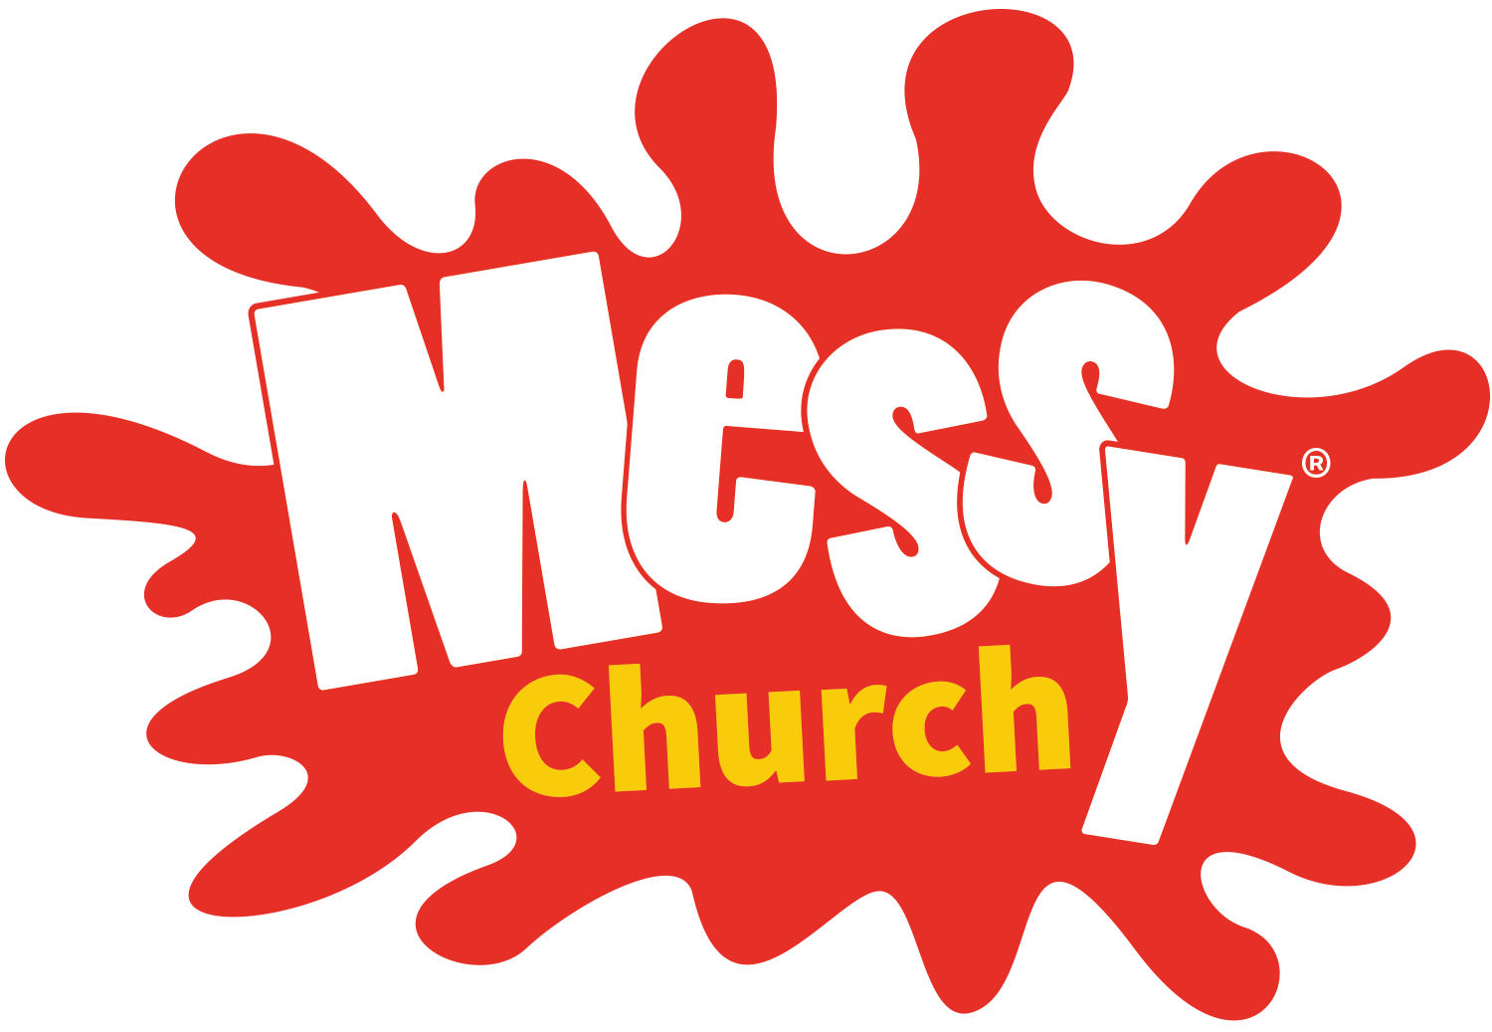
Messy church dates 2018
Sunday 28th January Ellerdine Village hall
Sunday 25th February High Ercall Village hall
Sunday 25th March Longdon Village hall
Sunday 22nd April Rodington village hall
Sunday 27th Mary Ellerdine Village hall
Sunday 24th June High Ercall Village hall
Sunday 22nd July Longdon Village hall
August- holiday club one? Rodington Village hall
Sunday 23rd September Ellerdine Village hall
Sunday 28th October Londgon Village hall
Sunday 25th November Rodington Village hall
Monday 24th December Messy Crib service at High Ercall

