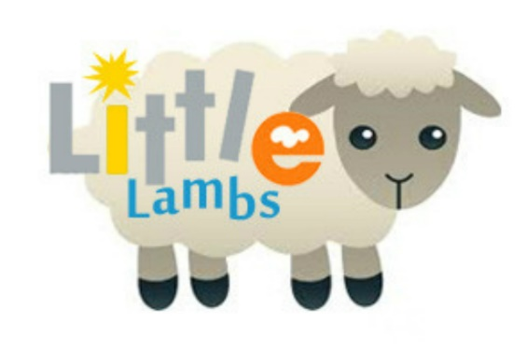

LITTLE LAMBS
Baby & Toddler Group
Every Tuesday
9:15am – 11.15am
St Mary’s Church
- Meet new friends
- Chat with other parents and carers
- Let the little ones play in a safe environment
- Get together with friends
- Have a well-deserved cup of coffee
- Songs, bible stories and crafts.
- Pre-school aged children and their carers.
(Term time only)

