Lent Study Course 2019
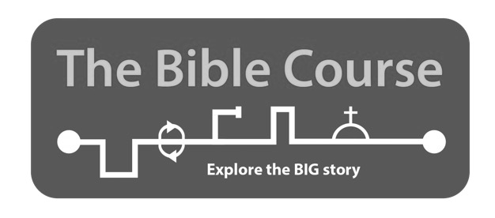
Eight interactive sessions (each about an hour in length)
7.30pm at the Vicarage
March 11, 18, 25. April 1, 8, 15. May 6, 13
Everybody with any background welcome.
Ideally let Mike the Vicar know that you are coming
but you are welcome just to come alon.
Manual (£5) available at the session
For more details see tinyurl.com/thebiblecourse

