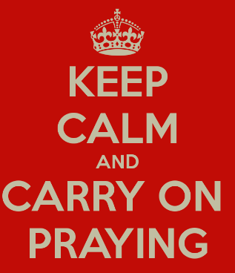
Join the Celebration
Worshipping together in spirit
second Sunday in Lent:
Wealth and poverty

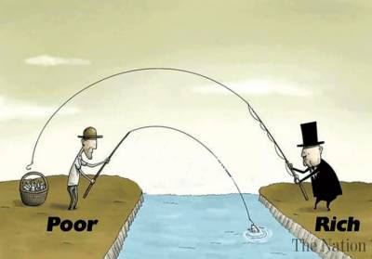
Our second reflection in our Lent series based on Church Action on Poverty’s Scripture from the Margins, is based on the sensational story of Ananias and Sapphira, found in Acts 5. As we come out of lockdown we will come to see more and more clearly how Covid has exacerbated the gulf between rich and poor in this country. How do we relate to this as Christians? What can we do?

Our YouTube video for our worship for today can be found at: https://youtu.be/BdRn2VpMDjQ

Opening Prayer:
Among the poor, among the proud, among the persecuted, among the privileged:
Christ is coming to make all things new.

In the private house, in the public place, in the wedding feast, in the judgement hall: Christ is coming to make all things new.

With gentle touch, with an angry word, with a clear conscience, with burning love: Christ is coming to make all things new.

That the kingdom might believe, that the world might believe, that the power-hungry might stumble, that the hidden might be seen:
Christ is coming to make all things new.

Within us, without us, behind us, before us, in this place, in every place, for this time, for all time: Christ is coming to make all things new.
Hymn – Be thou my vision
Be thou my vision, O Lord of my heart;
naught be all else to me, save that thou art.
Be thou my best thought in the day and the night,
both waking or sleeping, thy presence my light.

Be thou my wisdom, be thou my true word;
be thou ever with me, and I with thee, Lord,
be thou my great Father, and I thy true son,
Be thou in me dwelling, and I with thee one.

Be thou my breastplate, my sword for the fight.
Be thou my whole armour, be thou my true might,
be thou my soul’s shelter, be thou my strong tower,
O raise thou me heavenward, great Power of my power.

Riches I heed not, nor man’s empty praise;
be thou mine inheritance, now and always.
Be thou and thou only, first in my heart,
O Sovereign of heaven, my treasure thou art.

High King of heaven, thou heaven’s bright Sun,
O grant me its joys, after victory is won.
Great heart of my heart, whatever befall,
still be thou my vision, O Ruler of all.

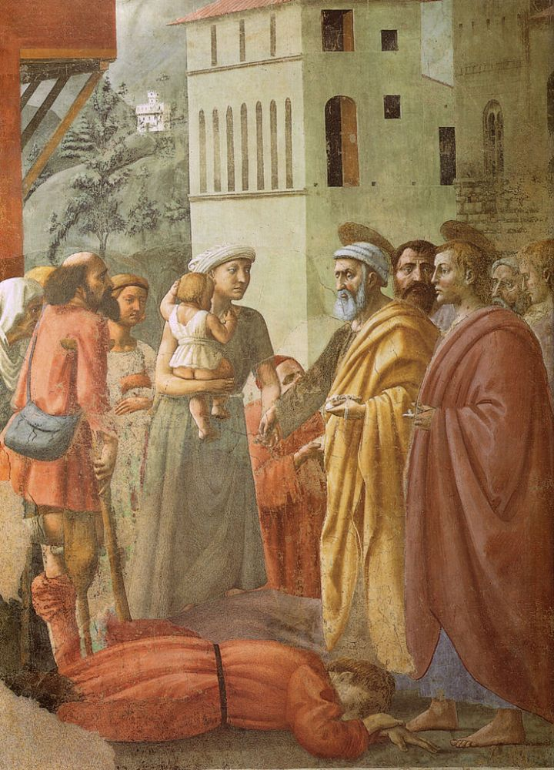
Bible Reading – Acts 5.1-11
A man named Ananias, with the consent of his wife Sapphira, sold a piece of property; with his wife’s knowledge, he kept back some of the proceeds, and brought only a part and laid it at the apostles’ feet. ‘Ananias,’ Peter asked, ‘why has Satan filled your heart to lie to the Holy Spirit and to keep back part of the proceeds of the land? While it remained unsold, did it not remain your own? And after it was sold, were not the proceeds at your disposal? How is it that you have contrived this deed in your heart? You did not lie to us but to God!’ Now when Ananias heard these words, he fell down and died. And great fear seized all who heard of it. The young men came and wrapped up his body, then carried him out and buried him.

After an interval of about three hours his wife came in, not knowing what had happened. Peter said to her, ‘Tell me whether you and your husband sold the land for such and such a price.’ And she said, ‘Yes, that was the price.’ Then Peter said to her, ‘How is it that you have agreed together to put the Spirit of the Lord to the test? Look, the feet of those who have buried your husband are at the door, and they will carry you out.’ Immediately she fell down at his feet and died. When the young men came in, they found her dead, so they carried her out and buried her beside her husband. And great fear seized the whole church and all who heard of these things.

The Reflection – written by Dr Hilary Gilbert
Are we all Ananias and Sapphira?

I rather thought I’d drawn the short straw when Anna gave me this story to reflect on. On the face of it, it looks pretty extreme, doesn’t it? - and if we’re honest, perhaps unfair, over the top. ‘Reluctant to give away your last penny? Capital crime!’ Perhaps we even secretly sympathize with Ananias
and Sapphira. After all, it wasn’t as if they had sold their land without meaning to share any of the proceeds. They’d just wanted to keep a bit back for a rainy day. Generous, but within reason. That strikes a chord with us, doesn’t it?

There are various interpretations of this demanding story. One has the couple dying of mortification at having been unmasked as hypocrites – taking credit for being devoted community members while all the while maintaining their secret stash. Another sees them as shamed to death: then as now in Middle Eastern societies an incredibly strong culture of reciprocal obligation operates. Caricatured as ‘You scratch my back, I’ll scratch yours’, this network of mutual support creates an unspoken but indelible contract between people. If you have helped me, in however small a way, I know I must be at your disposal when you need help – and I will not be forgiven if I fail you. (I learned this lesson the
hard way when a Bedouin girl who had brought me a really nice feather let me know that she needed a laptop….) Ananias and Sapphira had joined a community where everyone had given their all. By holding back, they had broken that critical social contract. But did they really deserve to die? I’m not sure I find these social explanations convincing.

As Anna explained last week, biblical narratives consistently emphasise God’s concern for the poor and marginalized; and Jesus’ encounters with those around him bring ‘Hope for those who need it, and challenge for those who need it.’ Where do we fall, I wonder, on that spectrum? The early Christian church, or community, had established itself as an act of resistance to the political culture
of its day: rejecting the acquisition of personal wealth and status in favour of radical sharing – of both resources, human love and God’s love - with fellow Christians and with the poor and marginalized. Inspired by the Spirit they were creating their own culture, one that put the first last and the last first; one that intentionally grounded itself in Christ’s values.

Our society, much like the Roman Empire, has little time for the poor and marginalized. I learned from a priest that the Magnificat - with its inconvenient references to raising up the lowly and banishing the arrogant rich – was quietly removed from Evening Prayer during the British Raj. What might Jesus have made of that, I wonder? In more recent times, our culture of ‘me-me-me’ has fed
rampant consumerism: a cult of fame, fortune and individual success in which perceived failures are tossed aside. ‘Out of my way, it’s a busy day, I’ve something on my mind’, Pink Floyd sang. ‘For want of the price of tea and a slice, the old man died’. This culture has landed us with one of the most
unequal societies in existence – one in which according to a new report by Oxfam the richest 10% own half the country’s wealth, while the poorest half of our citizens own just 10% of its assets.

What has all this to do with Ananias and Sapphira? St Luke depicts their deaths as shockingly literal, but perhaps they can be seen as metaphorical – as the final stage in a hardening of the heart towards the needs of others, of ‘looking after number one’, that is the antithesis of Christian community, and the rejection of Christ’s command to us to love God, and our neighbours as ourselves. Perhaps their hearts had grown so hard they simply stopped.

Or perhaps the truth is more uncomfortable. Like us, they were only human, seeking security, frightened perhaps of rocking the boat, cutting loose from a material safety-net, and the system that had let them live their lives in comfort. Not hypocrites, not outrageous liars, but too cautious to go the whole way, to commit themselves to living authentically and openly as Christians. I’ve just read
an account by Nikita Gill of her grandparents’ experience of Partition in India. ‘As they drove away from the only home they had ever known, through mobs and the wreckage of their village, ‘ she writes, ‘they stopped to pick up as many of their neighbours as they could. To do this they had to leave behind all their possessions. ‘People over things’ said my grandmother.’ People over things’.
How many of us would have made that choice? Ananias and Sapphira couldn’t do it. Perhaps they couldn’t forgive themselves, and died of disappointment.

The Catholic martyr Oscar Romero, Archbishop of San Salvador, famously said: ‘When I feed the poor, they call me a saint. When I ask why they are poor, they call me a communist.’ He paid for his Christian commitment with his life. We are blessed to live in a society that does not call us to martyrdom; but while we live in a system that ignores Christ’s values, we have to be braver than
Ananias and Sapphira. We have to share our substance with our neighbour, we have to speak up for the marginalized. To live authentically as Christians we have to make a stand.

Amen

Hymn – Tell out, my soul
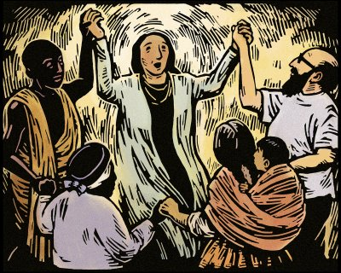
Tell out, my soul, the greatness of the Lord:
Unnumbered blessings give my spirit voice;
Tender to me the promise of his word;
In God my Saviour shall my heart rejoice.
Tell out, my soul, the greatness of his Name:
Make known his might, the deeds his arm has done;
His mercy sure, from age to age to same;
His holy Name, the Lord, the Mighty One.
Tell out, my soul, the greatness of his might:
Powers and dominions lay their glory by;
Proud hearts and stubborn wills are put to flight,
The hungry fed, the humble lifted high.
Tell out, my soul,
the glories of his word:
Firm is his promise,
and his mercy sure.
Tell out, my soul,
the greatness of the Lord
To children's children
and for evermore.

The Prayers:
Let us pray:
Because you made the world, and intended it to be a good place, and called its people your children; because, when thing seemed at their worst, you came in Christ to bring out the best in us; so gracious God, we gladly say:
Goodness is stronger than evil, love is stronger than hate,
light is stronger than darkness, truth is stronger than lies.
Pause
Because confusion can reign inside us, despite our faith; because anger, tension, bitterness and envy distort our vision; because our minds sometimes worry shall things out of all proportion; because we do not always get it right, we want to believe that:
Goodness is stronger than evil, love is stronger than hate,
light is stronger than darkness, truth is stronger than lies.
Pause
Because you have promised to hear us, and are able to change us, and are willing to make our hearts your home, we ask you to confront, forgive and encourage us as you know best.
Pause
Then let us cherish in our hearts that which we proclaim with our lips:
Goodness is stronger than evil, love is stronger than hate,
light is stronger than darkness, truth is stronger than lies.

Lord, hear our prayer, and change our lives until we illustrate the grace of the God who makes all things new. Amen.

Hymn – Be thou my guardian and my guide
Be thou my guardian and my guide,
and hear me when I call;
let not my slippery footsteps slide,
and hold me lest I fall.

The world, the flesh, and Satan dwell
around the path I tread;
O save me from the snares of hell,
thou quickener of the dead.

And if I tempted am to sin,
and outward things are strong,
do thou, O Lord, keep watch within,
and save my soul from wrong.

Still let me ever watch and pray,
and feel that I am frail;
that if the tempter cross my way,
yet he may not prevail.

The closing prayers:
From where we are now to where you need us;
Jesus now lead on.

From the security of what we know to the adventure of what you will reveal:
Jesus now lead on.

To refashion the fabric of this world until it resembles the shape of your kingdom: Jesus now lead on.

Because good things have been prepared for those who love God:
Jesus now lead on.

