**Lockington Railway Evenings**

We have now held four Lockington Railway Evenings, average attendance has been around 30 people. Subjects covered: BR Steam in the 1960’s; Narrow gauge railways: the Darjeeling and Himalayan Mountain Railway, IoM, the Ffestiniog and Welsh Highland; Class 314/5 EMUs and the new bi-mode IEP trains (Class 800).

A highlight has been Geoff Oliver and Alan Schofield in conversation recollecting their experiences as engine drivers in the 50’s /60’s.

In a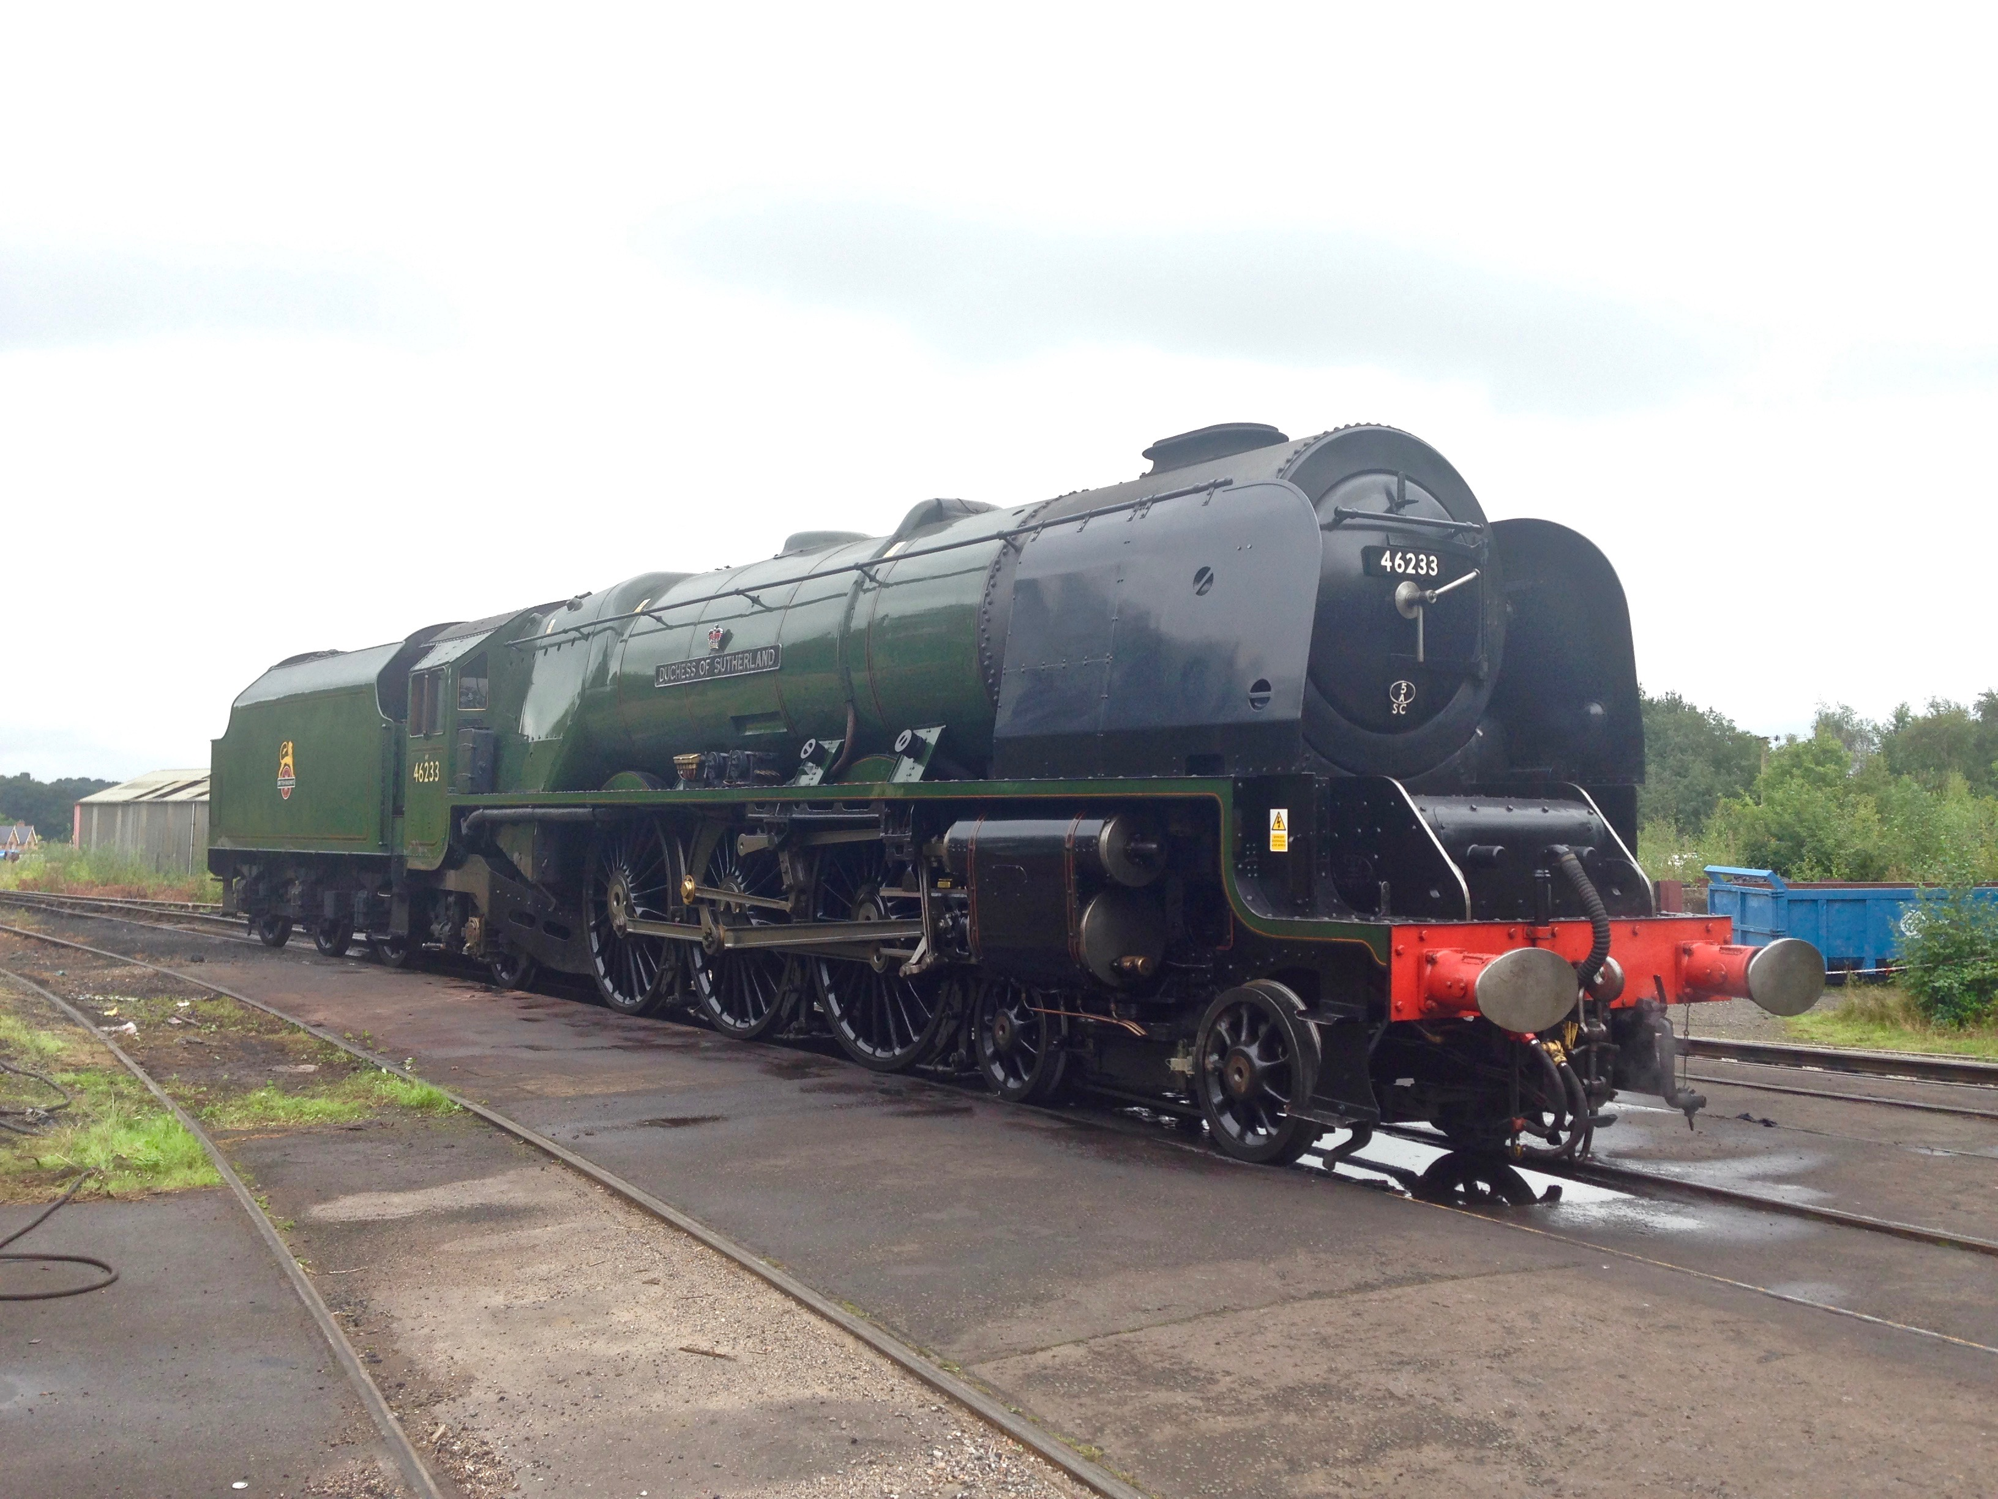ddition to Geoff and Alan, Allen Ferguson and I are indebted to Nick Wise, Mike Wynn and Roger Hateley.

We are organising a visit to the Hitachi factory at Newton Aycliffe, where the Class 800s are being built, 6 trainsets being procured by Hull Trains.

The evenings are informal, friendly with tea and biscuits provided. From the donations received around £300 has been raised for St Mary’s Church, Lockington.

The date of the next meeting will be Tuesday 6th March, all welcome.