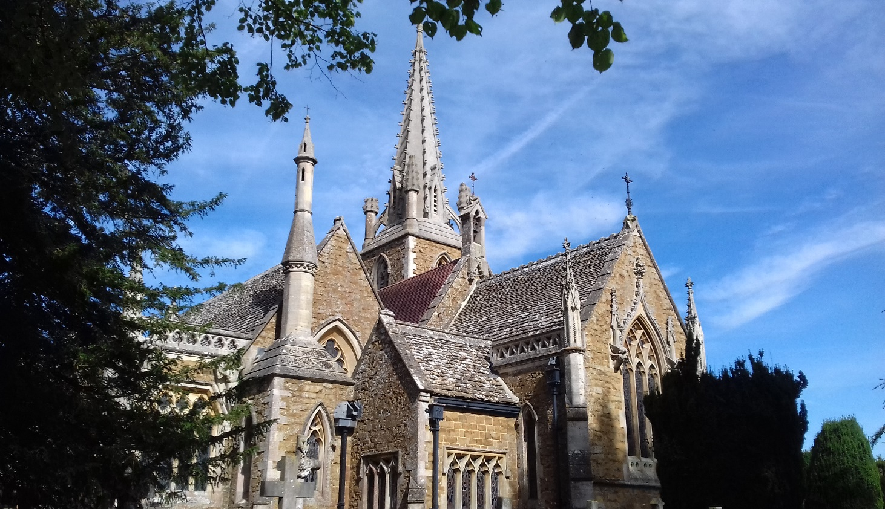

St Mary’s Church – The Historical Context

This is the third church known to have occupied this site.
It was built by two local firms: Ashbees of Kingscote and Cholertons of Quedgeley in the 1840s. Much of the money needed for the new church together with its fittings was provided by the Revd Sir William Darell, together with his father-in-law, Sir Edward Tierney
Known as Gloucestershire's Mini Cathedral, the church was dedicated in 1847 and is built of brown Stinchcombe sandstone with Bath dressings in the Late Dec style by the local architect Francis Niblett of Haresfield, with additions by the Oxford architect J W Hugall (who at one time had offices in Cheltenham) in 1857-9 and 1866. Francis Niblett was a great admirer of August Pugin who is famous for his work on the Houses of Parliament.
Alan Brooks' guide to the architecture of Gloucestershire describes the church as …..”a small but splendid Early Victorian Church…. the masterpiece of Francis Niblett…No expense spared in its construction.”
Records show that the site itself has been used as a place of worship for over 700 years with the first church on the site being consecrated in the early 1300s. The then Bishop of Worcester dedicated the altar in 1315,
The second church had a floor level about 3ft below the current external ground level and records suggest that there was a family vault beneath that, although this has not been confirmed in recent times and no reason as yet has been found for the difference in levels.
This church was demolished to make way for the present church because of the alleged bad state of repair it had fallen into.
Drawings of the second church depict a fairly standard stone building, similar to St Mary’s at Arlingham but smaller, and of a similar era i.e. Late 13th - Early 14th Century. It is quite possible that the church buildings were not actually in a state of disrepair as during the Victorian era it was quite common for applicants to exaggerate the bad state of their buildings as they preferred to build a completely new one as their monument rather than refurbish an old building.

We hope that you enjoy your visit to our little gem. If you would like to help us look after it, please feel free to leave a donation in the pot provided – we are happy to take cash!
If you would prefer to arrange for a BACS, please contact the Churchwarden at fretherne.church@gmail.com, or on 01452-740891.

Thank-you

St Mary’s PCC

