Hedgerow Communion 2022
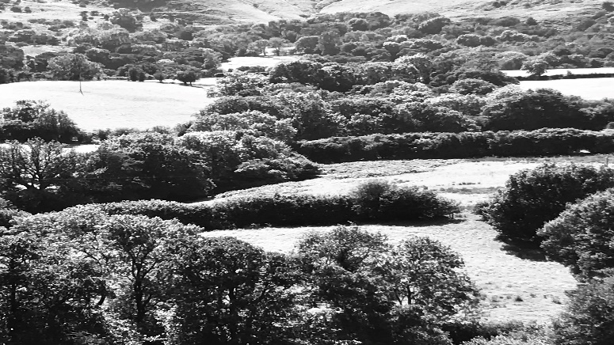
The other day I spoke with someone who told me of a conversation they had with a friend who said they did not go to church because they felt they could not experience the divine presence; instead, they meditated and walked. Many feel the same way so a few of us here in the Abbeydore Deanery are exploring what we have called ‘Hedgerow Communions’. We hope to have one Hedgerow Communion a month; typically, but not always, on ancient feast days or special days like the solstices. A Hedgerow Communion will be in nature, will involve a very simple communion by an unsuspecting hedge with silence and reflective music. Each event will usually include a walk, an activity, and may well end up in a pub.
John Donne the great poet and preacher spoke of creation being the second book of revelation. Dietrich Bonhoeffer, the great Protestant theologian, spoke of the church losing its way if it did not live in community, and Karl Rahner, the great Roman Catholic theologian, said the church would disappear if it lost its sense of the mystical. We hope to demystify and understand more the central feast and ritual of the Christian faith but, most of all, this enterprise is all about experiencing creation, human and non-human community for all ages and Divine, mystical presence. Bring your own spirituality: It's for all comers of all ages, especially seekers, questioners, doubters, lovers of life and radicals.
Thursday May 26 8pm Ascension Day night walk and star gazing
Craswall Bulls Head pub to Cats Back and back.

Tuesday June 21 Summer solstice wild swimming
Clodock, River Monnow and the Cornewall Arms

Saturday June 25th St Johns Day
Find a Holy Well and walk to Tyberton, St Mary’s, followed by Folk Music, BBQ and fire jumping @ St Marys, Tyberton.

Sunday July 31st Lammas Picnic
Madley Parish Church, Breadmaking, wide-game rush-bearing and Morris Dancing

Thursday September 29 Michaelmas night walk and star gazing
Michealchurch Escley, St Micheals to Canon Tump nature reserve -back to the Bridge Inn

Friday October 21 Autumn Equinox Circular walk
Llanveyno to The Crown, Longtown and back

Wednesday 21st of December Winter Solstice/St Thomas Day
Well blessing and healing yoga communion at St Thomas’s Well, Olchon Valley

