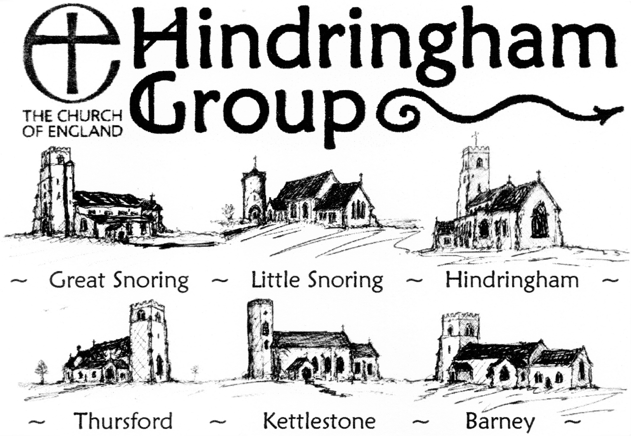

Church Services by Month per Page.

Services taken by Deanery Locum Priest
Revd Robin Stapleford
rev.hindringham@btinternet.com
01328 853 226

Visiting clergy or lay led, where noted:
NV Revd Nicholas Varnon; DH Revd David Head; ST Revd Canon Sally Theakston;
DS Revd Fr Daniel Sandham; Bishop of Lynn, Rt Revd Jane Steen;
*other, to be arranged. (TBA = to be arranged.)

~ SEPTEMBER 2022 ~
Sunday  4th Sept.  Trinity 12 | 10.30 am | Thursford | Benefice Communion (DH)
Sunday  11th Sept.  Trinity 13 | 8.30 am | Barney | Communion
 | 9.45 am | Great Snoring | Communion
 | 11.15 am | Kettlestone | Communion
Thursday 15th | 6 pm | Thursford | Harvest Festival & Supper
Sunday  18th Sept.  Trinity 14 | 10.30 am | Hindringham | Benefice Communion (NV)
Tuesday 20th | 11.30 am | Great Snoring | Communion and  Pilgrim Dance Group
Saturday 24th Sept. | 6 pm | Great Snoring | Harvest Festival (DH)
Sunday  25th Sept. Trinity 15 | 10.30 am | Little Snoring | Benefice Communion  with the Bishop of Lynn,  Rt Revd Jane Steen
 | 6.30 pm | Hindringham | Choral Evensong*
All Fridays | 8 am | Barney | Short Morning Prayer

~ OCTOBER 2022 ~
Sunday  2nd October  Trinity 16 | 10.30 am | Barney | Benefice Communion (ST)
Sunday  9th October  Trinity 17 | 8.30 am | Barney | Communion
 | 9.45 am | Great Snoring | Communion
 | 11.15 am | Kettlestone | Harvest Songs of Praise
Sunday  16th October  Trinity 18 | 10.30 am | Hindringham | Benefice Communion (ST)
Tuesday 18th | 10 am | Great Snoring | Communion
Sunday  23rd October Trinity 19 | 8.30 am | Thursford | Communion
 | 9.45 am | Hindringham | Communion
 | 11.15 am | Little Snoring | Communion
~ GMT – clocks ‘Fall’ backwards. ~
Sunday  30th October  All Saints | 10.30 am | Kettlestone | Benefice Communion
 | 6.30 pm | Hindringham | Choral Evensong
All Fridays | 8 am | Barney | Short Morning Prayer

~ NOVEMBER 2022 ~
Sunday  6th Nov.  Before Advent | 10.30 am | Great Snoring | Benefice Communion (ST)
Friday 11th | 10.55 am | Great Snoring | Act of Remembrance
Sunday  13th Nov.  Remembrance  Sunday | 9 am | Barney | Benefice Communion
 | 10.15 am | Hindringham | Remembrance Service*
 | 10.55 am | Kettlestone | Remembrance Service
 | 12.30 pm | Little Snoring | Act of Remembrance
Tuesday 15th | 10 am | Great Snoring | Communion
Sunday  20th Nov.  Christ the King | 10.30 am | Hindringham | Benefice Communion (DS)
Sunday  27th Nov.  Advent  Sunday | 8.30 am | Thursford | Communion
 | 9.45 am | Hindringham | Communion
 | 11.15 am | Little Snoring | Communion
All Fridays | 8 am | Barney | Informal Morning Prayer

~ DECEMBER 2022 ~
Sunday  4th Dec.  Advent 2 | 10.30 am | Thursford | Benefice Communion (ST)
 | 6.30 pm | Hindringham | Choral Evensong
Sunday  11th Dec.  Advent 3 | 8.30 am | Barney | Communion
 | 9.45 am | Great Snoring | Communion
 | 11.15 am | Kettlestone | Prayer Book Communion
Sunday  18th Dec.  Advent 4 | 10.30 am | Little Snoring | Benefice Communion (ST)
 | 6.30 pm | Hindringham | Carol Service
Tuesday 20th | 10 am | Great Snoring | Communion
Thurs. 22nd | - pm | Thursford | Carol Service
Friday 23rd | 3 pm | Little Snoring | Carol Service
 | 7 pm | Kettlestone | Carol Service
Christmas Eve  Saturday 24th | 6 pm | Barney | TBA
Christmas Day  Sunday 25th | 9.30 am | Great Snoring | Carol Service
 | 11 am | Hindringham | Benefice Communion
Sunday  1st January 2023 | 11 am | TBA | Benefice Communion
All Fridays | 8 am | Barney | Informal Morning Prayer

~ Proto Month 2022 ~
Sunday  First  Season | 10.30 am | alternating | Benefice Communion  (XX)
 | 6.30 pm | Hindringham | Choral Evensong
Sunday  Second  Season | 8.30 am | Barney | Communion
 | 9.45 am | Great Snoring | Communion
 | 11.15 am | Kettlestone | Communion CW / BCP
Sunday  Third  Season | 10.30 am | alternating | Benefice Communion (XX)
Tuesday Third | 10 am | Great Snoring | Communion
Sunday  Fourth  Season | 8.30 am | Thursford | Communion
 | 9.45 am | Hindringham | Communion
 | 11.15 am | Little Snoring | Communion
Sunday  Fifth  Season | 10.30 am | alternating | Benefice Communion
Fridays | 8 am | Barney | Informal Morning Prayer

