St Paul’s Church Thornton Heath

Preparing to go to Church during the COVID Pandemic 2020

We are looking forward to welcoming you back to the Church Building during July and August!

What do you need to know before you go to Church?

- Wearing a face covering is strongly advised, wearing of gloves is not recommended.
- The toilets will only be available for emergencies.
- There will be no refreshments available – so bring some water (in a reusable bottle) if you think you will need a drink.
- Numbers allowed to attend will be limited. You may need to book in advance.
- A record of those attending will be kept for Track and Trace purposes. Each register will be destroyed after 21 days.
- No Bibles will be available, so please bring your own.

What will church be like?
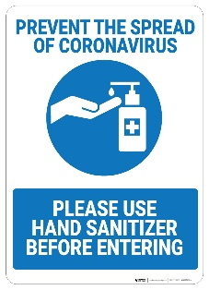
- Church is going to be very different!
- You will have to sanitise your hands when you arrive. Someone will welcome you and dispense some sanitiser into your hands (unless you bring your own sanitiser).
- There should be no hand shaking or hugging.
- There will be a ‘one way’ system in place in the entrance corridor.
- You should stay 2 meters apart at all times.
- You will only be able to sit next to people you live with. Some chairs will be grouped in twos and threes and you may be directed where to sit. All other chairs will be 2 meters apart.
- Children should stay with, and be supervised by, their parent/guardian at all times.
- You will be asked to put your Offerings in a basket on a table on the way in. There will be no offering bags or baskets passed round during the service.
- The words for the service will be projected on the screen.
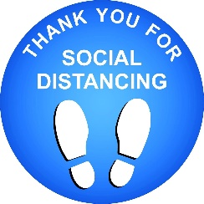
- The service will be live streamed for those who cannot attend. If you wish to not be visible on camera you may need to sit in a designated area.
- There will be no singing, but we will listen to music during the service.
- Spoken Responses during the service should be made quietly
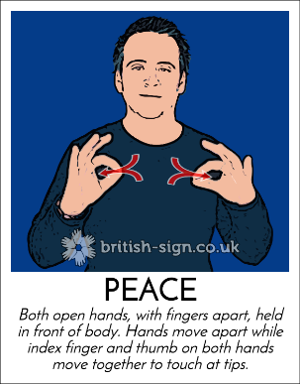
- The peace will be done by sign language only and there will be no moving around to greet everyone.
- Communion will be ‘in one kind’ only. In other words, you will only receive bread. The Priest will sanitise her/his hands several times during the communion prayers. Communion will be brought to you.
- Before you receive communion you should remove your face covering (if wearing one) and then sanitise your hands. Someone will be available to dispense hand sanitiser. The Priest will be wearing a facemask during the distribution of communion.
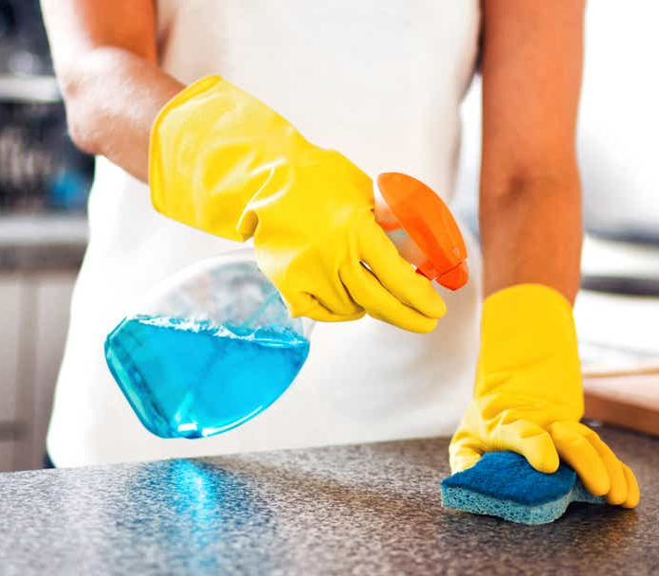
- After the service there will be no refreshments and you will be encouraged not to remain in the building too long.
- Those who are able will be asked to wipe down their chair with a sanitiser cloth, which should then be placed in the bin.
- Volunteers will be needed to wipe down chairs, door handles and other ‘multi-touch points’ before we leave the building.

This might seem like a lot to take in at the moment, but I am sure we will adapt quite quickly and will soon be used to this new way of doing things.

God bless you!

Revd Derrick
3rd July 2020
Updated:
28th July 2020

