St Michael and All Angels Junior Church, Brook Road, Borehamwood, WD6 5EQ
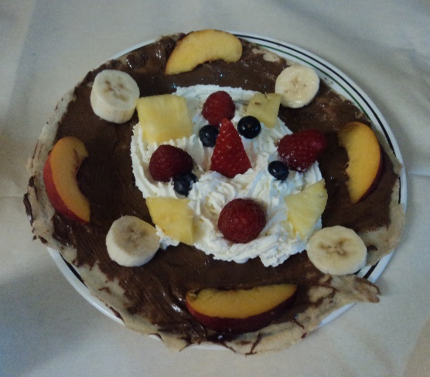
PANCAKES PLUS!
Family Pancake Party
- Pancake Races
- Pancake Tossing
- Pancake Puppets
- Pancake Prayers
- Pancake Decorating
- Pancake Teatime!

Sunday, March 3rd
from 3.00pm to 4.30pm
St Michael and All Angels in the Church Hall
Suggested donation £2.00 per family to cover costs
Pancakes may contain allergens
Please notify us of any dietary requirements (e.g. gluten-free pancakes)
To book your place, please contact Vicar - Revd Louise Collins 020 8953 2362 / louise.collins59 @hotmail.com

