Welcome to Fun Family Church at home for September 2020.
We hope you have had a lovely summer with lots of fun in the sunshine. You will probably be getting excited about going back to school and seeing all your friends.
This month’s FFC is all about Jesus and children and it is best to start by reading the story and then there are four interesting activities to have a go at; finishing with a prayer.
Hope you enjoy it; and don’t forget to send us some photos of your finished crafts.

Jesus and the Children
“I can’t see!” call a blind woman. “Can you help me, Jesus?
“I can’t walk!” called a lame man. “Heal me, Jesus, please!”
“He can’t hear!” called a deaf man’s friend. “Touch him, Jesus and make him well.”
They were everywhere – people with every kind of sickness. And Jesus felt sorry for them all. So he did what he could to help the crowd that day. “I can’t see,” said the little girl to her mother. “There are too many people in the way.”
“I can’t move,” said her little brother. “We’re all squashed together.”
“What did you say?” asked their father. I can’t hear. This crowd is so noisy!”
“Excuse me,” said their mother to one of Jesus’ friends. “We were wondering if Jesus could pray for our children.”
“Are they sick?” asked the friend.
“No,” the mother answered. “We just wanted Jesus to ask God to watch over them and protect them.”
“I see,” said the friend impatiently. “Well, as you must have noticed, Jesus is a very busy man. He has important things to do. Lots of sick people to make well.”
“That’s right!” added another of Jesus’ friends. “There are grown-ups here who need his help. He can’t be bothered with children.”
“Particularly children who aren’t even sick!” chimed in a third friend.
“It’s just a waste of his time.”
The mother and the father and the children looked at each other. Then they looked at the ground and turned to leave. They were sad and embarrassed.
“Does this mean we won’t see Jesus?” asked the little girl, rubbing the tears from her eyes.
But before her mother could answer, another voice called out across the crowd. “Wait!” It was the voice of Jesus!
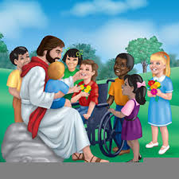
“Bring your children here,” called Jesus. “There’s nothing to be ashamed of.” And he gave his friends an unhappy look.
Jesus picked up the little boy and the little girl and put them on his lap. He gave them each a hug and then he said, “Listen I want everybody to listen. Particularly my friends. You must never keep the children away from me. They are as important to me as anyone Else. And I want to be their friend too.
“Don’t you see? God wants us all to be like these children. To love him like a father. To trust him completely. And to long to be with him.”
Then Jesus prayed for the children, hugged them one more time and sent them beaming back to their parents.
September 2020 Fun Family Church Activities
1. Watch over and protect
Make a picture of someone you would like Jesus to watch over and protect.
You could draw, paint or stick things on (such as material, sticks, leaves, petals, foil whatever you can find) like a collage. Make sure you include some children in your picture.

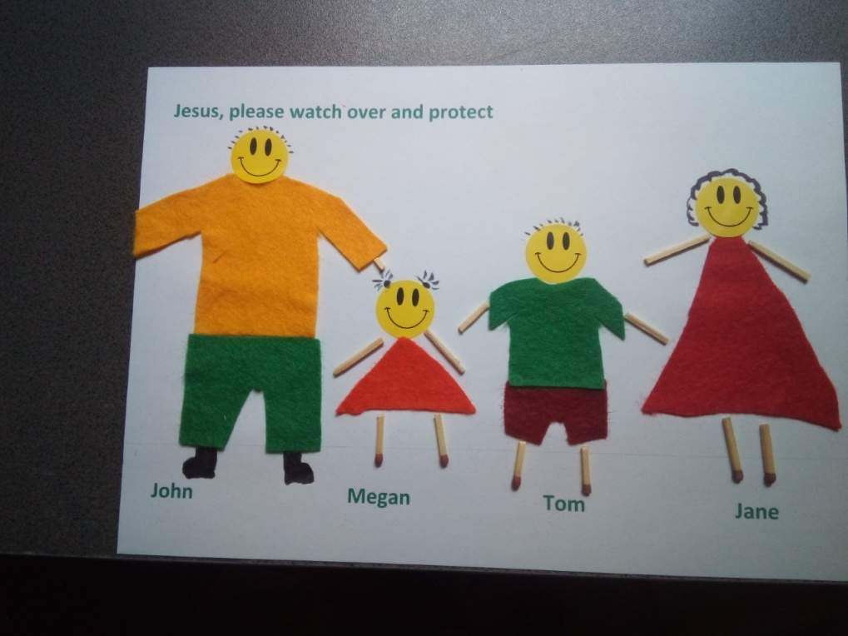
2. Jesus hug
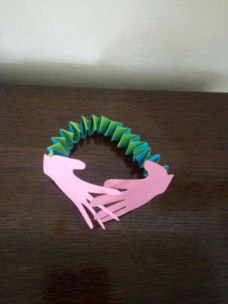
Imagine you are Jesus and you want to give all the children a big hug – you will need really long arms!
To make some ‘Jesus arms’ you will need some sheets of coloured card or paper.
First draw round your hands or ask someone to help you draw round your hands and then cut them out.
Next using different coloured paper if you have it (doesn’t really matter if you haven’t) and cut strips of equal width approx 2.5cms. It will depend on how many people you want to hug as to how many strips you cut. I used 6 X A4 lengths.
Now join 3 or more strips together with either glue or sticky tape to make e much longer strips of equal length.
Place them at right angle to each other. Stick them in position. Then, folding one strip one way and then the other concertina them until all the paper has been folded. You may need an adult to help you get started on the folding.
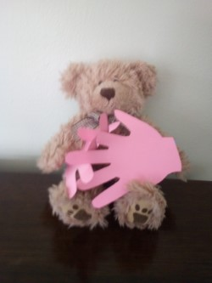
When all the paper has been folded and the ends stuck together so that it all doesn’t unfold again, stick a card hand on each end and find your favourite toys to hug with them

Hope you like my teddy!

3. Children included
Is there something that a grown up does at your house that you would really like to have a go at? Perhaps it’s feeding the cat/dog, or planning what everyone is going to have for dinner and then getting it ready or trimming a bush in the garden. Think of something that you would like to do and ask if you could have a go at it, just once, – you never know if you really enjoy it, you may be able to do it on a regular basis?
4. Buns that make you smile!!!
We know how much you all like buns, so for our foodie craft this month we thought you would enjoy making buns; which when you eat them and think about Jesus you just can’t help but smile.
You can either make or buy some plain buns and then it’s over to you to be as creative as you can with the things in the house, to decorate them with smiley faces. It could be icing or chocolate like our photo or you could use sultanas, strawberries or maybe even sweets.
Who can make the most people smile?

Prayer- after all that smiling it’s time to be still and thank God for all the things he gives us that make us smile. You may like to light a candle, carefully, before you pray – as we would do in church.

Heavenly Father, we thank you for caring for us and protecting us.
We know that everyone is important to you, whether they are a child or grown up.
Help us to love and trust you completely, knowing you will never let us down.
Don’t let us forget that you are with us all the time, like a best friend.
You are special to us, as we are to you.
We thank you for the beautiful world in which we live and all the things we have to smile about.
Lord we long to be near you.
Amen

