COMMUNITY DROP IN

Friday 10th June, 1st July and 5th August
10am – 12 noon
The Memorial Hall

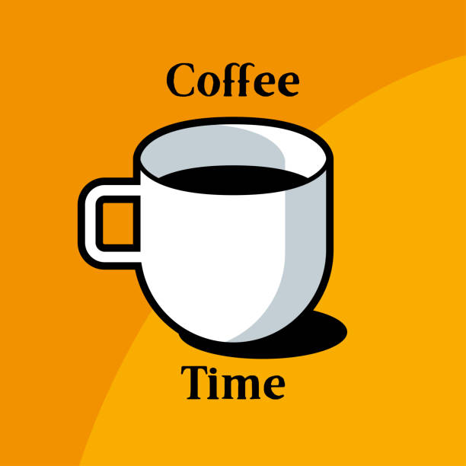

Come and enjoy a cuppa with friends.
All welcome – regardless of age.

