ST PETER AND ST PAUL CHURCH
BISHOPS HULL

Monday, Tuesday, Wednesday
15th - 17th April at 7.30pm

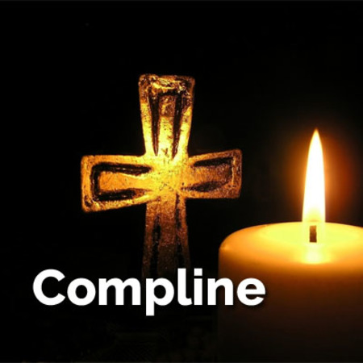

Holy Week

