A Service of Compline
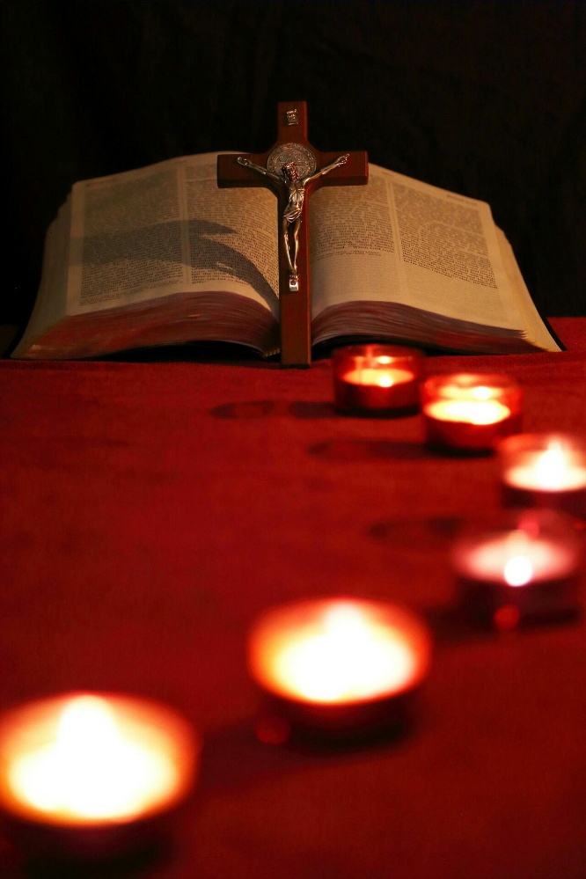
(Night Prayer)

Welcome to this Compline Service. This has been put together to enable us to expand the prayers of the church during times when we are not able to physically be in church. Compline, also called Night Prayer is usually read at around 9pm, as we’re winding down from our day. It is nice to remember that wherever you are, someone else from St. Mary’s is praying along with you. Compline is a quiet service, read as the day draws to a close and reminding us that God has been with us throughout our day, and will remain with us while we sleep,

Some suggestions before we begin:
- If you can, light a candle to place in your window. We are shining the light of Jesus from our homes, out into the community and the world.
- Find a quiet spot and try to limit potential distractions.
- Make sure you are comfortable, but not so much that you’re likely to doze off!
- Some people find they can pray easier with something to help them focus, such as a cross or image of the Lord, either held in the hand or within sight.
- If more than one person is praying together, you might like to alternate the verses of the Psalm.

We begin with the Preparation:
The Lord Almighty grant us a quiet night and a perfect end.
Amen.
Our help is in the name of the Lord
Who made heaven and earth.
Prayers of Penitence
You may wish to take a moment of silence to consider your day before the prayers of penitence.
Search me, O God, and know my heart.
Test me and know my thoughts.
See if there is any wicked way in me,
and lead me in the way everlasting.
Most merciful God,
we confess to you,
before the whole company of
heaven and one another,
that we have sinned in thought,
word and deed
and in what we have failed to do.
Forgive us our sins,
Heal us by your Spirit
And raise us to new life in Christ.
Amen.
O God, make speed to save us.
O Lord, make haste to help us.

This or another hymn may be sung.
Before the ending of the day,
Creator of the world, we pray
That you, with steadfast love, would keep
Your watch around us while we sleep.
From evil dreams defend our sight,
From fears and terrors of the night;
Tread underfoot our deadly foe
That we no sinful thought may know.
O Father, that we ask be done
Through Jesus Christ, your only Son;
And Holy Spirit, by whose breath
Our souls are raised to life from death.
The Psalm – Psalm 91
You who live in the shelter of the Most High,
who abide in the shadow of the Almighty,
will say to the Lord, “My refuge and my fortress;
my God, in whom I trust.”
For he will deliver you from the snare of the fowler
and from the deadly pestilence;
he will cover you with his pinions,
and under his wings you will find refuge;
his faithfulness is a shield and buckler.
You will not fear the terror of the night,
or the arrow that flies by day,
or the pestilence that stalks in darkness,
or the destruction that wastes at noonday.
A thousand may fall at your side,
ten thousand at your right hand,
but it will not come near you.
You will only look with your eyes
and see the punishment of the wicked.
Because you have made the Lord your refuge,[b]
the Most High your dwelling place,
no evil shall befall you,
no scourge come near your tent.
For he will command his angels concerning you
to guard you in all your ways.
On their hands they will bear you up,
so that you will not dash your foot against a stone.
You will tread on the lion and the adder,
the young lion and the serpent you will trample under foot.
Those who love me, I will deliver;
I will protect those who know my name.
When they call to me, I will answer them;
I will be with them in trouble,
I will rescue them and honour them.
With long life I will satisfy them,
and show them my salvation.

Glory to the Father and to the Son
and to the Holy Spirit;
as it was in the beginning is now
and shall be forever. Amen.
Gospel Canticle – Luke 2:29-32
Christ died for us,
So that, whether we wake or sleep,
We might live with him.
Now, Lord, you let your servant go in peace:
your word has been fulfilled.
My own eyes have seen the salvation
which you have prepared in the sight of every people;
A light to reveal you to the nations
And the Glory of your people Israel.
Glory to the Father and to the Son
and to the Holy Spirit;
as it was in the beginning is now
and shall be forever. Amen.
Christ died for us,
so that, whether we wake or sleep,
we might live with him.

The Prayers
We give our cares and concerns to God at this time.
You might like to pray for:
- Those in need of healing or solace.
- People who have died or who are in mourning.
- Politicians and decision makers around the world.
- The church, locally or globally.
- Any person, place or situation that is on your heart.
A time of silence may follow the prayers.
The Collect
Keep watch, dear Lord,
with those who wait, or watch, or weep this night,
and give your angels charge over those who sleep.
Tend the sick, Lord Christ;
give rest to the weary,
bless the dying,
soothe the suffering,
pity the afflicted,
shield the joyous;
and all for your love's sake.
Amen.

The Conclusion
In peace we will lie down and sleep,
For you alone, Lord, make us dwell in safety.
May the peace of the Spirit be ours this night.
May the peace of the Son be ours this night.
May the peace of the Father be ours this night.
May the peace of all peace be ours this night.
May God bless us,
that in us may be found love and humility,
obedience and thanksgiving,
Discipline, gentleness and peace.
In the name of the Father,
and of the Son,
and of the Holy Spirit.
Amen.

