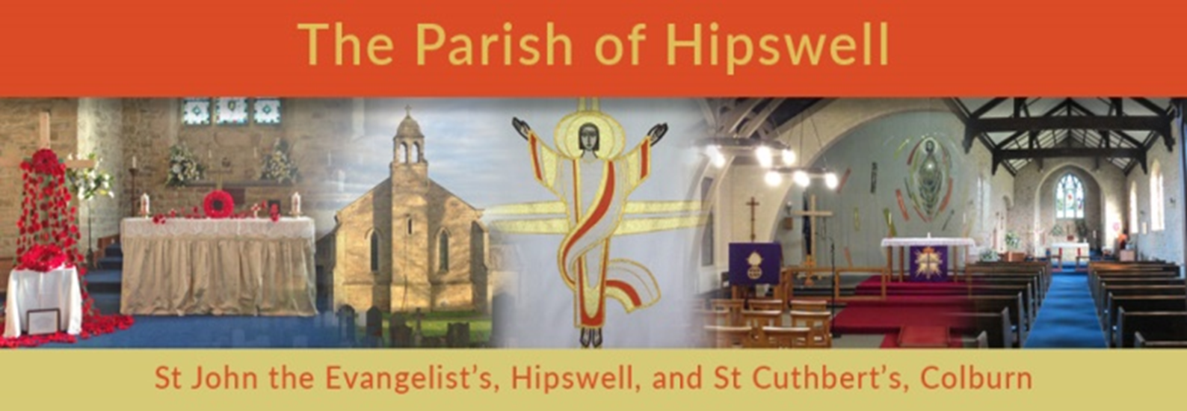
St John the Evangelist, Hipswell
Sunday Services restart 9.30am July 5th!
We look forward to welcoming you back!
Please arrive early, so we can advise you about Covid-19 safety and to take names and contact details for ‘Track & Trace’..

St Cuthbert’s Church, Colburn
For now, the church community continues to meet continue online by Zoom for our shared 11am Sunday services – for details: click the link on front page of website for ‘A Church Near You’.. We will be reviewing this, and hope, if it is safe, to be able to open St Cuthbert’s later this summer.

