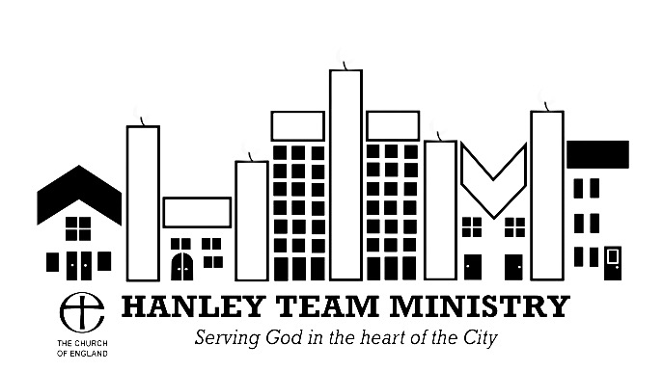
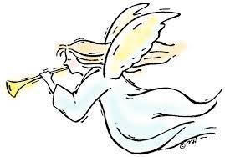
HANLEY TEAM MINISTRY &
ST. PAUL’S CHURCH, BURSLEM
CHRISTMAS SERVICES & EVENTS 2022

Christmas Lights Turn On St. Luke’s Monday 5 Dec. 6.00

Carol Service Holy Trinity Sunday. 11 Dec. 4.00

Contemplative Prayer Holy Trinity Monday, 12 Dec 7.15

Mon. 12th December Carol Singing at Royal Stoke 6.00 – 8.00
(meeting point Atrium, Main Building but do not go if you have Covid or ‘flu-like symptoms)

Coffee Morning St Matthew’s Saturday, 17 Dec 10.00

Christmas Celebration St. Mark’s Saturday. 17 Dec. 4.00

Carol Service St. Paul’s, Sunday. 18 Dec. 11.00
Burslem

Messy Play St. Luke’s Monday, 19 Dec. 1.00
And Christingle

Messy Church / Nativity St. Matthew’s Thursday. 22 Dec. 3.30
(Blessing of the Crib)

Holy Communion St. Matthew’s Saturday. 24 Dec. 8.30
for Christmas Eve

Christmas Day Christ Church Sunday. 25 Dec. 10.00
Eucharist

New Year’s Day Holy Trinity Sun. 1st Jan 2023 10.00
Team Eucharist
