Great is the mystery of faith: Christ has died:
Christ is risen: Christ will come again.

Accept though him, our great high priest, this our sacrifice of thanks and praise, and as we eat and drink these holy gifts in the presence of your divine majesty, renew us by your Spirit, inspire us with or love and unite us in the body of your Son, Jesus Christ our Lord.
To you be glory and praise for ever.

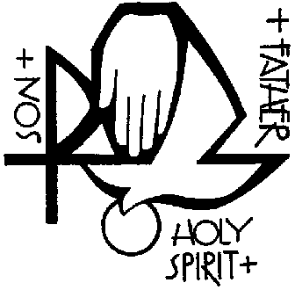
Through him and with him and in him, in the unity of the Holy Spirit, with al who stand before you in earth and heaven, we worship you Father almighty, in songs of everlasting praise:

Blessing and honour and glory and power be yours
forever and ever. Amen.

THE LORD’S PRAYER
We break the bread of life and that life is the light of the world.
God here among us, light in the midst of us,
bring us to light and life.

PRAYER AFTER COMMUNION

NOTICES

HYMN

BLESSING
Go in peace. Proclaim the Word made flesh.
Glory, thanks and praise to God. Amen.

©Times and Seasons, Archbishops’ Council 2006

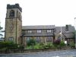
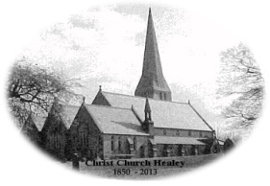
Healey, Hamer and Belfield
Communion in Christmas Season

WELCOME AND INTRODUCTION
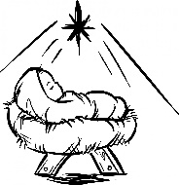
I bring you good news of great joy,
a Saviour has been born to you. Alleluia!
Unto us a child is born, unto us a Son is given. Alleluia!

HYMN

CONFESSION and ABSOLUTION
Most merciful God, Father of our Lord Jesus Christ,
we confess that we have sinned
in thought, word and deed.
We have not loved you with our whole heart.
We have not loved our neighbours as ourselves.
In your mercy forgive what we have been,
help us to amend what we are,
and direct what we shall be;
that we may do justly, love mercy,
and walk humbly with you, our God. Amen.
GLORIA

COLLECT

READINGS
This is the word of the Lord.
Thanks be to God.

HYMN

GOSPEL
Alleluia, alleluia. The word became flesh and dwelt among us,
and we have seen his glory. Alleluia.

SERMON

CREED
I believe in God, the Father almighty,
creator of heaven and earth.

I believe in Jesus Christ, his only Son, our Lord,
who was conceived by the Holy Spirit, born of the Virgin Mary,
suffered under Pontius Pilate, was crucified, died, and was buried;
he descended to the dead.
On the third day he rose again; he ascended into heaven,
he is seated at the right hand of the Father,
and he will come to judge the living and the dead.

I believe in the Holy Spirit, the holy catholic Church,
the communion of saints, the forgiveness of sins,
the resurrection of the body, and the life everlasting. Amen.
PRAYERS of INTERCESSION
Jesus, Saviour. Hear our prayer.

THE PEACE
Unto us a child is born, unto us a Son is given,
and his name shall be called Prince of Peace.
The peace of the Lord be always with you
And also with you.

THE EUCHARISTIC PRAYER
The Lord is here. His Spirit is with us.
Lift up your hearts. We lift them to the Lord.
Let us give thanks to the Lord our God.
It is right to give thanks and praise.

And now we give you thanks because in coming to dwell among us as a man, he revealed the radiance of your glory and brought us out of darkness into your own marvellous light. Therefore with angels and archangels and with all the company of heaven, we proclaim your great and glorious name, forever praising you and saying:

Holy, holy, holy Lord, God of power and might,
heaven and earth are full of your glory.

Accept our praises, heavenly Father, through your Son our Saviour Jesus Christ and as we follow his example and obey his commend, grant that by the power of your Holy Spirit, these gifts of bread and wine may be to us his body and his blood; who, in the same night he was betrayed, took bread and gave you thanks.
He broke it and gave it to his disciples, saying,
“Take, eat; this is my body which is given for you.
Do this in remembrance of me.”
To you be glory and praise for ever.

In the same way after supper, he took the cup of wine and gave you thanks. He gave it to them saying, “Drink this all of you; this is my blood of the new covenant which is shed for you and for many for the forgiveness of sins. Do this as often as you drink it, in remembrance of me.
To you be glory and praise for ever.

Therefore, heavenly Father, we remember his offering of himself made once for all upon the cross; we proclaim his mighty resurrection and glorious ascension; we look for the coming of your kingdom, and with this bread and this cup we make the memorial of Christ your Son our Lord.

