The Parish of S. Philip & S. James
Up Hatherley

CHRISTMAS SERVICES

DECEMBER 2021
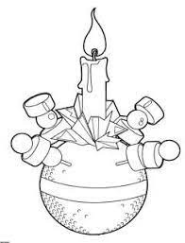

Tues 7th 6pm Christingle Service.

Wed 8th 6.30pm Christingle Service.
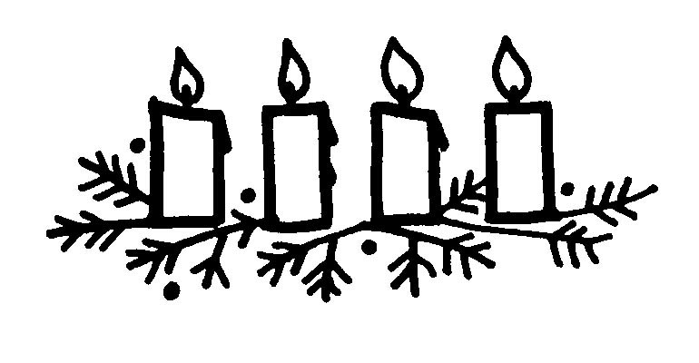

Fri 24th 6pm Carols by Candlelight.

11.30pm Midnight Mass.

Sat 25th 10.00am Mass of the Nativity.

Sun 26th 10.00am Sunday Mass – Holy Family.

