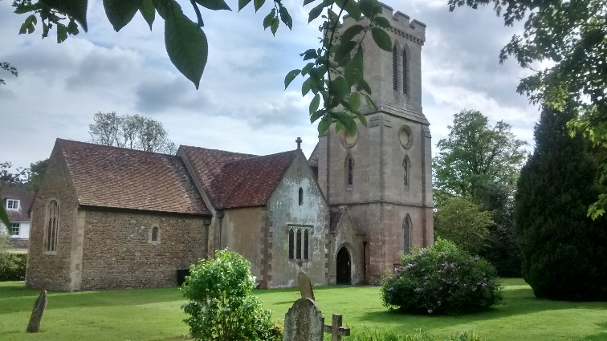 St. Peter’s Church, Milton Bryan

Breakfast and the Bible
2nd Sundays at 10:30am

10:30 am: Welcome and Short Opening Prayer

Time for tea, coffee, toast, cereals, pastries and a catch up *A collection plate is available for an offering in response

11:00 am: Bible Reading for the Day

More time for catching up

11:30 am: Short Closing prayer and Blessing

Prayer ministry and support is available after 11:30am
__________________________________________________________________
Breakfast and the Bible Dates
2020 | 2021 | 2021 continued
Sunday 14th June 10:30am | Sunday 10th January 10:30 am | Sunday 8th August 10:30am
Sunday 12th July 10:30am | Sunday 14th February 10:30am | Sunday 12th September 10:30am
Sunday 9th August 10:30am | Sunday 14th March 10:30am | Sunday 10th October 10:30am
Sunday 13th September 10:30am | Sunday 11th April 10:30am | Not on in November
Sunday 11th October 10:30am | Sunday 9th May 10:30am | Not on in December
Not on in November | Sunday 13th June 10:30am
Not on in December | Sunday 11th July 10:30am

Milton Bryan Village Hall will be booked for 2nd Sunday's at 10:30am for the winter months of October, January, February and March enabling Breakfast and the Bible to continue in comfort in the event of adverse weather conditions. There will be a break in November and December to accommodate Remembrance Sunday and Christmas arrangements.

