Zoom All Age Service of Holy Communion
Sunday Trinity 4, 5th July 2020
Welcome to this second Sunday of Ordinary (ordered) time as we continue to celebrate together although physically apart and prepare to have our our church buildings open for private prayer.

Bells recording, then Introduction and Hymn ‘When a knight won his spurs’

Call to worship – candles may be lit
As we seek to worship today We come before you Lord.
In your light we see light We will live your way
As we seek to serve you Help us to know your presence with us

We say 'sorry Lord' in our Confession tune 'Cockles and Mussels' with actions

For the things that we've thought, that we wish we'd not thought ...
(response) We're sorry, we're sorry, need a new start

For the things that we've said, that we wish we'd not said.... (response)

For the things that we've done, that we wish we'd not done.... (response)

Absolution

God gives us a new start every time we come to him and are truly sorry. Hear the promise;

God sets you free from your past wrong-doing, receive a new start this day. Amen.

We sing Glory to God - the Peruvian Gloria –

Glory to God, Glory to God Glory to the Father, (….Son of the Father)(…. Glory to the Spirit)(echo)
To him be glory forever (echo), Alleluia Amen (echo) Alleluia Amen (echo)

The Collect for this day – let us pray
Gracious Father, by the obedience of Jesus you brought salvation to our wayward world: draw us into harmony with your will, that we may find all things restored in him, our Saviour Jesus Christ. Amen.

We sing before the Bible readings
Jesus open up my; - eyes/-lips/-heart - Alleluia, Jesus help me hear your voice Alleluia,

Bible Readings Zechariah 9.9-12, Psalm 145 v 8-15, (Romans 7.15-25a)

Gospel Matthew11.16-19, 25-30

'Hear the Gospel of our Lord Jesus Christ according to Matthew Glory to you O Lord,

At the end 'This is the Gospel of the Lord' Praise to you O Christ

Sermon/Presentation/Address ‘Because I’m worth it’

This is our faith Lord!
We believe in God the Father, from whom every family in heaven and on earth is named.
We believe in God the Son, who lives in our hearts through faith, and fills us with his love.
We believe in God the Holy Spirit, who strengthens us with power from on high.
We believe in one God; Father, Son and Holy Spirit. Amen.

Prayers of intercession

during which the bidding may be used: we bring our prayers to you, Lord hear us

And set us free
At the end Merciful Father
Accept these prayers for the sake of your son, our Saviour Jesus Christ. Amen'
The peace of Christ
Peace on earth. Peace within us. Peace in each place. Peace within us.
Peace to each of us who worship this day. Peace within us. Amen.
The peace of the Lord be always with you And also with you

Hymn ‘Trust and Obey’
The Great Communion Prayer of Thanksgiving

The Lord be with you And also with you
Lift up your hearts. We lift them to the Lord.
Let us give thanks to the Lord our God. It is right to give him thanks and praise.

It is always right, wherever we are, to give you thanks and praise, God our Father, holy and strong, king forever. Through your Son, you made us and the whole universe. And so we join on earth with saints and angels in heaven to praise your name and sing:

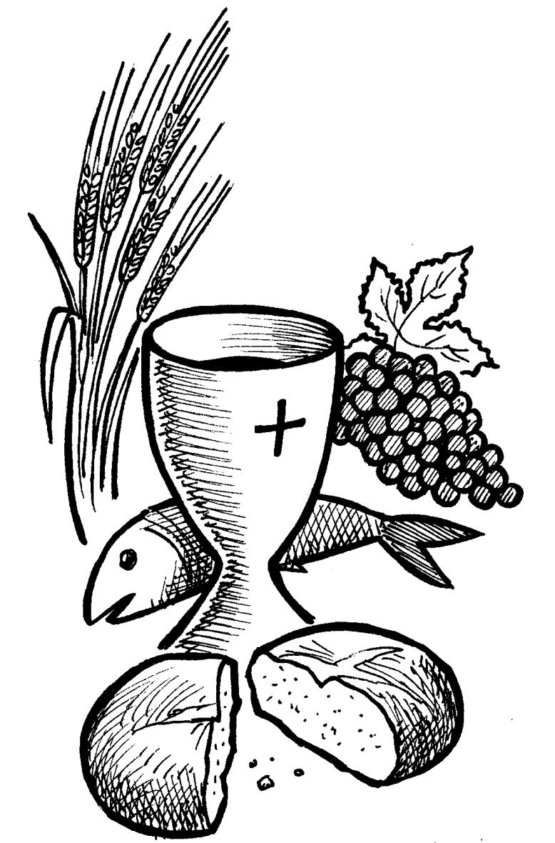
Holy, holy, holy is the Lord, Holy is the Lord God almighty. (repeat)
Who was and is and is to come, Holy, holy, holy is the Lord

On the night before he died, Jesus had a meal with his friends. He took the bread, and thanked you. He broke it, gave it to them and said: Take this and eat it; this is my body, given for you. After the meal, Jesus took the cup of wine. He thanked you, gave it to them and said: Drink this, all of you. This is my blood, the new covenant of God’s love. Do this to remember me.

Jesus Christ has died. Jesus Christ has died.
Jesus Christ is risen. Jesus Christ is risen.
Jesus Christ will come again Jesus Christ will come again.

Father, as we remember his death and resurrection, send your Holy Spirit, that the bread and wine we bring before you may be for us Christ’s body and his blood. Pour your Spirit on us that we may live as children of your heavenly kingdom. Help us to love one another, as we work for the peace of the earth, and wait for Jesus to come in glory. For all honour and glory belong to you, Father, through Jesus Christ your Son, with the Holy Spirit: one God, for ever and ever. Amen.

The Lord’s Prayer 'Our father who art in heaven...

Bread is Broken in the view of all.
All may say Blessed, praised and adored be Jesus in the most Holy Sacrament.
Though we are many, we are one body, because we all share in the one bread
(All take part in the Communion, physically or spiritually, receiving God's gift of himself in Jesus Christ who gave us this sacrament to feed our souls) – music ‘Anthem ‘Lord for they tender mercy’s sake

Prayer after Communion The prayer for the day follows,
Eternal God, comfort of the afflicted and healer of the broken, you have fed us at the table of life and hope: teach us the ways of gentleness and peace, that all the world may acknowledge
the kingdom of your Son Jesus Christ our Lord. Amen.
Give us the courage to witness and to serve in the name of Jesus Christ, your risen Son, that he may be adored in all the earth, to the praise of your holy name. Amen.

Hymn ‘He who would valiant be’

Blessing
God the Trinity make you strong in faith, hope and love, defend you on every side and make you strong in faith, hope and love: and the blessing.....

Dismissal
God who said 'Let light shine out of darkness' has caused his light to shine within us
To give the light of the knowledge of the glory of God revealed in the face of Jesus Christ
we have this treasure in earthen vessels to show that the power belongs to God.
We go out to live life as children of God's Kingdom Thanks be to God

Play out - All things bright and beautiful

