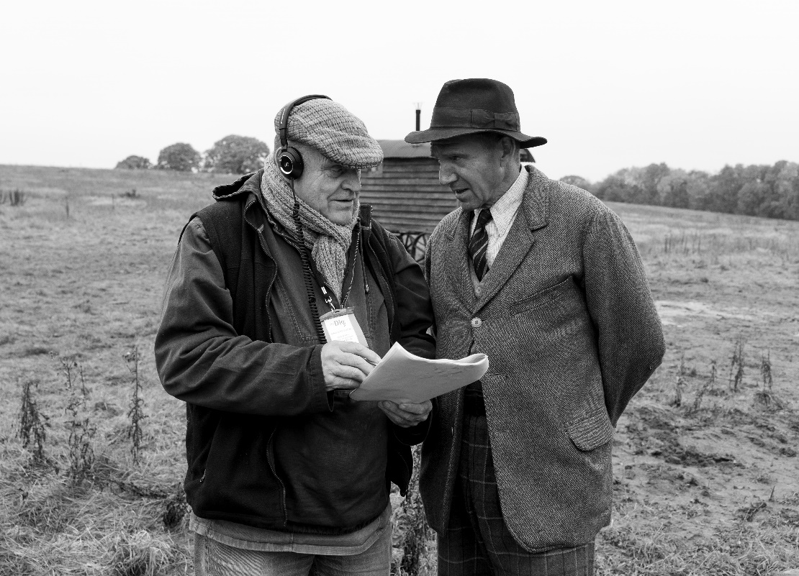

Saturday 10th September
All Saints' Church, Bury St Edmunds
Afternoon tea and speaker
Doors open: 3:00pm for a 3:30pm start
​
The brilliant speaker Charlie Haylock and his talk
'Charlie and The Dig'.
Tickets £8.00
All Welcome.
​
Charlie and "The Dig"
This is an intriguing and sometimes hilarious look behind-the-scenes in the making of the Netflix film "The Dig" . . . a film based on a novel with the same title about the famous Sutton Hoo burial ship and the people involved.
Charlie will explain how a potential "scam" email from "The Dig" producer, turned out to be real, and was followed by a phone call from Ralph Fiennes.
Charlie will show how Ralph Fiennes, who played Basil Brown, and the other "Suffolk" actors learnt their Suffolk accent . . . and not sound like West Country pirates !
Charlie will also explain the extreme lengths Ralph Fiennes took, not only to play Basil Brown . . . but to become Basil Brown.
The talk is both informative and very entertaining

