The ART Benefice
Anslow, Rolleston and Tutbury

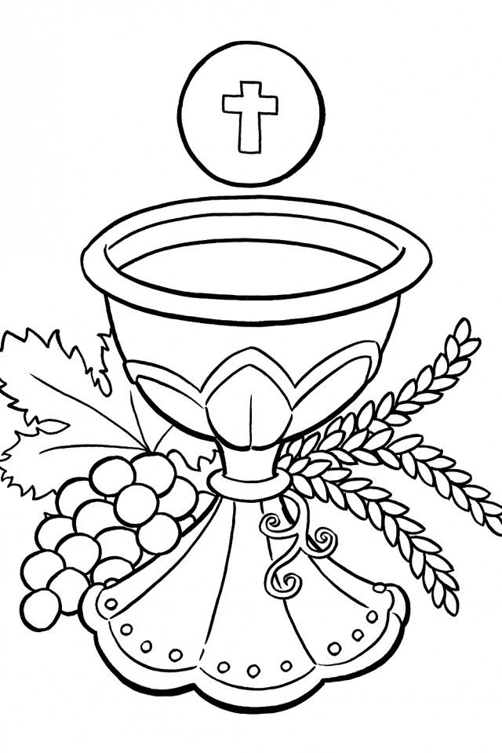

Holy Communuion in Trinity Season, August and September
with Eucharistic Prayer F
and the Prayer for Spiritual Communion, in Rolleston facebook and zoom.

Welcome
Grace, mercy and peace from God our Father
and the Lord Jesus Christ be with you,
And also with you.

Optional Opening Hymn

The Prayer of Preparation
We all say….:
Almighty God, to whom all hearts are open, all desires known,
and from whom no secrets are hidden:
cleanse the thoughts of our hearts by the inspiration of your Holy Spirit,
that we may perfectly love you,
and worthily magnify your holy name; through Christ our Lord. Amen.

Confession

Jesus says, 'Repent, for the kingdom of heaven is close at hand.’
So let us turn away from sin and turn to the Lord,
confessing our sins in penitence and faith.

The minister introduces the confession, then all say
Almighty God, our heavenly Father,
we have sinned against you and against our neighbour,
in thought and word and deed, through negligence,
through weakness, through our own deliberate fault.
We are truly sorry and repent of all our sins.
For the sake of your Son Jesus Christ, who died for us,
forgive us all that is past and grant that we may serve you
in newness of life to the glory of your name. Amen.

The minister assures the people of God’s forgiveness
using these or other suitable words

Almighty God, who forgives all who truly repent,

have mercy upon you/us, pardon and deliver you/us from all your sins,

confirm and strengthen you/us in all goodness,

and keep you/us in life eternal; through Jesus Christ our Lord. Amen.

A Song of Praise (The ‘Gloria)

We may say, or sing, this or an alternative song of praise.

Glory to God in the highest, and peace to his people on earth.
Lord God, heavenly King, almighty God and Father,
we worship you, we give you thanks,
we praise you for your glory.

Lord Jesus Christ, only Son of the Father, Lord God, Lamb of God,
you take away the sin of the world: have mercy on us;
you are seated at the right hand of the Father: receive our prayer.

For you alone are the Holy One, you alone are the Lord,
you alone are the Most High, Jesus Christ,
with the Holy Spirit, in the glory of God the Father. Amen.

Option 2. The Peruvian Gloria
Glory to God, Glory to God, Glory to the Father
Glory to God, Glory to God, Glory to the Father
Chorus To God be glory for ever. To God be glory for ever
Alleluia, Amen. Alleluia Amen, Alleluia Amen, Alleluia Amen!

Glory to God, Glory to God, Glory to Christ Jesus
Glory to God, Glory to God, Glory to Christ Jesus. Chorus

Glory to God, Glory to God, Glory to the Spirit,
Glory to God, Glory to God, Glory to the Spirit. Chorus
Option 3. The Woodlands Gloria

Glory to God, we give you thanks and praise;
of heavenly joy and earthly peace we sing.
We worship you, to you our hearts we raise,
Lord God, almighty Father, heavenly King.

Lord Jesus Christ, the Father’s only Son,
you bore for us the load of this world’s sin.
O Lamb of God, your glorious victory won,
receive our prayer, grant us your peace within.

Alone, O Christ, you are the only Lord,
at God’s right hand in majesty most high;
who with the Spirit worshipped and adored;
with all the heavenly host we glorify.

A few moments of silent prayer then The Collect Prayer is prayed.

We listen to God’s Word

At the end the reader may say
This is the word of the Lord. Thanks be to God.
Optional Hymn

Gospel Reading
When the Gospel is announced the reader may say
Hear the Gospel of our Lord Jesus Christ according to N.
Glory to you, O Lord.

At the end the reader may say
This is the Gospel of the Lord. Praise to you, O Christ.

A Sermon, reflection, conversation or a story

We respond to God

A Declaration of Faith (The Nicene Creed)

We believe in one God, the Father, the Almighty,
maker of heaven and earth, of all that is, seen and unseen.

We believe in one Lord, Jesus Christ, the only Son of God,
eternally begotten of the Father, God from God, Light from Light,
true God from true God, begotten, not made,
of one Being with the Father; through him all things were made.
For us and for our salvation he came down from heaven,
was incarnate by the Holy Spirit of the Virgin Mary and was made man.
For our sake he was crucified under Pontius Pilate;
he suffered death and was buried.
On the third day he rose again in accordance with the Scriptures;
he ascended into heaven and is seated at the right hand of the Father.
He will come again in glory to judge the living and the dead,
and his kingdom will have no end.

We believe in the Holy Spirit, the Lord,
the giver of life, who proceeds from the Father and the Son,
who with the Father and the Son is worshipped and glorified,
who has spoken through the prophets.
We believe in one holy catholic and apostolic Church.
We acknowledge one baptism for the forgiveness of sins.
We look for the resurrection of the dead,
and the life of the world to come. Amen.

or The Creed in the questions form

Do you believe and trust God the Father, source of all life?
I believe and trust in Him.
Do you believe and trust in God the Son, who redeemed the world?
I believe and trust in Him.
Do you believe and trust in God the Holy Spirit,
who gives life to the people of God and makes Christ known in the world?
I believe and trust in Him.
This is the faith of the Church. This is our faith.
We believe and trust in one God, Father, Son and Holy Spirit.

News, Notices and banns (at this point or later)

Prayers of Intercession
These responses may be used
Lord, in your mercy, Hear our prayer.
or Lord, hear us, Lord, graciously hear us.

And at the end, the leader may say
Merciful Father
accept these prayers for the sake of your Son,
our Saviour, Jesus Christ. Amen.

We stand for The Peace
The minister may introduce The Peace with a seasonal sentence eg
We are the body of Christ.
In the one Spirit we were all baptized into one body.
Let us then pursue all that makes for peace and builds up our common life.

The peace of the Lord be always with you and also with you.
Let us share with one another a sign of God’s peace.

Optional: Offertory hymn or music and Preparation of The Table

Our offering is an act of worship.
If you are new to church or a visitor, please do not feel obliged to give.

When the collection is brought forward, this or another prayer is prayed.
Yours, Lord, is the greatness, the power, the glory, the splendour
and the majesty; for everything in heaven and on earth is yours.
All things come from you, and of your own do we give you.

Eucharistic Prayer F
The Lord is here. His Spirit is with us.
Lift up your hearts. We lift them to the Lord.
Let us give thanks to the Lord our God.
It is right to give thanks and praise.

Please sit or kneel for the Communion Prayer.
Here follows an Extended Preface or the following.

You are worthy of our thanks and praise,
Lord God of truth, for by the breath of your mouth,
you have spoken your word and all things have come into being.
You fashioned us in your image and placed us in the garden of your delight. Though we chose the path of rebellion, you would not abandon your own.

Again and again, you drew us into your covenant of grace.
You gave your people the law and taught us by your prophets
to look for your reign of justice, mercy and peace.

As we watch for the signs of your kingdom on earth, we echo the song
of the angels in heaven, evermore praising you and saying:

Holy, holy, holy Lord, God of power and might,
heaven and earth are full of your glory.
Hosanna in the highest.

Lord God, you are the most Holy One, enthroned in splendour and light,
yet in the coming of your Son Jesus Christ, you reveal the power of your
love made perfect in our human weakness. Amen. Lord, we believe.

Embracing our humanity, Jesus showed us the way of salvation;
loving us to the end, he gave himself to death for us;
dying for his own, he set us free from the bonds of sin,
that we might rise and reign with him in glory. Amen. Lord, we believe.

On the night he gave up himself for us all, he took bread
and gave you thanks; he broke it and gave it to his disciples, saying:
“Take, eat; this is my body which is given for you;
do this in remembrance of me”. Amen. Lord, we believe.

In the same way, after supper, he took the cup and gave you thanks;
he gave it to them, saying: “Drink this, all of you; this is my blood of the
new covenant which is shed for you and for many for the forgiveness of sins. Do this, as often as you drink it, in remembrance of me”.
Amen. Lord, we believe.

Therefore, we proclaim the death that he suffered on the cross,
we celebrate his resurrection, his bursting from the tomb,
we rejoice that he reigns at your right hand on high
and we long for his coming in glory. Amen. Come, Lord Jesus.

As we recall the one, perfect sacrifice of our redemption,
Father, by your Holy Spirit, let these gifts of your creation be to us
the body and blood of our Lord Jesus Christ; form us into the likeness
of Christ and make us a perfect offering in your sight.
Amen. Come, Holy Spirit.
Look with favour on your people,
and in your mercy, hear the cry of our hearts.
Bless the earth, heal the sick, let the oppressed go free
and fill your Church with power from on high.
Amen. Come, Holy Spirit.

Gather your people from the ends of the earth to feast with (X)
and all your saints at the table in your kingdom,
where the new creation is brought to perfection in Jesus Christ our Lord;
by whom, and with whom, and in whom,
in the unity of the Holy Spirit,
all honour and glory be yours,
almighty Father, for ever and ever. Amen.

As our Saviour gave us, so we pray together

CofE Common Worship 2000 | BCP Traditional version
Our Father in heaven,  hallowed be your name,  your kingdom come,  your will be done,  on earth as in heaven.  Give us today our daily bread.  Forgive us our sins  as we forgive those  who sin against us.  Lead us not into temptation  but deliver us from evil.  For the kingdom, the power,  and the glory are yours  now and for ever. Amen. | Our Father, who art in heaven,  hallowed be thy name,  thy kingdom come,  thy will be done on earth  as it is in heaven  Give us this day our daily bread.  And forgive us our trespasses,  as we forgive those  who trespass against us.  And lead us not into temptation;  but deliver us from evil.  For thine is the kingdom,  the power and the glory,  for ever and ever. Amen.

The president breaks the bread, if not done earlier.
We break this bread to share in the body of Christ.
Though we are many, we are one body,
because we all share in one bread.

Draw near with faith.
Receive the body of our Lord Jesus Christ
which he gave for you and his blood which he shed for you.
Eat and drink in remembrance that he died for you,
and feed on him in your hearts by faith with thanksgiving.

The prayer below may be said by all.

Most merciful Lord, your love compels us to come in.
Our hands were unclean, our hearts were unprepared,
we were not fit even to eat the crumbs from under your table.

But you, Lord, are the God of our salvation,
and share your bread with sinners.

So cleanse and feed us with the precious body
and blood of your Son, that he may live in us and we in him;
and that we, with the whole company of Christ,
may sit and eat in your kingdom. Amen.

A prayer for Spiritual Communion
I invite you to open your hands as a sign of your openness
to receiving God’s grace as we pray together…

Thanks be to you, Lord Jesus Christ,
for all the benefits you have given me,
for all the pains and insults you have borne for me.

Since I cannot now receive you sacramentally,
I ask you to come spiritually into my life.

O most merciful redeemer, friend and brother,
I embrace you as truly present and I unite myself wholly to you.
Help me to follow you more closely every day. Amen.

All Christians are welcome at the Lord’s Table.
Please follow the sidepeople’s instructions as we move around the building.

A Post Communion or other suitable prayer may be prayed then all say
Almighty God, we thank you for feeding us
with the body and blood of your Son, Jesus Christ.
Through him we offer you our souls
and bodies to be a living sacrifice.
Send us out in the power of your Spirit
to live and work to your praise and glory. Amen.
Optional Hymn

The Blessing

A seasonal introduction or a similar prayer may be prayed.
God the Father, who has given his Son the name above every name,
strengthen you to proclaim Christ as Lord
through the power of the Holy Spirit;
and the blessing of God Almighty,
the Father, the Son and the Holy Spirit,
be among us / you and remain with us / you always. Amen

The Sending Out
Go in peace to love and serve the Lord.
In the name of Christ. Amen.

Common Worship; The Archbishop’s Council 2000.
St Marys Rolleston CCLI 1227348 Tutbury CCLI. RG19-395688.
P M Bainbridge

