1st DAY of SPRING Benefice
ZOOM QUIZ 7 30pm
Saturday 20th March
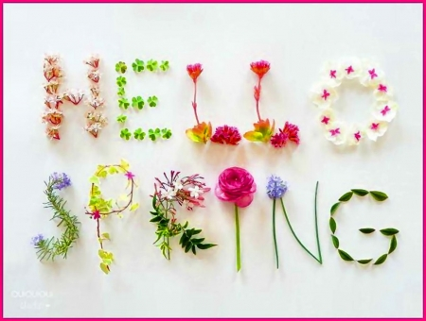
The Ministry Team invite you to join in celebrating the arrival of spring with a benefice ZOOM QUIZ Email Martin Lynas mdlynas@gmail.com to join.
By popular request Ann will be quiz master again. Get a TEAM NAME and LUCKY MASCOT.
A JOKER card will double your score on (hopefully) your best round.
A DONKEY card will halve your points on (hopefully) your worst round. BYO drinks and nibbles (obviously!) Have fun together - this is NOT Mastermind and you keep your own score. The MARATHON round (thanks to Fern) will be sent round in advance. If YOU would like to SUBMIT a round please email Ann edwardsa@ntlworld.com We’ll let you know the rounds are in next week’s newsletter. Click the zoom link from 7 15pm while we find our sound and video and catch up before the Quiz begins at 7 30pm Happy Spring Quizzing

